

Prime Minister Narendra Modi issued seven key economic appeals to Indian citizens under the headline
“Nation First, Duty Above Comfort".

The advisory aims to strengthen economic resilience, protect foreign exchange reserves, and counter rising global fuel and commodity prices triggered by the ongoing conflict in West Asia.
The seven instructions for citizens and companies include:
Prioritise Work From Home (WFH): Revive Covid-era remote work, online meetings, and virtual conferences wherever feasible to slash daily travel costs and national energy consumption.
Avoid Gold Purchases for One Year: Refrain from buying physical gold or jewellery. India imports over 90% of its gold, creating a massive drain on foreign exchange reserves.
Reduce Petrol and Diesel Consumption: Conserve fuel by using public transport, metro rail networks, carpooling, or switching to electric vehicles (EVs).
Cut Down on Cooking Oil: Reduce household consumption of edible oils by 10%. This simultaneously lowers India's massive import bill and promotes personal health.
Move Towards Natural Farming: Farmers are urged to reduce chemical fertiliser use by 50% to decrease national import dependency and shield the economy from surging global urea prices.
Embrace Swadeshi ("Vocal for Local"): Buy products made in India over foreign-branded luxury goods for everyday items like shoes, bags, and electronics.
Avoid Foreign Travel for One Year: Postpone overseas vacations, international destination weddings, and non-essential travel to keep leisure spending within domestic tourism markets.

Underlying Impact Strategy- The government designed these voluntary guidelines to drive behavioral economics rather than enforcing legal mandates. As highlighted in economic briefs by imposing iindividual restraint on these specific items directly tackles India's most expensive import categories (crude oil, gold, edible oil, and fertilisers). By curbing demand, the initiative helps stabilise the Indian Rupee against geopolitical shockwaves.

Petrol and diesel prices were increased by 90 paise per litre on Tuesday, 19th May, the second increase in less than a week. Prices were hiked by ₹3 a litre on Friday. Despite last week’s ₹3 per litre hike, state-run oil marketing companies (OMCs) continue to face significant under-recoveries on the sale of petrol, diesel and LPG. According to estimates cited by The Times of India, OMCs are currently losing around ₹750 crore daily on fuel sales.

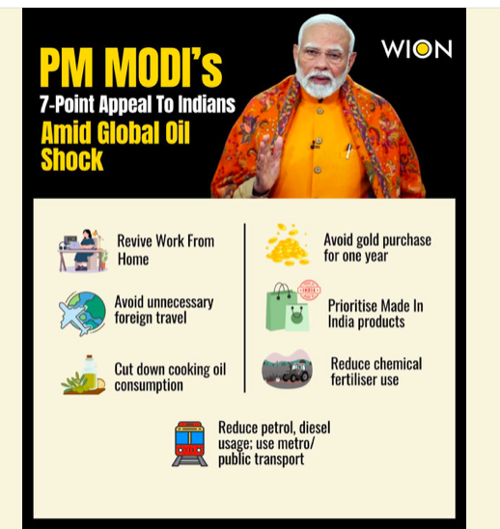
THE WORLD AROUND US
WHEN THE GOING GETS TOUGH, WE GET WRITING!
Edition 19 24th May 2026

The US State Department confirmed that Marco Rubio would participate on Friday (May 22, 2026) in talks among NATO Foreign Ministers in Helsingborg, Sweden, which will prepare for a NATO summit in Turkey in July. U.S. Secretary of State Marco Rubio will meet NATO counterparts following U.S. threats to pull troops and also pay his first visit to India following a chilly patch between the countries, it was announced Tuesday (May 19, 2026).

A China-U.S. summit that drew global attention. Global turmoil has heightened the need for stable China-U.S. ties. After a nine-year hiatus, United States President Donald Trump once again set foot on Chinese soil, and the “Beijing Moment” immediately went viral around the world.

UN Security Council condemns attack on UAE nuclear plant
The unclaimed drone struck an electrical generator on May 17 near the Arab world’s first nuclear power plant in Barakah in the emirate of Abu Dhabi, triggering a fire but causing no injuries nor radiation leak.

BRICS members agree on ‘independent’ State of Palestine with East Jerusalem as capital
Members disagree on future of Gaza Strip and Strait of Hormuz, which Iran claims falls in Iranian and Omani “territorial waters”. The BRICS Foreign Ministers’ meeting that concluded here on Friday (May 15, 2026), reaffirmed the grouping’s call for the creation of an ‘independent and viable State of Palestine’ within the pre-1967 borders, with East Jerusalem as its capital.

Tennis icon Billie Jean King earns college degree at 82
The 82-year-old sports and equality icon received her Bachelor of Arts in History from Cal State Los Angeles on May 18. Billie Jean King raised her right arm in triumph. Not for another victory on the tennis court. This time, she was celebrating earning a college degree 65 years after she first took classes. The 82-year-old sports and equality icon received her Bachelor of Arts in History from Cal State Los Angeles on Monday (May 18, 2026), walking across the stage in hot pink glasses and royal blue sneakers at the Shrine Auditorium with about 6,000 others in the Class of 2026.

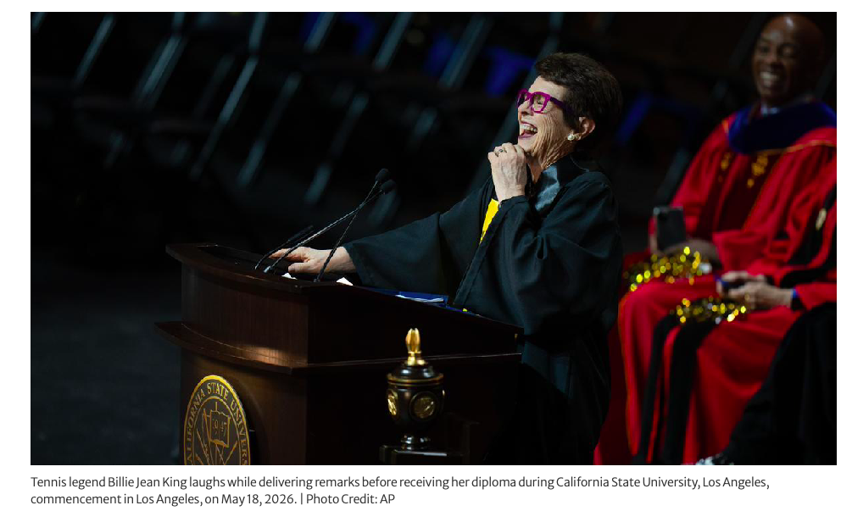
# CURRENT AFFAIRS INTERNATIONAL

INTER
# CURRENT AFFAIRS INDIA

INTER

In libris graecis appetere mea. At vim odio lorem omnes, pri id iuvaret partiendo. Vivendo menandri et sed.

Children who lived through war and turned their pain into activism. No capes, just courage.
Michel Chikwanine – From child soldier to motivational speaker
War zone: Democratic Republic of Congo, 1990s, when he was just 05 years of age. Michel was kidnapped by rebel militias at age 5 and forced to become a child soldier. For 3 years he was made to fight, carry an AK-47, and “shoot at everything that moved”. After escaping to Uganda, his father, a human-rights activist, was assassinated. Michel eventually made it to Canada as a refugee.
What he does now: He travels North America speaking to students about forgiveness. After one talk at an inner-city NYC school, a student who planned to avenge his brother’s murder told Michel: “I was talking a lot about forgiveness, and how I forgive the people that killed my dad. It had such a huge impact on him”. He also co-wrote a graphic novel Child Soldier so kids understand what war really costs.
His take: “Canada has shaped me into the person that I am today… I might have been born in Congo, but I grew up in Canada”.
Ajna Jusić, Alen Muhić & Lejla Damon – Breaking silence Bosnia,
Born into: The Bosnian War, 1994-1995
Born from wartime sexual violence, they were rejected by one or both birth parents and grew up with intense stigma. Most "children born of war" stay invisible their whole lives.
What they did: They went public. Through documentaries, TV, and social media interviews, they told their stories on camera. Not just for themselves, but to fight for legal rights for thousands of other kids born of war who get no birth certificates, no healthcare, no recognition. They’ve been filmed since birth in some cases. Speaking out means reliving trauma, but they said it’s worth it if it changes law


"India’s 2026 Green Oscar Winners

Saving Endangered Species Through Community Action"
"Local Heroes, Global Impact.
Barkha Subba is a conservation biologist from Darjeeling who just won the 2026 Whitley Award – aka the "Green Oscar" – for saving the Himalayan salamander. She grew up in Darjeeling surrounded by forests and tea plantations. Spent her childhood "endlessly curious" about birds, frogs, snakes, and one animal that stuck with her: the Himalayan salamander. As a Scientific Adviser to the Federation of Societies for Environmental Protection (FOSEP), a Darjeeling-based NGO.
Her project: "Survivor of a Lost World: Saving the Himalayan Salamander and its Wetlands"
The crisis: Only ∼30 breeding sites left in Darjeeling Himalaya. Most are outside protected areas. Wetlands are vanishing due to tourism, construction, tea garden expansion Deadly chytrid fungal disease wiping out amphibians worldwide .
Training 200+ locals – tea garden workers, villagers, students, officials – to lead conservation. Links ecology with livelihoods, works across govt land, private tea gardens, and community-owned lands.
Whitley Award 2026, presented at Royal Geographical Society, London
Grant: £50,000 (~₹50 lakh) to scale up her work
Why it matters?
She calls the salamander a "living fossil" – it's survived millions of years. Salamanders are wetland indicators: "when they vanish, the water itself is in trouble".
"I see a species that has survived for millions of years, still trying, still returning home". Salamanders return to the exact spot they were born to lay eggs. She’s building the first grassroots movement to protect this species by making villagers, tea estates, and govt work together.
Parveen Shaikh also won the 2026 Whitley Award "Green Oscar" She works to save the Indian skimmer.
Job: Conservationist and researcher with Bombay Natural History Society (BNHS)
She protects Indian skimmer Rynchops albicollis, a white bird, black cap, bright orange bill with a weird lower beak that's longer than the upper one. It flies low over rivers with its lower beak "skimming" the water surface to catch fish. Nests primarily on sandbars along the Chambal River in Central India, sandbars are disappearing due to sand mining, dams, and irrigation that change river flow
Tourism, cattle, fishing, and festivals on riverbanks destroy nests. Only ∼250-300 breeding pairs left in India. The Chambal holds one of the last major populations
Status: Endangered
BNHS teams guard skimmer colonies during breeding season so eggs/chicks don't get trampled
Community work: Trains local "river guardians" – fishermen, boatmen, villagers – to monitor nests and report threats, safer nesting: Experiments with artificial nesting platforms and "headstarting" – raising chicks safely then releasing them. Works with forest depts to regulate sand mining and tourism in key breeding zones. From sandbars in the Chambal to wetlands in Darjeeling, both Parveen and Barkha show "how change can start small and still make a global impact"

# HEAL THE WORLD

INTER
# REASON TO CHEER

INTER

# WEEKLY WATCH

INTER
# BELIEVE IT OR NOT

INTER


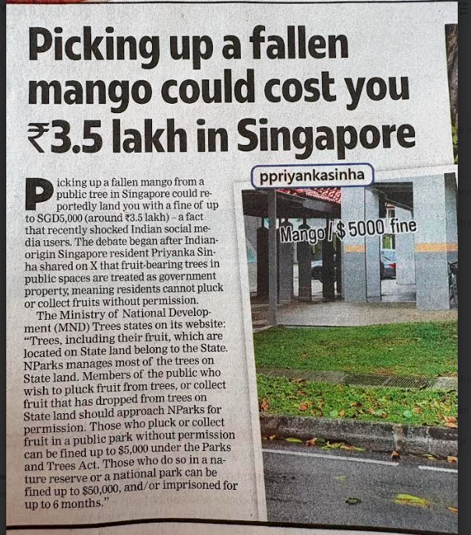

# FASHION FORWARD
# RECOMMENDED READS
Noor Jahan was one of the greatest Mughal begums of all time. She was the beloved wife of Mughal Emperor Jahangir. She is considered by historians to have been the real power behind the throne for much of her husband's reign. If you like to know more about her, well then, let us tell you a book you can read.

Did you know Noor Jahan sat where no other Mughal queen had sat before? That is, in the Jharokha – an elaborately carved balcony projecting from the palace wall, from which government business was conducted. Subjects gathered below to pray for her health, and getting a look at her was considered auspicious. Many of her male contemporaries were in awe of her, seeing her as a person of uncommon political and cultural acumen, and a remarkable leader. The book, a graphic comic from the stable of Amar Chitra Katha is available on amazon and on Kindle.

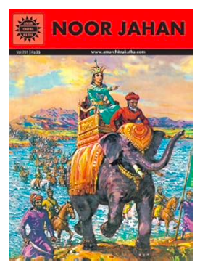
High heels: from war horses to TikTok trends
Basically, heels were invented for guys. Then they became illegal drip. Now they're prom-core.
Level 1: Warzone to throne zone – 1500s
Persian soldiers invented them to not die. The heel hooked onto stirrups so they could shoot arrows on horseback and not slip off. King Louis XIV was 5'4" and insecure about it. He wore 4-inch red-bottom heels and made a law: only he could wear red soles. Sound familiar? Yep, Louboutins stole his idea 300 years later
Level 2: The great breakup – 1700s
Guys decided heels were "too extra" and dropped them for flats. Called it the "Great Male Renunciation"
Girls kept them and made them thinner. Heels became a gendered thing right here. Marketing win for the 1700s
Level 3: The comeback – 1950s to now
WW2 plane tech = stiletto invented. Literally used aircraft metal so the tiny heel wouldn't snap
Marilyn Monroe said heels gave her that iconic walk. Every movie star copied her
1980s power suits: women wore heels in boardrooms to be taken seriously. "Dress like the boss"
2023-2026: Heels are optional. You’ve got Harry Styles in block heels, Zendaya in stilettos, and also Tabi boots + Crocs on red carpets. TikTok dragged uncomfortable heels and made platform sneakers cool again
Why teens still care?
Prom/homecoming: The one night heels still rule
Height hack: Instant +3 inches for photos
Main character energy: They change how you walk. Even Billy Eilish said performing in heels hits different
Thrifting flex: Vintage 90s square-toe heels are huge on Depop right now. Heels started as male combat boots and now they're either a slay or a "never again" after 20 minutes.

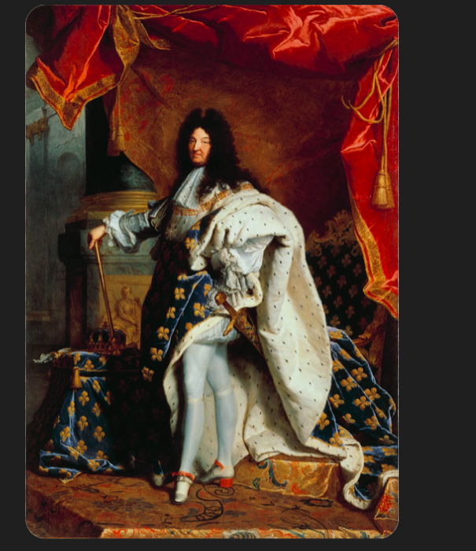

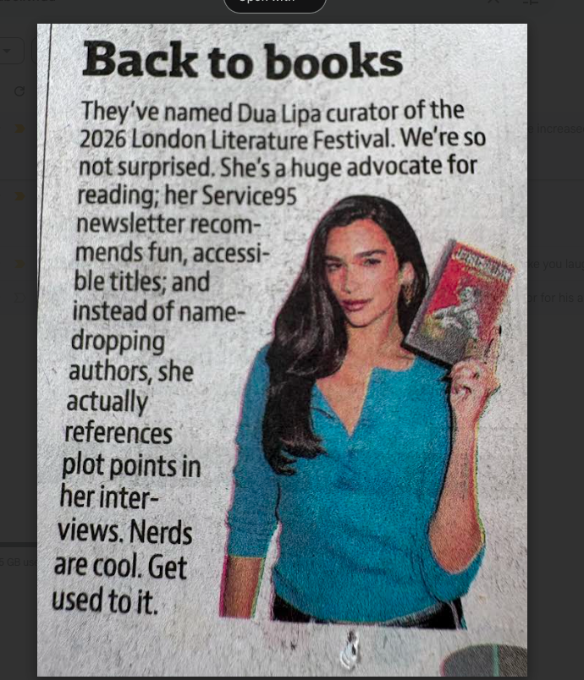



# SPORTS SCOREBOARD

INTER#

Which player won the Ballon D’or for his amazing performance in the 2021-2022 season ?
a) Kevin De Bruyne
b) Vinicius Junior
c) Benzema
d) Lionel Messi
Name the term used for when an opposition player is behind the second last player of the other team ?
a) Offside
b) Freekick
c) Last man
d) Throw-In
Name the home stadium of Liverpool FC?
a) Anfield Stadium
b) Spotify Camp Nou
c) San Siro
d) Vitality Stadium
Which country was the won the runners-up medal in the Copa America held in 2024 ?
a) Brazil
b) Argentina
c) Colombia
d) Paraguay
What was Kaka’s first name ?
a) Sam
b) Ricardo
c) Ivanovich
d) Paulo
Which was the African first country to qualify for a World Cup ?
a) Egypt
b) Nigeria
c) Ivory Coast
d) Morocco
Which club was the last winner of the Saudi league ?
a) Qarabak
b) Neom SC
c) Al Hilal
d) Damac
Who is known as the “Father of Indian Football” in the late 19th century?
a) Rabindranath Tagore
b) Nagendra P. Sarbadhikari
c) Michael Madhusudan Dutt
d) Hukum Singh
Which of the following is the youngest player to score in three consecutive Champions League Matches ?
a) Cristiano Ronaldo
b) Neymar Junior
c) Ronaldo Nazario
d) Lennart Karl
Which club has won the most Copa Del Rey’s ever ?
(Hint: use the first letters of the each correct choice . ITS AN ANAGRAM)
Answers ——>
1 - Benzema
2 - Offside
3 - Anfield
4 - Colombia
5 - Ricardo
6 - Egypt
7 - Al Hilal
8 - Nagendra P. Sarbadhikari
9 - Lennart Karl
10 - FC Barcelona

