

Amid pressure on fuel supplies due to the conflict in West Asia and related concerns over under-recoveries, oil-marketing companies today morning raised petrol and diesel prices by ₹3 across all variants. That is, the latest price hikes apply to both the regular petrol and diesel variants and the premium and high-octane products.

Major reason for economic crisis in India is Modi Government’s leadership crisis: Kharge after fuel hike
The Congress president said when diesel prices rise, inflation has a cascading effect across the country, adversely affecting everyone — from industries to household budgets and farmers.

Trinamool party office, clock tower demolished in West Bengal. A Kolkata Municipal Corporation team demolished a green clock tower in south Kolkata’s Garia area; in North 24 Parganas’ Naihati area, an illegal Trinamool party office was razed; authorities said the party office was constructed on land belonging to the Railways.

Iran Foreign Minister Abbas Araghchi arrives in India, to attend BRICS FM meet Araghchi will be coming face to face with UAE Minister of State for Foreign Affairs on Thursday (May 14, 2026) at BRICS Foreign Ministers summit. Mr. Araghchi indicated that UAE will be “held to account” for colluding with Israel, after Israel Prime Minister Benjamin Netanyahu office disclosed secret visit to Abu Dhabi during war. In a X post, Mr. Araghchi said “Netanyahu has now publicly revealed what Iran’s security services long ago conveyed to our leadership. Enmity with the Great People of Iran is a foolish gamble. Collusion with Israel in doing so: unforgivable. Those colluding with Israel to sow division will be held to account.”

PM Modi UAE visit: 'Impact of West Asia conflict being felt globally,' PM tells UAE President. India, UAE sign pacts ‌on ‌defence ⁠cooperation, petroleum reserves and ​LPG supply. Prime Minister Narendra Modi, who arrived in the UAE on Friday (May 15, 2026), held talks with President Sheikh Mohammed bin Zayed Al Nahyan and condemned the attacks on the country amid the West Asia war. “India is ready to extend all possible support to bring peace,” PM Modi said. The two countries also signed key pacts over strategic defence cooperation, petroleum reserves and supply of LPG, officials said. Energy security is likely to be a central theme of the discussions, as India monitors rising instability in the Gulf region amid concerns over oil supplies and maritime trade routes.

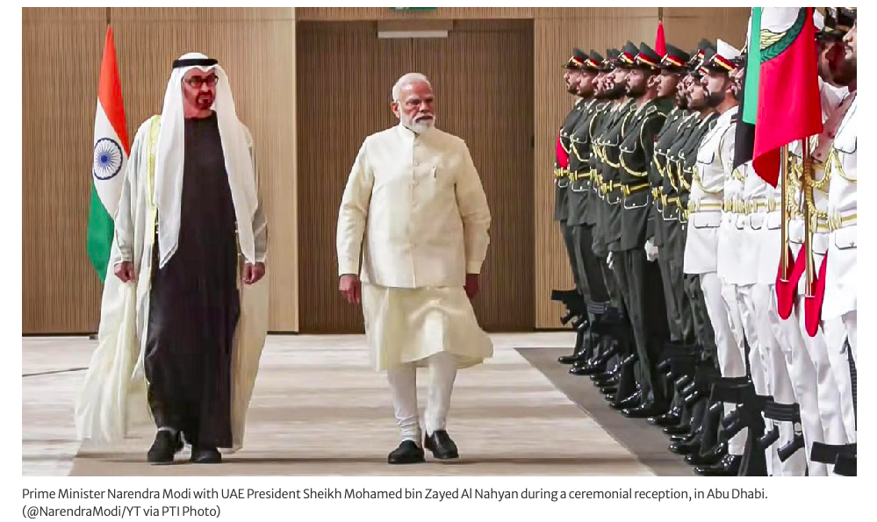
THE WORLD AROUND US
WHEN THE GOING GETS TOUGH, WE GET WRITING!
Edition 18 16th May 2026

‘Never mess it up’: What Xi and Trump said on day one of Beijing talks- Xi and Trump agree to frame their relationship as ‘constructive, strategic and stable’ on the first day of talks in Beijing. One day into United States President Donald Trump’s visit to China for trade talks, he and Chinese President Xi Jinping exchanged toasts at a state banquet at the Great Hall of the People in Beijing and hailed their relationship as the world’s most “consequential”. Following a visit to the Temple of Heaven, a 600-year-old landmark in the Chinese capital, Xi spoke of a “shared US-China future”, while also warning that failure to handle this bond would create a “very dangerous situation”.

Iran war week 8: Trump, Xi discuss Hormuz as Tehran rallies BRICS. The US and Chinese leaders agreed during talks in Beijing that the Strait of Hormuz should remain open to ensure global energy supplies. United States President Donald Trump and Chinese President Xi Jinping discussed the Strait of Hormuz during talks in Beijing, with the White House saying Xi agreed the strategic waterway “must remain open to support the free flow of energy” as tensions over the Iran war continue to roil global markets. Meanwhile, Iran’s Foreign Minister Abbas Araghchi urged fellow BRICS nations at a meeting in New Delhi, India, to condemn the US-Israel war on Iran as a violation of international law, insisting Tehran would “never bow to any pressure”.

Britain’s Health Secretary Streeting resigns as pressure on Starmer grows-A Labour lawmaker also resigns his seat in parliament in a bid to help clear a path for challenger to PM Starmer. Britain’s Health Secretary Wes Streeting has resigned from the ruling Labour government, deepening a crisis that threatens to topple Prime Minister Keir Starmer after less than two years in office. Hours after Streeting’s announcement on Thursday, Labour lawmaker Josh Simons said he would resign from ⁠his seat in parliament in a move designed to give Greater Manchester Mayor Andy Burnham a ⁠chance to return to parliament and challenge Starmer.

Macron’s Kenya visit -France is facing deepening resentment in former African colonies where it once had political influence. France’s President Emmanuel Macron has hosted a high-level meeting of heads of state and business leaders alongside his Kenyan counterpart, William Ruto, as Paris continues to pivot to other parts of the continent due to its strained relations with French-speaking West African countries. The conference, which was held on Monday and Tuesday in Kenya’s capital, Nairobi, was France’s first Africa summit in an English-speaking country. France’s Macron announces $27bn investment in Africa at Kenya summit
The Africa Forward summit comes amid France’s fading ties with its former African colonies, as Kenya seeks greater trade.

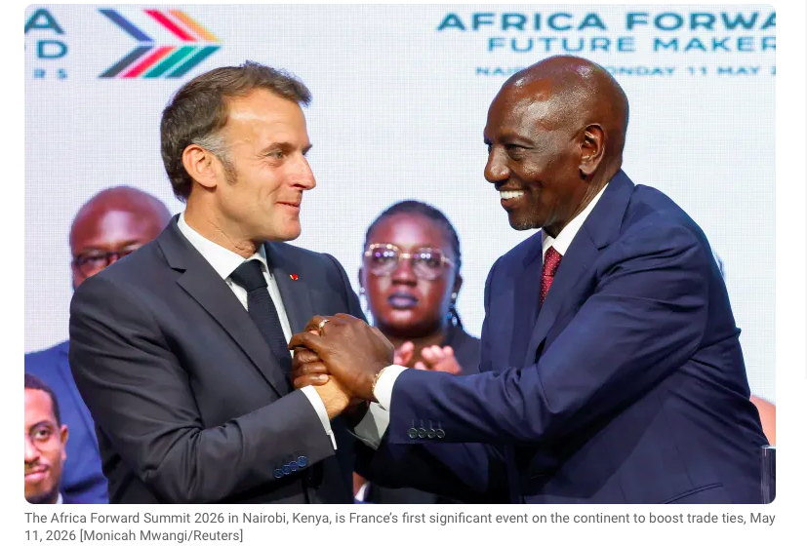
# CURRENT AFFAIRS INTERNATIONAL

INTER
# CURRENT AFFAIRS INDIA

INTER

In libris graecis appetere mea. At vim odio lorem omnes, pri id iuvaret partiendo. Vivendo menandri et sed.

FIFA World Cup: Madonna, Shakira, and BTS are announced as the headline acts for the 2026 World Cup Final halftime show, with Coldplay set to curate. The tournament, which will be co-hosted by the United States, Canada and Mexico, concludes with the final in New Jersey on 19 July. The show will be 11 minutes long. Although there have been reports the show could last longer than 15 minutes, which the laws of the game say the interval should not exceed.
Paris Jackson secured a win in her lawsuit against the Michael Jackson estate. The 28-year-old had raised legal flags about bonuses paid to third party beneficiaries.
Paris, along with her brothers Prince and Bigi, remain primary beneficiaries, but have engaged in multiple disputes regarding the management of the estate.
Streaming & Technology: Netflix reported massive investment in content, while Lionsgate Play announced expansion plans in India involving AI.
Dhurandhar 2: The Revenge, the action-thriller, starring Ranveer Singh is coming soon on OTT. Directed by Aditya Dhar, the blockbuster movie, which was released in theatres on March 19, has completed its eight-week window on the big screen and is set to be released on a OTT platform. It can be viewed in the U.S and Canada on Netflix and on JioHotstar in India. The tentative date for release is May 14th - 15th 2026.
Saif Ali Khan has been at the heart of the streaming revolution in India. It began with him donning the uniform and the turban for the role of Sartaj Singh in Anurag Kashyap and Vikramaditya Motwane’s 2017 crime thriller show Sacred Games, which laid the foundation stone 0f Netflix in India. Nine years later, he’s donned the police uniform again for Pulkit’s cop drama Kartavya, which drops on Netflix India on May 15.
Shah Rukh Khan turned heads in Mumbai as he stepped out in his Cadillac Escalade, regarded as one of the world’s most premium luxury SUVs. The Cadillac Escalade is worth nearly Rs 5 crore.
How Jane Fonda became an activist? She, recently reflected on a deeply personal chapter of her life — her solo journey across India that ultimately shaped her into the activist she is today. “I travelled all through India alone on buses. I had never seen poverty before. I realised that I had a choice: I could become a hippie and go into an ashram, or I would become an activist and try to do something about poverty. And that’s when I became an activist.”

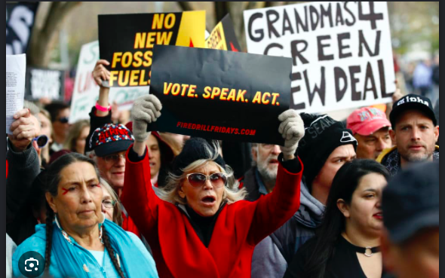

Millions of Palestinians mark 78 years since the Nakba
Nakba commemorations serve as remembrance and a call for justice, self-determination and the right to return. Arabic for “catastrophe” – a term that refers to the mass expulsion and flight of some 750,000 Palestinians from their homes during the 1948 war surrounding the creation of Israel. Friday’s anniversary is the third Nakba commemoration since Israel’s genocidal war on Gaza began, and comes as more than two million people in the besieged enclave remain displaced and confined to a fraction of their territory. More than six months after an October ceasefire, Gaza’s population is crammed into less than half of the 40km (25-mile) strip along the Mediterranean coast, hemmed in by an Israeli-controlled zone that encompasses the rest of the territory.
The Nakba refers to the systematic dispossession and displacement of Palestinians between 1947 and 1949, when Zionist paramilitary groups captured towns and villages in what became the state of Israel.
Historians estimate that about 750,000 Palestinians – roughly one-third of the population at the time – were forced from their homes, and more than 400 villages and urban neighbourhoods were depopulated or destroyed to make way for new Jewish immigrants.
Hundreds of thousands of those expelled and their descendants now live in refugee camps in the occupied West Bank, Gaza and across the region, including Jordan, Lebanon and Syria. Many still preserve keys, deeds and documents to homes in what is today Israel, passing them down through generations as symbols of their displacement and of a future return.

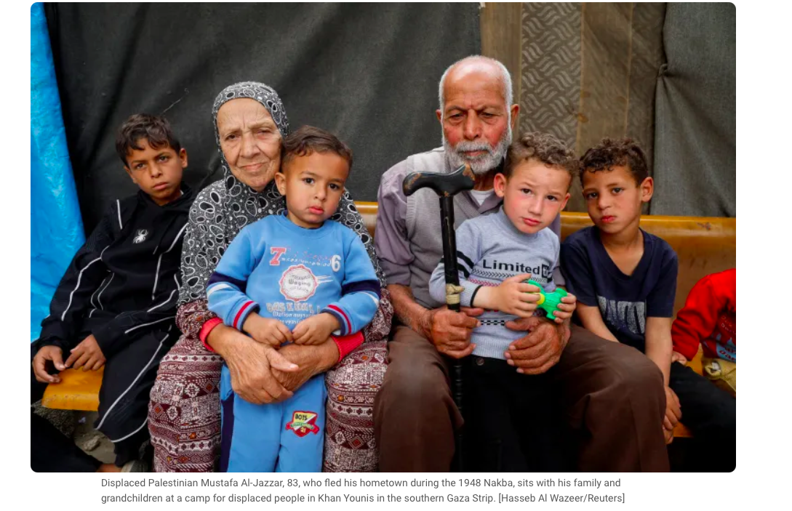
# HEAL THE WORLD

INTER
# ENTERTAINMENT NEWS

INTER



# TECHNOLOGY TALKING
# RECOMMENDED READS
ALICE IN WONDERLAND

Alice’s Adventures in Wonderland by Lewis Carroll is a children’s fantasy novel. The story follows Alice, who falls down a rabbit hole and ends up in a fantasy world that is unique and weird yet wonderful. Alice is bored one afternoon in the garden when she sees a rabbit darting towards some bushes. His human-like actions intrigue her, and she follows him. The rabbit jumps down the rabbit hole, and Alice falls behind him. This is how she ends up in Wonderland. In Wonderland, she meets a lot of interesting characters.

When she gets to Wonderland, she is scared and confused. Then, she starts going through the doors to get to the garden she can see. Her size constantly keeps changing as she tries to eat the cake to get to the right size. This shows Alice’s confusion and worries over growing up. As children we expect the world to be different as we grow up, but it isn’t how we pictured it. Alice shrinks and grows throughout the story trying to find the right size for her situation. It’s a metaphor for the idea of growing up and how confusing it can be. Alice follows what her family and teachers have taught her about kindness, affection, and goodness. It bothers her when in Wonderland she comes across characters that are rude or make personal remarks. It is not what has been taught to her.

The adults in the novel and the wonderland characters try to sound wise and advise Alice. But, often their ideas are silly and even cruel in the queen’s case. Alice is an innocent child, so she looks at the adults in a certain way. There is a clear disillusionment and contradiction between how adults are expected to be from a child’s perspective and how they actually are two different things. These situations Alice finds herself in are shown as funny which they are, but it’s also dangerous. All this happens in the safe space of a ‘dream’ so that such themes are easier to explore.

THROUGH THE LOOKING GLASS





# WEEKLY WATCH

Michael : The King of Pops movie Review
The 30-Second Lowdown-Michael hit theaters April 24, 2026. It’s the Michael Jackson story from age 5 to 30, starring his real nephew Jaafar Jackson. Think Bohemian Rhapsody but with more glitter and way less controversy. Critics are fighting. Fans are dancing in the aisles.
Why You’ll Actually Care- Jaafar Jackson = Cheat Code
This dude is MJ’s nephew and it’s creepy how perfect he is. The voice, the “hee-hee,” the moonwalk, the way he tips his hat — it’s like Michael came back. His Motown 25 Billie Jean scene? You’ll forget it’s not the real 1983 footage. Even haters admit: “He brought his uncle back to life”.
The Concert Scenes SLAP -Director Antoine Fuqua filmed the performances wide so you see every dance move. Thriller with zombies. Bad at Wembley. Man in the Mirror finale. It’s like Coachella 1988 and you’re front row. Billie Jean re-entered Spotify’s global top 10 after the movie dropped.
The Dad Drama is REAL -Colman Domingo plays Joe Jackson and he is terrifying. Belt in hand, screaming at 8-year-old Michael. Nia Long as mom Katherine is the only softness.
Missing Pieces -Janet Jackson doesn’t exist in this movie. The script was rewritten last-minute due to legal issues. You see Joe hitting Michael, but the movie won’t really explore how that trauma shaped him. It’s all “here’s the hits, now dance.


Britain’s David Attenborough, who has for decades been the world’s most authoritative voice on the natural world and whose documentaries have been watched by hundreds ​of
millions, celebrated his 100th birthday on 8th May 2026.
After more than 70 years of film-making, his instantly recognisable voice is synonymous with the story of ‌nature. He is still at the vanguard of efforts to protect the
environment and has produced some of his most impactful work in recent years.
Just last year, on his 99th birthday, Attenborough released a new documentary. After living for nearly 100 years on this planet. Attenborough says in the trailer for the
feature-length film, “I now understand the most important place on Earth is not on land but at sea. Through the course of my life, we have been on a course of ocean discovery”.
A newly identified species has been named after him. The
wasp, called Attenboroughnculus tau, had been sitting in the collection of London’s Natural History Museum since 1983 after its discovery in southern Chile’s Valdivia province.

King Charles III and Queen Camilla are among well-wishers to share a birthday message celebrating Sir David Attenborough turning 100. The royal couple also shared photographs of Sir David, including one of him with a young Prince Charles and Princess Anne in 1958, in which he is introducing them to Cocky the cockatoo, from his BBC Zoo Quest TV series. The King and Queen wished him a very happy birthday, adding, “Enjoy your special celebration this evening!”. The veteran broadcaster and environmentalist has said he was completely overwhelmed by messages he had received ahead of his big day, which includes a special concert on Friday evening at the Royal Albert Hall in London.

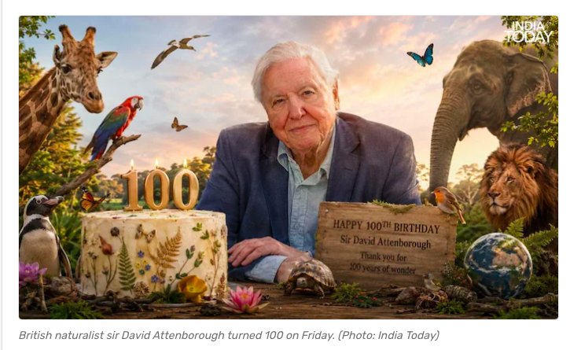
# HAPPY BIRTHDAY SIR DAVID ATTENBOROUGH

# SPORTS SCOREBOARD

INTER#

Cricket – IPL 2026 Madness
Kohli’s 9th IPL Ton: Virat hit 105 off 60 balls vs KKR on May 13. RCB won by 6 wickets and took top spot.
Last-Ball Thriller: RCB beat MI by 2 wickets on May 10. Needed 2 off 1, got it after a fumble. MI + LSG eliminated from playoffs.
Playoff Race: RCB + GT both on 16 pts. SRH 3rd with 14. PBKS vs MI today is do-or-die for PBKS.
Here’s the simple IPL 2026 leader board as of May 14, 2026:
Top 4 – Playoff Zone
RCB – 16 pts
GT – 16 pts
SRH – 14 pts
PBKS – 13 pts
Still in the Hunt
CSK – 12 pts
RR – 12 pts
Almost Out
DC – 10 pts
KKR – 9 pts
Eliminated
MI – 6 pts
LSG – 6 pts
RCB + GT are basically through. PBKS vs MI today could shake up 3rd/4th place.
Women’s Cricket: The Blaze chased 223 to beat Somerset by 6 wickets in One-Day Cup on May 13.
Football
Ligue 1: PSG beat Lens 2-0 on May 13 to close their season.
Argentina: Rosario Central beat Racing Club 2-1 in extra time on May 13.
MMA – UFC 328 Upset
May 9, Newark: Sean Strickland beat Khamzat Chimaev by split decision to reclaim the UFC middleweight title. Joshua Van won the flyweight belt with a 5th-round stoppage of Tatsuro Taira.
Tennis
WTA 125K Parma: Fossa Huergo/Kulambayeva beat Cascino/Feng 7-6, 2-6, 10-5 on May 13.
Other Headlines
Motorsports: Indy 500 practice + Sonsio Grand Prix qualifying highlights dropped May 9-12.
Indian Sports: Lakshay in Asian Boxing U-17 gold medal bout. S8UL qualified for Honor of Kings World Cup.

