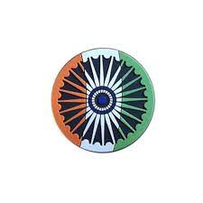
THE WORLD AROUND US
WHEN THE GOING GETS TOUGH, WE GET WRITING!
Edition 17 09th May 2026

Bengal Elections: BJP won a resounding election victory in West Bengal, a state which had been a rare opposition stronghold, expanding his unrivalled consolidation of power across the country. It is the first time they have won assembly elections in West Bengal, a large and politically significant state in eastern India.

BJP Leader Suvendu Adhikari's PA Chandranath Rath shot dead near Madhyagram, West Bengal. According to party sources, the attack occurred near Doharia on Jessore Road in North 24 Parganas district when Rath was returning to his flat from Kolkata in a car. Assailants riding a motorcycle intercepted his vehicle and opened fire at close range before fleeing the scene.

Tamil Nadu Elections: Actor-turned-politician Vijay, made a blockbuster debut in politics by breaking the DMK's and AIADMK's traditional duopoly, with his party the Tamilaga Vettri Kazhagam (TVK). The TVK emerged as the single-largest party with 108 seats in the 234-member assembly, falling short of the majority mark of 118. Congress, which has five seats, has decided to back Vijay, taking the seat count to 113. TVK insiders had told NDTV that they are counting on backing from other key DMK allies - CPI (two seats), CPM (two seats), and VCK (two seats).

Kerala: The Congress-led UDF won, with the party high command deciding the next Chief Minister amid internal tussles. Three leaders in contention – Ramesh Chennithala, K.C. Venugopal and V.D. Satheesan – are involved in hectic parleys to secure support of MLAs.

Assam election news: Assam was among five states where elections were held the first half of 2026. Here are the detail results. The Bharatiya Janata Party (BJP)-led National Democratic Alliance (NDA) secured a decisive victory in the 2026 Assam Assembly elections, winning 102 out of 126 seats. The results, declared on 4 May 2026, confirmed a "hat-trick" third consecutive term for the alliance in the state.

Bihar: A cabinet expansion saw 32 new ministers sworn in, including Nitish Kumar's son, Nishant.

Operation Sindoor Anniversary: The Indian Army and Air Force marked one year of the operation, calling it a successful response to terror threats, with drone capabilities being enhanced.

NCRB Data: The 2024 National Crime Records Bureau report showed a rise in cybercrime and crimes against foreigners in Delhi, though overall crime rates dropped.

The story behind Met Gala’s 2026 handwoven carpet: Kerala-based brand Neytt by Extraweave once again created the base carpet for the Met Gala, one of fashion’s most high-profile events. The carpet was produced in Cherthala, Kerala, before being shipped to New York City for the final installation. The carpet was made using hand-sorted natural sisal fibre sourced from Madagascar. It took 100 artisans over 90 days to make it.

Iran-Israel war:
Iran denied on May 7, 2026 attacking a South Korean cargo ship in the Strait of Hormuz this week, as U.S. President Donald Trump said a deal to end the war was “very possible” but warned that Washington would resume bombing if talks failed. Iran is reviewing the proposal as Trump pressurises Tehran for agreement on deal to end war
"Our priority is that they announce a permanent end to war and the rest of the issues could be thrashed out once they get back to direct talks," said a senior Pakistani official involved in the mediation.

Hezbollah commander killed: Israel killed Hezbollah Radwan Force commander in Lebanon’s Beirut strike amid ceasefire tensions.
Israel-Hezbollah conflict escalated after Israel’s claim.

Russia Tells Foreign Embassies in Kyiv to Evacuate:
Russia told foreign governments and organisations to evacuate diplomatic staff and citizens from Kyiv, saying a retaliatory strike would be inevitable if Ukraine tried to attack Moscow during May 9 World War II Victory Day celebrations.

Hantavirus outbreak on cruise ship: 3 infected patients evacuated to Netherlands, says WHO.
According to the World Health Organization, the vessel remains at sea with nearly 150 passengers and crew members still onboard as it heads toward Spain’s Canary Islands. The vessel’s British doctor had earlier been in “serious condition” but had since improved. WHO said three people have died in connection with the outbreak, while one body remains on the ship.

Epstein’s suicide note: A suicide note, purportedly written by Jeffrey Epstein, was recently released by a federal judge, The New York Times reported. The note, which remained sealed for years as part of a criminal case of Epstein’s inmate, read: “They investigated me for months — FOUND NOTHING!!! It is a treat to be able to choose one’s time to say goodbye. Watcha want me to do — Bust out cryin!! NO FUN. NOT WORTH IT!!” It was made public on Wednesday by the judge who oversaw Epstein’s cellmate Nicholas Tartaglione’s case.

China's former defence ministers given suspended death sentences on graft charges:The punishments are believed to rank among the harshest imposed on senior Chinese military officials - former defence ministers Wei Fenghe and Li Shangfuin decades, highlighting the severity of China's anti-corruption drive within its armed forces.

Social media ban: Indonesia may extend its recent under-16 social media restrictions to online shopping platforms, as the government pushes for broader safeguards to protect children online. In March, Indonesia started enforcing a social media ban for under-16s in a bid to shield some 70 million children from the threats of online pornography, cyberbullying and internet addiction. The policy followed Australia's landmark move in December to stop teenagers holding accounts on many popular platforms.

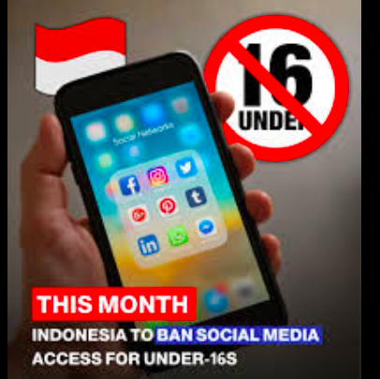
# CURRENT AFFAIRS INTERNATIONAL

INTER
# CURRENT AFFAIRS INDIA

INTER

In libris graecis appetere mea. At vim odio lorem omnes, pri id iuvaret partiendo. Vivendo menandri et sed.

So… What Even is the Met Gala?
Think of it as the Super Bowl of fashion. Once a year, the richest, most famous people wear outfits that cost more than a car and climb the steps of a museum in NYC. It’s for charity, but let’s be real — we’re here for the fits. On May 4, 2026, the theme was “Costume Art” and the dress code was “Fashion Is Art.” Translation: Your outfit should belong in a museum, not just on Insta.
The Main Character Energy: The Theme
This year the Met Museum basically said, “What if we put a $10,000 dress next to a Van Gogh painting?” They placed designer gowns beside actual sculptures and art. The point? Clothes aren’t “just clothes.” They’re art you wear.
Even the carpet got a glow-up. No more red carpet — it was a tan + moss-green “stone garden path.” Aesthetic.
Who Ran the Show?
Co-chairs: Beyoncé (back after 10 years!), Venus Williams, Nicole Kidman, and Anna Wintour aka the boss of fashion.
Vibe: “Dress like you’re the painting.”
Fits That Broke the Internet
Beyoncé + Blue Ivy = Skeletons But Make It Fashion
Queen Bey wore a crystal skeleton gown with a massive feather cape. Blue Ivy matched. It was anatomy class meets haute couture. Jay-Z just stood there looking proud.
Sabrina Carpenter’s “Movie Dress”-She literally wore film reels. Her Dior dress was wrapped in strips from the 1954 movie Sabrina with Audrey Hepburn. Film student core unlocked.
Rihanna’s Silver Cocoon-Late as usual, but worth it. Crystal Maison Margiela dress that looked like she hatched from a diamond egg. Icon behavior.
Indian Represntatives : Karan Johar made his Met debut in Manish Malhotra. Isha Ambani, Priyanka, and Deepika also slayed.
Money raised: $42 MILLION. A new record.
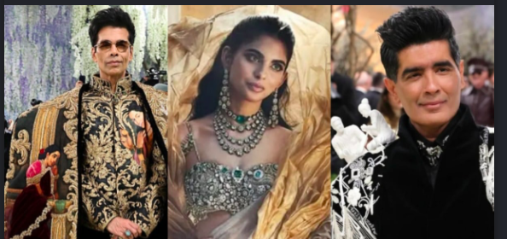

Doctors Without Borders (MSF) – Saving Lives in War
Doctors Without Borders is a group of doctors and nurses who go to places where there is war, like Gaza, Ukraine, and Iran in 2026. They do operations, help pregnant women, and give medicine even when hospitals are bombed. They do not choose sides. They just want to save lives. In May 2026, they asked world leaders to protect hospitals, because many doctors are getting hurt while trying to help others.
Victor Ochen – Teaching People to Heal Minds
Victor Ochen is from Uganda. He started a group to help children hurt by war. When the war in Ukraine began, many psychologists went to help but did not know how to work in a warzone. Victor’s team had experience from wars in Africa, so they trained the Ukrainian doctors. He says, “We are all brothers and sisters,” and believes people from one country can help another. He shows that kindness has no borders.
WHO in Ukraine – Bringing Back Hospitals
The World Health Organization is helping people in Ukraine during the war. In 2025, they sent 319 tonnes of medicine and built 28 small clinics to replace hospitals that were destroyed. They also taught 2,500 doctors how to treat people hurt in bombings. Their leader, Dr. Jarno Habicht, said they want to make sure “no one is left without care”. They are not waiting for the war to end. They are healing people right now.
These doctors, teachers, and volunteers show us what “Heal the World” really means. They prove that even when countries fight, ordinary people can choose to mend, not break. One hospital, one child, one act of kindness at a time — that is how the world starts to heal.

# HEAL THE WORLD

INTER
# REASON TO CHEER

INTER

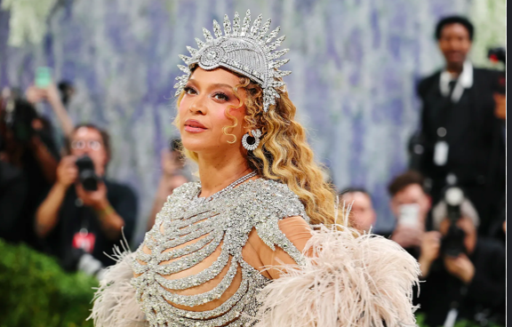

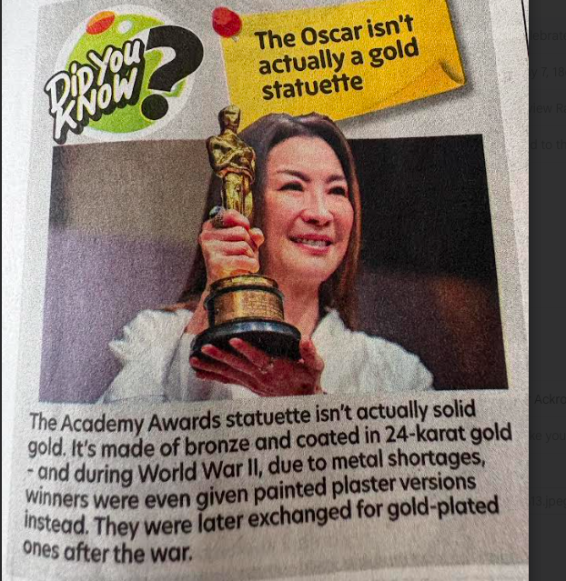


# TECHNOLOGY TALKING
# RECOMMENDED READS
The Boy, the Mole, the Fox and the Horse -Charlie Mackesy
What it actually is ?
Not a book. A lifeline. Charlie Mackesy took ink, watercolor, and the stuff we’re all scared to say out loud, and scribbled it onto pages. 2019 it was a book. 2022 it became an Oscar-winning short that’ll ruin your mascara in 32 minutes flat.
Imagine walking into a forest when your brain won’t shut up. You meet a kid who’s lost, a mole who thinks cake solves everything, a fox who’s been hurt too many times to talk, and a horse who’s seen it all. And instead of fixing you, they just… sit with you. No plot. No villain. Just four weirdos figuring out how to be human.
“What’s the bravest thing you’ve ever said?” “Help.”
Read that during exams and suddenly exhaling feels possible.
“You don’t have to be interesting. You just have to be you.”
Anti-Instagram in one sentence.
“What do we do when our hearts hurt?” “We wrap them with friendship.”
13? 30? 80? Doesn’t matter. If you’ve ever stared at the ceiling because the world feels too loud — Iran war, $126 oil, homework — this is for you. You can inhale it in 20 minutes. Or you’ll get stuck on one page for a week because it called you out.
Why it works ?
It’s messy: The drawings look like they were done on napkins during a breakdown. Which is why they feel real.
It gives you permission: To be tired. To not know. To ask for help without a PowerPoint of reasons.
Mole = us: “I’m greedy for cake.” Translation: “I cope with small joys and I’m not sorry.”
Fox = your trust issues: He doesn’t talk for half the book. And that’s okay.
Why it might not ?
If you need car chases or cliff hangers, you’ll hate this. It’s repetitive. “Be kind” shows up like 40 times. Some people roll their eyes and call it “Tumblr wisdom for adults.”
Verdict:
Read it if: Your group chat is all war news and you forgot what hope feels like. This book is a blanket.
Skip if: You think vulnerability is cringe and you only read thrillers.
2026 reality check
Last week the Strait of Hormuz closed, oil hit $126, and my feed was just fear. Then the horse says “This storm will pass.” And for 10 seconds, I believed him. That’s why this book exists!


National Technology Day

India celebrates National Technology Day on 11th May every year. This day reminds us how science and technology make our country stronge, and was first declared in 1999 by Prime Minister Atal Bihari Vajpayee to honour India’s achievements in technology.
Why 11th May?
On 11th May 1998, India did something historic. Three important events happened on this day: Pokhran Nuclear Tests-India successfully conducted nuclear tests at Pokhran, Rajasthan. This was called ‘Operation Shakti’. It showed the world that India is strong in science and defense. Hansa-3 Flight-India’s first home-made aircraft, Hansa-3, took its first flight on this day. It was designed by NAL, Bangalore. Trishul Missile-The DRDO successfully test-fired the Trishul missile on 11th May. Because of these three big achievements, the government chose 11th May as National Technology Day. What is its importance of Technology ? It changed our lives.

In space-ISRO sent Chandrayaan to the Moon and Mangalyaan to Mars at very low cost.

In communication-From letters to mobile phones and internet, we can talk to anyone in seconds. In education-Online classes, smart boards, and YouTube help us learn better.

In health-New machines and medicines save lives. Vaccines for COVID-19 were made quickly because of technology. In farming-Tractors, drip irrigation, and weather apps help farmers grow more crops.

How We Celebrate?
On this day, schools organize science quizzes, essay contests, and model-making competitions. The President gives awards to scientists who do great work. The theme changes every year. The theme for National Technology Day 2026 is expected to be "Responsible Innovation for Inclusive Growth." This theme focuses on key sectors such as Artificial Intelligence, semiconductor manufacturing, clean energy, space innovation, deep-tech research, and digital public infrastructure. Conclusion Technology is like a tool. If we use it well, it can solve big problems like pollution, disease, and poverty. Dr. A.P.J. Abdul Kalam said, “Science is a beautiful gift to humanity”.

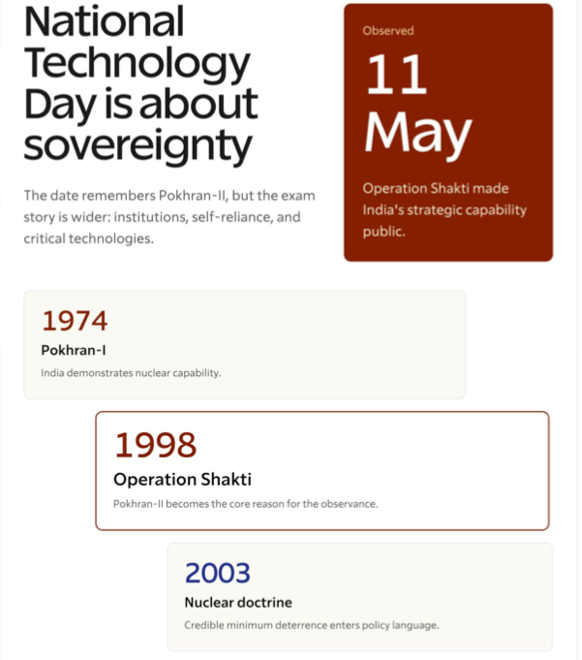

BUDDHA AND NON THEISM

In times of extreme ideologies, doctrines and isms wreaking havoc across the world, the Buddha’s non-doctrinal approach comes across as an ideal antidote.

Buddha went beyond theism and atheism. He was referred to as Eesh-Parangmukh by Ashvaghosh of Saket in his epic poem ‘Buddhacharita’, composed in the early 2nd bc.

Buddha was against all beliefs and ideologies because all isms restrict humans. He knew very well that the debate pertaining to the existence or non-existence of a god was
futile and eternally inconclusive because both theism and atheism stand on false and indefinite premises. God cannot be proven or disproven. Humans have been wasting their time arguing about whether or not god exists. This hasn’t made us wiser. Rather, this perennial debate has left us mired in inertia and inactivity. Buddha believed that even the truth was subjective and all the so-called realities were relative.
Things that cannot be proven or disproven must be left behind. Moreover, what does one get out of an otiose debate like god’s existence or non –existence?

Pragmatism is central crucial and integral to Buddha’s philosophy. It doesn’t dwell upon anything that’s vague and amorphous. So, the Buddha never wasted is time on unimportant speculations about god’s perceived and putative presence and existence. We can learn from Buddha and go
beyond theism and atheism to become evolved beings. But are we ready?

This is million-dollar poser.

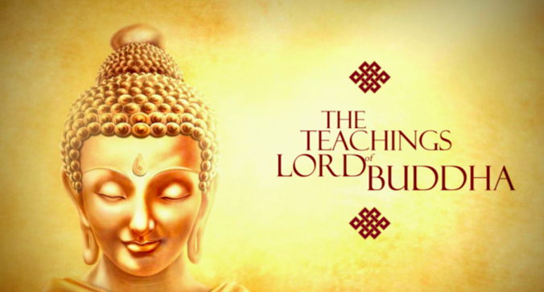
# SPORTS SCOREBOARD

INTER#
# POINT TO PONDER

INTER#

IPL 2026: Sunrisers Hyderabad moved to the top of the table after defeating Punjab Kings. Chennai Super Kings secured an 8-wicket win over Mumbai Indians.
Speculation continues over Hardik Pandya’s travel with the Mumbai Indians squad. Pandya was advised a precautionary rest for about a week after the back spasm he sustained against the Chennai Super Kings.

Chess: D Gukesh defeated Javokhir Sindarov of Uzbekistan in the Grand Chess Tour, in Warsaw, despite his blunders and the controversy.

Champions League (Football): Arsenal advanced to the final after defeating Atletico Madrid. PSG will face them in the final after beating Bayern Munich. Kylian Mbappé is recovering from his hamstring injury, and Arsenal's Bukayo Saka received praise for his performance against Atletico Madrid.

Tennis: Jannik Sinner became the first man to win five consecutive Masters 1,000 titles after beating Alexander Zverev in straight sets to win the men’s title in the Madrid Open. Ukraine’s Marta Kostyuk beat Russia’s Mirra Andreeva in straight sets to win the women’s title in the Madrid Open. It is her first title at WTA 1,000 level.Aryna Sabalenka and Jannik Sinner warned they might boycott Grand Slams over prize money disputes.

Badminton: India's men's team was knocked out by France in the Thomas Cup semifinals, taking home the bronze.

Athletics: Kuldeep Kumar broke the national pole vault record with a 5.41m jump in Bhubaneswar.

Wrestling: The Wrestling Federation of India (WFI) restricted selection trials for the Asian Games to only medallists from last year's Nationals and Federation Cup, impacting Vinesh Phogat. The Wrestling Federation of India (WFI) announced her ineligible for the 2026 Asian Games selection.

India Squad For Women's T20 World Cup 2026 announced. Harmanpreet Kaur will lead the 15-member team. Smriti Mandhana will be the vice-captain. The Women's T20 World Cup will be held in England and Wales, beginning on June 14. Many of the big names have been left out due to injury.

Boxing: Tashkent, 6th May 2026: India’s young boxers have ensured 27 medals in the Asian Boxing U-15 and U-17 Championships in Tashkent, Uzbekistan. The Under-15 girls’ team today delivered an outstanding performance, securing 14 out of 15 medals, while the Under-15 boys also performed strongly, ensuring 13 out of 15 medals.

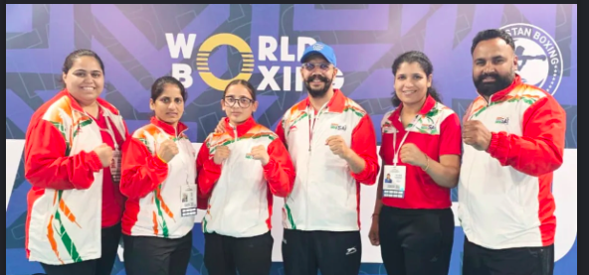
HAPPY BIRTHDAY

