

Elections & Politics
Record turnout in West Bengal: 92.65% polling in Phase 2 of Assembly elections on April 29, pushing total turnout to ∼93% — highest since Independence. ECI announces bypolls in 15 booths in West Bengal. The repolls are for 11 booths in the Magrahat Paschim Assembly seat and 4 booths in Diamond Harbour Assembly seat. The repoll will be conducted from 7 a.m. to 6 p.m. on Saturday (May 2, 2026).
Exit polls predict tight race in WB, BJP+ ahead in Assam with ∼102 seats, DMK-led ahead in TN, UDF in Kerala.

Economy & Trade
Exports surge- First 3 weeks of April saw significant export increase vs 2025 despite West Asia war. Commerce Min Piyush Goyal-New trade deals giving India preferential access in autos, textiles, leather, agriculture, seafood. Strait of Hormuz still a challenge but exporters using alternate routes.
Finance Minister’s View-Global drift = opportunity for India. Real GDP grew 7.6% last FY, forecast 7-7.4% for FY26-27, though Iran war clouds outlook.

Infrastructure & Defence
Ganga Expressway -PM Modi inaugurated 594-km Meerut-Prayagraj expressway in Uttar Pradesh, praises overall development Uttar Pradesh is swiftly progressing towards becoming a one-trillion-dollar economy, says the Prime Minister. Describing it as the identity of a “New Uttar Pradesh,” which would emerge as a new lifeline for the State’s connectivity and employment.
S-400 delivery- India to get 4th unit of Russian S-400 Triumf missile system early May.
DRDO ready for Agni-6: Awaiting Centre’s nod, India’s next-generation ballistic missile programme is poised for a major leap, with the DRDO (Defence Research and Development Organisation) declaring its readiness to begin work on the Agni-VI missile once the government grants formal approval.

Law & Society
Supreme Court- 9 judge bench hearing Sabarimala temple entry review. Says existing laws sufficient for hate speech, no new legislation needed.Upholds mandatory RTE admissions as “national mission”.

Chief Minister Lalduhoma declared Mizoram “insurgency-free” after the last remaining insurgent group in the state laid down arms on Wednesday. According to officials, a faction of the Hmar People’s Convention (Democratic), or HPC (D), headed by Lalhmingthanga Sanate, had remained largely dormant for several years but would occasionally engage in sporadic criminal activities. The Sanate faction was considered the last surviving insurgent group in the state.
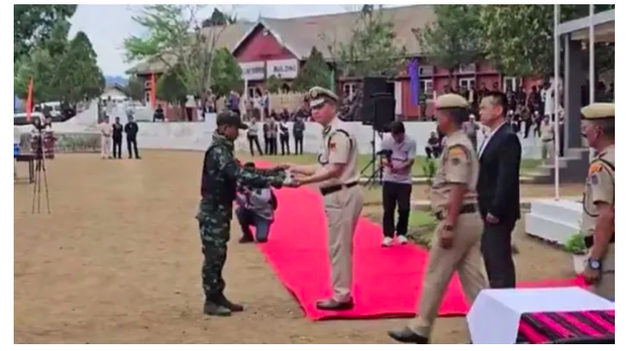

Iran War – Oil & Shipping Crisis
Strait of Hormuz still closed: 2 months into US-Israel-Iran war. Blocks 20% of world oil/gas. Brent hit $126/barrel, highest since Mar 2022. US gas at $4.30/gallon.
Cease-fire fragile: In place since April 8, but Iran still blocking strait over US naval blockade of Iran oil. Trump to get briefing on “short and powerful” strikes + plan to take over part of strait with ground forces. Iran warned “long and painful strikes” on US positions if attacks resume. Amazon reported damage to cloud regions in Bahrain/UAE, restoration may take months.
Diplomacy
Iran asked for time till end of week to respond to US observations. Japan PM spoke to Iran President for safe passage of vessels. US planning “Maritime Freedom Construct” coalition to reopen strait. The Iran War Mediation and Pakistan’s ‘Reverse Bismarck’. Despite the positive optics of punching above its weight in diplomacy, Pakistan has become weaker over time.
Global News
In the ongoing Russia-Ukraine war, Russia proposed brief May 9 ceasefire for WW2 anniversary. Trump and Putin discuss Iran war and float temporary Ukraine ceasefire in call. Russian president welcomed decision to extend Iran ceasefire in what US president said was a ‘very good conversation’. In the call, which lasted more than 90 minutes, the Russian president said Moscow viewed the prospect of a US ground operation in Iran as dangerous, Russia has largely been side lined in diplomacy over the war in Iran, an ally of the Kremlin, but western intelligence agencies say Moscow has continued to provide support, including intelligence and drones to strike US targets in the area.
President Donald Trump, who has criticized Germany and other NATO allies for not ​sending their navies to help open the Strait of Hormuz, said on Wednesday his administration is looking at reducing the number of ‌U.S. troops in Germany.
"The United States is studying and reviewing the possible reduction of Troops in Germany, with a determination to be made over the next short period of time," Trump said on Truth Social.

UAE leaves OPEC in blow to oil cartel during war on Iran
Announcement of its exit comes as Gulf producers are already struggling to ship exports through the Strait of Hormuz. The United ‌Arab Emirates has announced its decision to quit OPEC and OPEC+ to focus on “national interests”, dealing ⁠a heavy ⁠blow to the oil-exporting groups at a time when the US-Israel war on Iran has caused ⁠a historic energy shock and rattled the global economy.

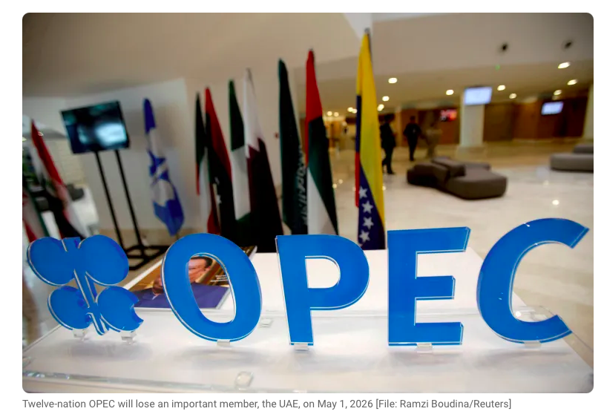
# CURRENT AFFAIRS INTERNATIONAL

INTER
# CURRENT AFFAIRS INDIA

INTER
THE WORLD AROUND US
WHEN THE GOING GETS TOUGH, WE GET WRITING!
Edition 16 02nd May 2026

In libris graecis appetere mea. At vim odio lorem omnes, pri id iuvaret partiendo. Vivendo menandri et sed.

The Changemakers

Col Christopher Rego (Retd.) and his wife Myrna didn't set out to build an organisation. They started by sponsoring a handful of students from remote villages in Mizoram — just helping, in the way people sometimes do when they see something they can't unsee.
In 2012, during one of Manipur's recurring periods of unrest, Christopher Rego was asked to help build a hostel for a small school in Ijeirong village. Villagers came together with wood, stone, and their own labour. Rego arranged cement and funding. The local Assam Rifles commander contributed roofing sheets. Friends sent money. Six months later, the hostel was standing. Enrolment at the school grew from 70 students to 250 because children from nearby villages could now stay.

It was not a handful of students who needed sponsoring, but a region that needed sustained, structural attention. Sunbird Trust was born from that realisation. These students went on to higher education, some going for post graduate programs both in India and abroad, and many built careers. This is not an exception. For children in many of the region's remote villages,the classrooms nearby are built from whatever the village could spare — and they are full of children who will sit on whatever bench exists, share whatever notebook can be found, and learn in whatever patch of light comes through the gaps in the roof. Getting to school means crossing streams that run fast during the monsoon, walking on paths that aren't really paths. Shoes give out. Socks wear thin. Uniforms get washed mid-week because there's only one set. And still, every morning, they come. Sunbird Trust has spent over a decade making sure that when those children arrive, there is something worth arriving for. Not a perfect school. Not a fully-funded future. Just a door that's open, and someone on the other side who believes they should walk through it.
That, it turns out, is enough to change everything.

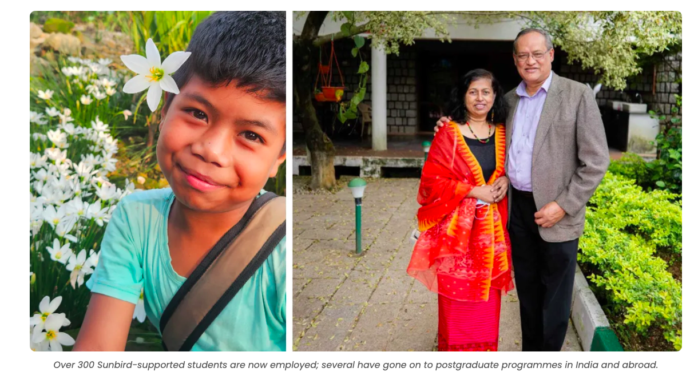

Boston Marathon Runners Praised for Stopping to Help Injured Competitor Cross Finish Line: Two runners at the Boston Marathon stopped mid-race to help a fellow competitor who had collapsed due to severe leg cramps. Spectator Sasi Bejrakashem was watching the race on April 20th 2026, when she witnessed the emotional scene unfold near the closing stages. She said she noticed a runner, Ajay Haridasse, in a black top suddenly come to a halt and buckle over in pain with cramp in his muscles. While several athletes ran past, two competitors, Aaron Beggs and Robson Oliveira, made the decision to stop and help. The pair lifted the struggling runner between them, each taking one side, and supported him as they continued along the course together.

Phone-free social events led by the generations who didn’t have them until adulthood, grow: Members of Gen Z and Millennials are attending phone-free experiences 567% more often across the globe, signalling a major shift in how people want to gather. In a world shaped by algorithms and constant visibility, Eventbrite data shows that the generations having grown up with limited to no social media and smartphone use, is now leading the world back—away from constant connectivity. The United Kingdom has emerged as the global leader for phone-free socializing, with events growing by 1,200% and attendance increasing by 1,441%.


# HEAL THE WORLD

INTER
# REASON TO CHEER

INTER

# FEED FORWARD
# CURRENT AFFAIRS साप्ताहिक

INTER

Managing Editors- Aniruddha Iyer Bali, Sabir Singh Ahuja, Vaibhav. S.Uppal, Vihaan.S. Uppal
Hey everyone!  We are teenagers from a boarding school in the foothills, who believe change begins with us. The newsletter, a fortnightly, explores stories, events and ideas that shape our world. From happenings to global issues, we'll dive into it all. Join us, collaborate, critique and voice your opinions as we share our perspectives, insights, and creativity with you!

Your feedback and contributions would be a game changer!

Do write to us, @theworldthisweek4@gmail.com

May 1, known as International Workers' Day or Labour Day, recognise laborers and the working class. It commemorates the 1886 Haymarket affair in Chicago, where a general strike for an eight-hour workday occurred. The day serves to honour worker contributions and advocate for better working conditions.
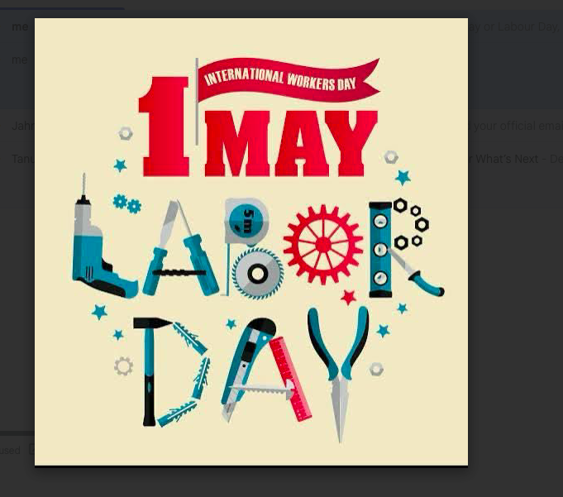

# ENTERTAINMENT NEWS
# RECOMMENDED READS

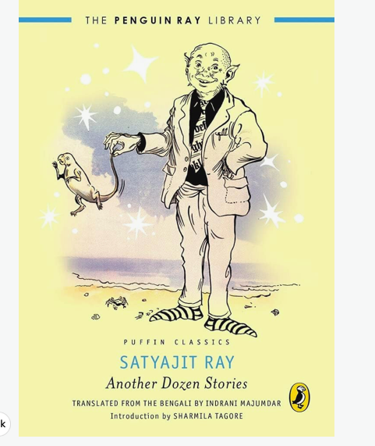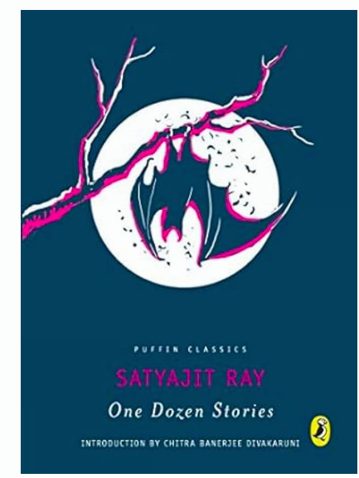

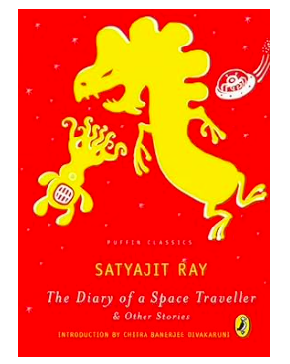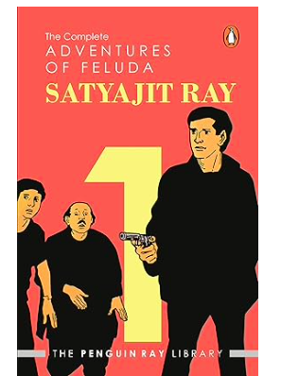

Happy 105th Birthday Satyajit Ray, an author, a filmmaker, artist, screenwriter for shaping our imagination.
Assamese film ‘Aakuti’ heads to New York Indian Film Festival 2026: Snigdha P Roy on her Assamese debut, working with a first-time child actor, crafting emotion, and taking the film from short to feature. It is the emotional journey of eight-year-old Lakhi as she copes with the loss of her mother.

Michael is a 2026 biographical musical drama directed by Antoine Fuqua and written by John Logan. It follows the life of American singer Michael Jackson. The April release The opened to record-setting worldwide box office numbers for a biopic, though it received mixed critical reviews compared to high audience praise. The film has reportedly sanitised the singer’s controversial life.

The Devil Wears Prada 2 premiered on April 20, 2026, in New York, and is scheduled to be released in theatres in the United States by 20th Century Studios on May 1, 2026. The film received generally positive reviews from critics. All the original cast members Streep and Hathaway were initially hesitant on the prospects of a sequel but signed up. Development on the film began in July 2024, with all four leading actors - Streep, Hathaway, Blunt, and Tucci.

Christopher Nolan explains why The Odyssey won't be longer than Oppenheimer. The Oscar-winning director said "there's a massive amount of pressure" in adapting the Greek epic, which stars Matt Damon and Anne Hathaway. It arrives at theatres on July 17, 2026.

Raghu Rai didn’t just photograph India, he invented a way of seeing it …. His passing at 83, last week, has left a void in the photo-journalism. The audacity of Raghu Rai’s wide-angle lens, the tension he seemed to choreograph at the edges of the frame added a cinematic aside long before cinema caught up with that language. He is known for shooting important events in Indian modern history, including the Bangladesh refugee crisis, 1972 and the Bhopal gas tragedy, 1984. Over the years, his photo essays appeared in Time, Life, The New York Times, The Independent, and The New Yorker.

HE CAME, HE SAW, HE CAPTURED !

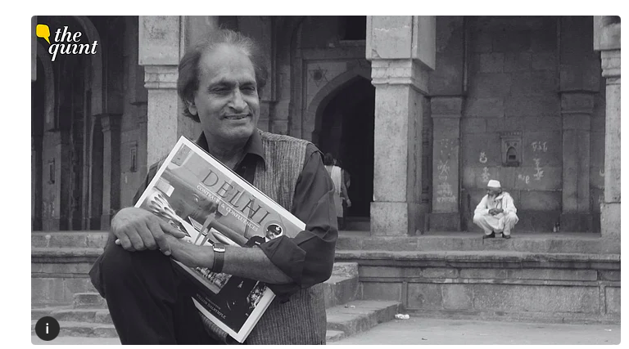

# STAR WARS DAY



Star Wars Day was created by fans as a sly nod to one of the films’ most popular catchphrases, “May the force be with you.” Get it? Good, now May the 4th be with you too.

It’s not an official holiday but has become so well-known that even former President Joe Biden marked it when “Star Wars” actor Mark Hamill dropped by the White House a day beforehand. Last year, the Trump administration marked the occasion with a Star Wars-themed meme.

UAE quits OPEC

What that means for the Gulf, energy markets and beyond. UAE signalling intent to pursue independent economic policies and reshape Gulf oil politics. After decades of membership, the United Arab Emirates has decided to quit the oil producers’ group, OPEC, in order to focus on “national interests” and forge its own path, it has said. The move is seen as a major blow to the Vienna-based oil cartel – but will not spell the end of it altogether, observers say.

The UAE’s decision to quit comes after years of open dissatisfaction with the oil cartel’s policy of capping members’ production as a way to control prices and stabilise the market. The country has invested billions of dollars in increasing its oil production capacity from 3 to 5 million barrels per day (bpd) by 2027. As it has grown its ability to produce more oil, it has demanded a larger quota than has been assigned to it.

The moves also come at a particularly tricky moment as the region, and the rest of the world, grapples with an energy crisis triggered by the US-Israel war on Iran, which began on February 28. Tehran responded by hitting back at Israel, US military assets and other infrastructure in Gulf countries. It also closed off most access to the Strait of Hormuz, through which 20 percent of the world’s supplies of oil and liquefied natural gas (LNG) are shipped from Gulf producers.

Before the start of the war, the UAE’s production capacity had grown to 4.8 million bpd, but under its OPEC agreement, it was only allowed to produce 3.2 million bpd.

Experts say its departure from the cartel is unlikely to have an immediate impact on the market because the UAE’s exports, like those of all its neighbouring countries, are currently constrained by Iran’s control of the Strait of Hormuz. The UAE has been able to sell some of its oil via the Fujairah terminal, which sits on the Gulf of Oman, allowing it to circumvent the waterway. Last year, it exported 1.7 million bpd of crude oil and refined fuels this way – not enough to meet its ambitions.

This could all change, however, if the conflict ends with an agreement between Iran and the US that allows for the resumption of free navigation through the strait. For now, that is up in the air, as the US continues its naval blockade of Iranian ports and Iran, in return, refuses to allow any foreign-flagged ships to transit the strait. Iran has also indicated that it may wish to maintain its leverage over the strait post-conflict through a system of tolls.

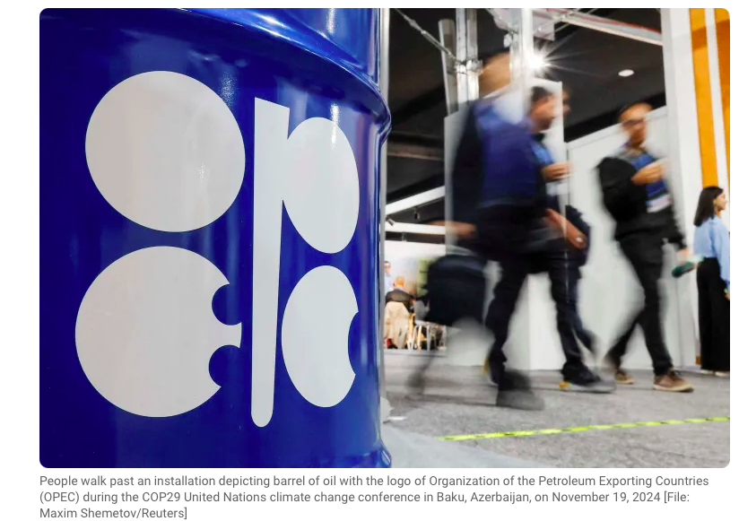
# SPORTS SCOREBOARD

INTER#
# MONEY MATTERS

INTER#

Howe says Saudi owners’ desire for success at Newcastle remains unchanged. PIF said that it would cut funding of LIV Golf at the close of the 2026 ​season. Manager Eddie Howe says that Newcastle United’s Saudi Arabian owners remained as committed as ever to ⁠the club’s success, even ⁠as their Public Investment Fund prepares to cut ties with the LIV Golf series. PIF, which spent more than $5 billion on LIV Golf since it launched in ⁠2022, said on Thursday that it would cut funding at the close of the 2026 season, leaving the breakaway circuit scrambling for new backers.

Timberwolves eliminate Nuggets as Knicks demolish Hawks in NBA playoffs. Meanwhile, the Celtics-76ers playoff heads for a decisive Game 7 after Philadelphia beat Boston 106-93.
The Minnesota Timberwolves eliminated Nikola Jokic’s Denver Nuggets while the New York Knicks put on one of the most dominant displays in NBA playoff history, destroying Atlanta to advance, and the surging Sixers beat the visiting Celtics again to force a decisive Game 7.Sixth-seeded Minnesota will play the San Antonio Spurs in the Western Conference semi-finals after completing a 110-98 win on Thursday for a 4-2 series upset of third-seeded Denver.

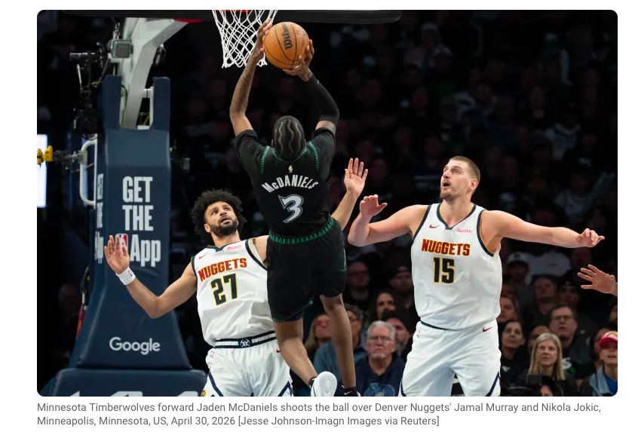

Egypt international Mohamed Salah set to return for Liverpool before the season ends as Anfield exit looms. Liverpool manager Arne Slot said Mohamed Salah “deserves a big send-off” as he confirmed he expected the departing superstar to return from injury before the end of the season.
The Egypt forward, who will leave Anfield at the end of the campaign, was forced off in last weekend’s 3-1 win at home to Crystal Palace, prompting fears he may have played his final game for the Reds.

