
Karnataka Budget 2026-27
The state government has announced a ban on social media for children under 16, with a total outlay of ₹4,48,004 crore.

Census-2027
Union Minister Amit Shah launched four digital tools and mascots 'Pragati' and 'Vikas' to improve public awareness and ensure efficient data collection.

Green Hydrogen Mission
India is rapidly expanding its green hydrogen sector to achieve carbon neutrality and strengthen energy security.

Sukhoi Su-30 Crash
An Indian Air Force Sukhoi Su-30 fighter jet crashed in Assam, with the pilot missing.
New Governors Appointed
President Droupadi Murmu appointed new governors for several states, including Lt Gen Syed Ata Hasnain as the Governor of Bihar.

India-US Relations
The US has allowed India to import Russian oil for 30 days amid the West Asia conflict.

India-Canada Relations
India and Canada announced a strategic energy partnership and revived CEPA talks.

Top Indian cities with the highest literacy rates
Based on the government literacy data, several smaller and mid-sized cities have emerged as India's most educated urban centres, with places like Aizawl and Kochi leading the national rankings. Aizawl, the capital of Mizoram, has emerged as India’s most literate city, recording a literacy rate of 98.36 per cent, according to the latest city-level data. The figures place the north eastern hill city ahead of major urban centres across the country, highlighting the strong education culture that has taken root in the region. Aizawl’s performance is marked by near-universal literacy among both men and women, with 98.52 per cent of males and 98.21 per cent of females able to read and write. Kerala continues to dominate the national literacy map, with five cities in the top six. Kochi ranks second with an overall literacy rate of 97.36 per cent, followed closely by Thrissur (97.06 per cent), Kozhikode (96.53 per cent) and Alappuzha (96.20 per cent). The state capital Thiruvananthapuram also features in the list, posting a literacy rate of 95.10 per cent.

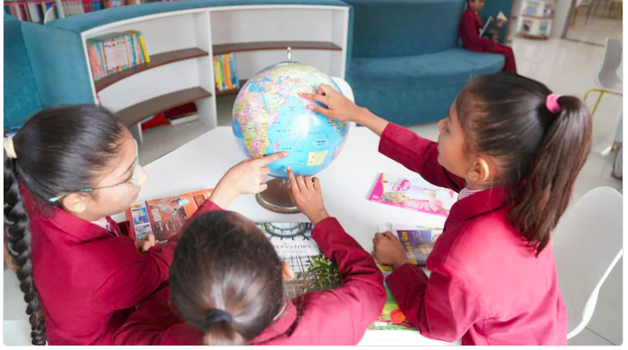
# CURRENT AFFAIRS INTERNATIONAL

INTER

The killing of Iranian Supreme Leader Ali Khamenei in a United States-Israeli air campaign has sent shockwaves through the Middle East, decapitating the leadership of the “axis of resistance” at its most critical moment. For decades, this network of groups allied with Iran was Tehran’s forward line of defence. But today, with its commander-in-chief dead and its logistical arteries cut, the alliance looks less like a unified war machine and more like a series of isolated islands fighting desperate survival wars.

Iran war threatens prolonged impact on energy markets as oil prices rise. The conflict has already led to the suspension of about a fifth of global crude oil and natural gas supply. The outlook poses a global economic threat and a political vulnerability for US President Donald Trump leading into the midterm elections, with voters sensitive to energy bills and unfavourable to foreign entanglements.

‘No popular support’: China warns against government change in Iran. Beijing calls for Iran’s sovereignty to be respected and demands ‘immediate stop to military operations’ in the Middle East. China has warned against seeking government change in Iran amid the ongoing US-Israeli offensive, saying any such move lacks public support.
“Plotting a ‘colour’ revolution or seeking government change will find no popular support,” China’s Foreign Minister Wang Yi told a news conference.

Iranian authorities warn against ‘fifth column’, as no signs of war abating. The Intelligence Ministry renews call for people to report any suspicious activity through phone calls and local messaging services, as the global internet remains disconnected. The internet blackout has restricted Iranians’ news sources to state media, which do not cover many developments, including forced evacuation orders issued by the Israeli military, instead mostly focusing on successful Iranian strikes.

Tens of thousands in scramble for flights out of Middle East amid the crisis. Wealthy travellers are paying up to $200,000 to charter flights out of the region. Much of the region’s airspace remains closed amid the conflict, with only a limited number of flights departing from a handful of regional gateways, including Dubai in the United Arab Emirates, Saudi Arabia’s capital Riyadh, and Oman’s Muscat.

Six months after the Gen Z protests unseated the coalition government led by Prime Minister K P Sharma Oli, Nepal went to the polls on Thursday (March 5) to vote in a new government. The Rastriya Swatantra Party, with rapper-turned-mayor Balendra Shah as its prime minister candidate, is set for a two-thirds parliamentary majority. Shah had highlighted health and education for poor Nepalis as a key focus of his campaign, which rode a wave of public anger towards traditional political parties. He said the vote reflected his refusal to take “the easy way out” and signalled a reckoning with the “problems and betrayals that have affected the country”.



# CURRENT AFFAIRS INDIA

INTER
THE WORLD AROUND US-A NEWSLETTER
Edition 9 09th March 2026

In libris graecis appetere mea. At vim odio lorem omnes, pri id iuvaret partiendo. Vivendo menandri et sed.

Avatar: Fire and Ash

On the 19th of December, 2025, moviegoers internationally were flocking to the cinemas to watch the new Avatar movie - the third film of the series. The series had begun with Avatar (2009), which is currently the highest-grossing movie of all time. It was succeeded by Avatar: The Way of Water (2022), which was delayed due to lack of advanced technology. Its sequel was released at the end of last year. It grossed over $1.33 Billion. So, the question remains - is it actually any good? And if it is, does it match the extremely high benchmark set by its Oscar-winning predecessors?

The movie has quite good graphics and visual effects, already having been awarded the Critics' Choice Movie Award for Best Visual Effects, matching the standard of its prequels, both of which have won the same award for their respective years of release. Well, what about the plot? The story? The main thing that happens? To understand it, you must watch the first two Avatar movies, or risk being completely lost for a full 3 hours and 17 minutes.

SPOILER ALERT! (for Avatar: Fire and Ash)

So what happens in this, you may ask?

Fear not, for here is all you need to know about Avatar 3. This movie continues from where the second left off, with the Sullys still grieving about the Neteyam’s loss, which has led to an intense hatred for humans in Neytiri, Jake’s wife. This causes struggle within the family, as they have adopted Miles “Spider” Socorro, the son of Colonel Quaritch. Miles also houses an immense dislike for his villainous father, regarding Jake as his father. However, an attack by the Na’vi tribe of the Ash People (Mangkwan) caused the enemies to join forces to fight them. However, in an attempt to kill Jake for his betrayal in Avatar and find his son, Quaritch strikes a deal with the shaman leader of the Mangkwan, Varang. In return for human weapons, Varang aids the RDA against the Metkayina. After a bloody battle, the humans and the Mangkwan are, once more, defeated, but with Varang escaping, alive.

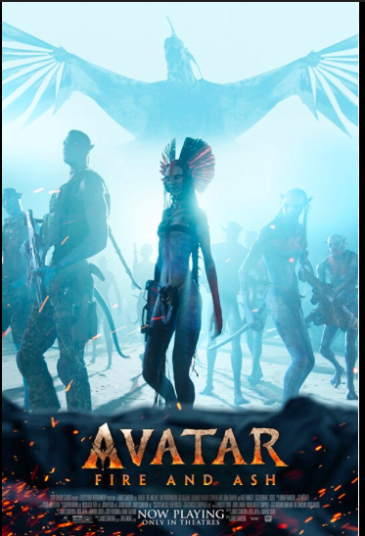

In late February, zookeepers at Ichikawa City Zoo began posting videos of lonely little Punch, a macaque, who dragged his beloved stuffed orangutan around with him everywhere he went. Prime fodder for baby animal-obsessed citizens of the internet, he quickly went mega-viral.

Punch was abandoned by his mother at birth—a common occurrence in the animal kingdom—so his caretakers gave him the toy because it “stimulates clinging to a mother but also prevents excessive dependence on humans,” the zoo posted on X. That’s right about when hearts across the internet started to break.

The problem was that Punch lacked some basic social skills. When Punch was released into the zoo’s wider macaque population back in January, videos surfaced of the adult residents pushing and hitting Punch when he tried to seek affection. Anyone who has ever felt left out or lonely is probably rooting for Punch’s eventual acceptance into the zoo’s macaque family.

Luckily, things are going well for Punch, too, at least in terms of his social life. Since his initial rejection, Punch has been filmed being hugged by an adult monkey, groomed (apparently a high honour in monkey society), and seems to be making friends.

In a statement released in mid-February, Punch’s zookeepers wrote that he shows “resilience and mental strength,” despite his rough start in life. Those are two traits that most parents want to teach their children—to be strong and capable when they aren’t around. Meanwhile, Punch the Orphan Macaque Is Outgrowing His plushie and making friends
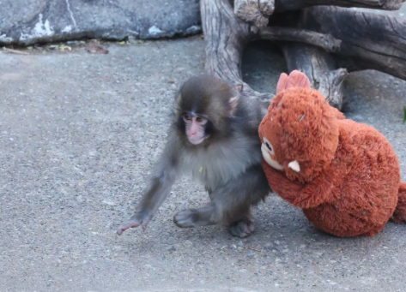
# REASON TO CHEER

INTER
# WEEKLY WATCH

INTER

# FEED FORWARD
# CURRENT AFFAIRS साप्ताहिक

INTER

Managing Editors- Aniruddha Iyer Bali, Sabir Singh Ahuja, Vaibhav. S.Uppal, Vihaan.S. Uppal
Hey everyone!  We are teenagers from a boarding school in the foothills, who believe change begins with us. The newsletter, a fortnightly, explores stories, events and ideas that shape our world. From happenings to global issues, we'll dive into it all. Join us, collaborate, critique and voice your opinions as we share our perspectives, insights, and creativity with you!

Your feedback and contributions would be a game changer!

Do write to us, @theworldthisweek4@gmail.com



# RECOMMENDED READS
# HEAL THE WORLD
PERCY JACKSON- THE SERIES

In the realm where gods and mortals entwine,
A tale unfolds, oh, so divine.
Rick Riordan wields his pen with might,
Crafting the Percy Jackson series, a mythic delight.
Book one opens, lightning striking the sky,
Percy Jackson, a boy, caught in the high.
Camp Half-Blood beckons, a haven unseen,
Demigods unite, where destinies convene.
From the blood of gods and the spirit of man,
Emerges a hero with a grander plan.
Percy, Annabeth, and Grover, their bond so strong,
Through quests and battles, they journey along.
The Lightning Thief, a quest so bold,
Percy's journey starts, myths to unfold.
Medusa's lair and the Underworld's door,
Each challenge faced, the trio wants more.
Sea of Monsters, where the ship sets sail,
On the Sea of Monsters, a perilous trail.
The Golden Fleece, their quest to find,
In Cyclops' cave, danger intertwined.
Titan's Curse, where friends are lost,
A prophecy whispers, a destiny tossed.
Thalia, the daughter of Zeus, takes the lead,
In the quest to thwart an ancient creed.
Battle of the Labyrinth, a maze untold,
Daedalus' creation, secrets to unfold.
Luke's betrayal, the Titan's design,
In the heart of the labyrinth, the plot aligns.
Last Olympian, the final strife,
As the gods clash, determining life.
Percy's destiny, a burden to bear,
In the war of Olympus, who'll emerge fair?
Riordan's pen dances with gods and with fate,
Crafting a world, both thrilling and great.
With humour and heart, the characters shine,
In Percy Jackson's world, an epic design.
Mount Olympus trembles, the heavens applaud,
A series profound, a modern myth awed.
So embark on this odyssey, a journey so long,
Percy Jackson's legacy, a mythical song.

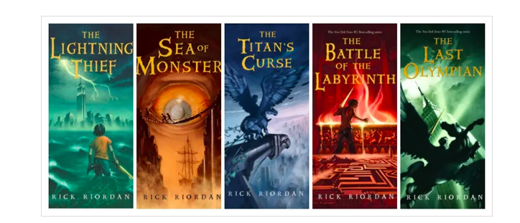
US - Iran - Israel War
On February 28, the United States and Israel launched a large-scale offensive against Iran after weeks of military buildup and threats from President Trump. In a Truth Social post, Trump said the goal of the operation is to prevent Iran from obtaining a nuclear weapon and “to defend the American people by eliminating imminent threats from the Iranian regime.” Trump urged Iranians to capitalize on the attack as the “only chance for generations” to take over their government. Trump and Israeli officials later confirmed that Israel Defense Force (IDF) strikes on Tehran killed Iranian Supreme Leader Ayatollah Ali Khamenei. Tehran retaliated with a campaign aimed at US bases and embassies in a host of Middle Eastern countries, as well as oil refineries and tourist infrastructure like airports and hotels. Washington warned Americans to leave the region. Israel launched simultaneous strikes on Tehran and Beirut on the morning of March 3rd, targeting both Iranian military sites and Hezbollah. Israeli forces also seized more locations in southern Lebanon, carrying out strikes against what it says are Hezbollah’s sites in the country. The Israeli military also shut all crossings in and out of the occupied West Bank, leaving Palestinians unable to access urgent aid as settler attacks rise.

Iran continued its retaliatory strikes on Israel and US military assets in Kuwait, Qatar, Saudi Arabia, Bahrain and the United Arab Emirates, despite Iranian President Masoud Pezeshkian promising on Saturday to halt attacks on Gulf states as long as their territories were not used to attack Iran.

Russia - Ukraine war
Russian forces deployed a new weapon in their latest strike on Ukraine that left at least 10 people dead. Regional authorities said a residential building in Kharkiv was hit by a new Russian cruise missile known as Izdeliye-30. Ukrainian reports state, Russia started using the new subsonic air-launched weapon recently. It has a range of 1,500km and is equipped with a new satellite navigation system more resistant to jamming.

Ukraine’s low-cost Shahed killers draw US and Gulf interest, but a wartime ban blocks sales. As the war in the Middle East strains US missile stocks, Ukraine is hoping it can turn a wartime innovation of low-cost interceptors designed to shoot down Russian attack drones – into geopolitical leverage. Ukraine is offering that expertise to the United States and its Gulf partners for the war in the Middle East, hoping to receive in return the high-end weaponry it can’t manufacture at home.

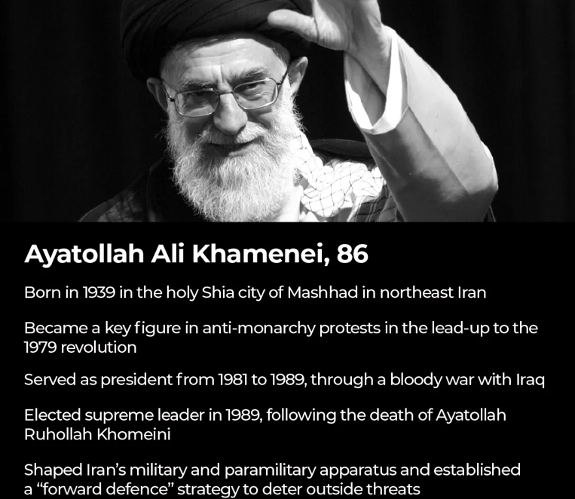



# MONEY MATTERS

INTER#
# TECH TALKING

INTER#
Iran war is latest threat to a global economy rattled by Trump
Rising energy prices threaten to stoke inflation and hobble economic growth in countries around the world.

As the United States and Israel’s war on Iran unfolds over the coming days and weeks, the scale of the fallout for the global economy will be measured at the petrol pump. The biggest threat the conflict poses to global economic health lies in rising energy prices.

Iran’s effective closure of the Strait of Hormuz and Iranian attacks on key energy production facilities in Qatar and Saudi Arabia have paralysed a substantial chunk of the world’s energy supply. For a global economy already rattled by US President Donald Trump’s tariffs and what many see as his unravelling of the post-World War II order, much now depends on how long the disruption lasts.

A sustained surge in energy prices would drive up the cost of everyday goods. Central banks would then likely raise borrowing costs to curb inflation, dampening consumer spending and dragging down economic growth. “It’s really a question on how long the disruption of flows through the Strait of Hormuz lasts and whether there will be destruction of physical assets,” said Anne-Sophie Corbeau, an analyst at Columbia University’s Center on Global Energy Policy.

While Iran’s threats to shipping have halted traffic through the Strait of Hormuz, the conduit for one-fifth of the world’s oil, crude prices have seen relatively modest gains so far. During the 1973-74 oil embargo led by OPEC’s Arab members, prices quadrupled in just three months. Since then, the world’s dependence on Middle Eastern oil has declined substantially.

Today, the US is the biggest producer globally, producing some 13 million barrels a day, more than Iran, Iraq and the UAE combined, according to the US Energy Information Administration. But, if supply disruptions extend beyond a few weeks, oil prices could rise precipitously.

The International Monetary Fund has estimated that global economic growth is reduced by 0.15 percent for every 10 percent rise in oil prices. The pain would not be spread evenly.
About 80 percent of the oil shipped through the strait goes to Asia. India, Japan, South Korea and the Philippines, which are all highly dependent on foreign energy imports, would be among the economies most vulnerable to spikes in the cost of necessities such as food and fuel.

Liquefied natural gas (LNG), which is also shipped through the strait and has fewer alternative suppliers outside the region than crude oil, has already seen much steeper price rises. European prices of LNG surged by as much as 50 percent on Monday after state-run QatarEnergy, which ships about one-fifth of global supply through the waterway, announced a halt to production following drone attacks blamed on Iran
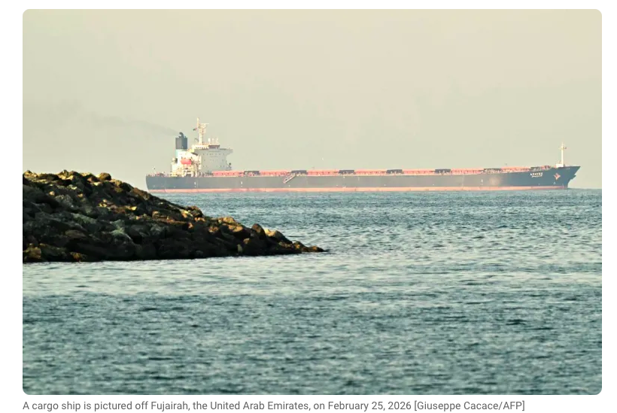
Supermassive black holes not so massive say scientists
Study of galaxy more than 12 billion light years away shows black holes may be smaller than believed, challenging models of cosmic growth. Astronomers told the media on Thursday that, following a breakthrough study of a distant quasar, an extremely bright, active core of a very distant galaxy, the supermassive black hole at its heart has a mass that is equal to “only” about one billion suns, making it one-10th of what was assumed.

A team from the University of Southampton, working with European colleagues, observed the galaxy, more than 12 billion light years away, using state-of-the-art equipment at the European Southern Observatory (ESO) in Chile. “Despite the quasar’s extreme luminosity, the black hole at its heart was found to have a mass equal to ‘only’ around one billion suns,” instead of spinning rapidly as expected, the black hole was “belching up” gas, driven outwards by the blinding intensity of light. The black hole at the centre of this young galaxy was first detected in 2024 by Wolf and his colleagues at the Australian National University. The study, published in Astronomy and Astrophysics, used Gravity+, an instrument that combines light from four of the world’s largest telescopes at ESO’s Very Large Telescope in Chile. The team, which also included researchers from France, Germany, Portugal and Belgium, analysed the hot gas spiralling into the black hole
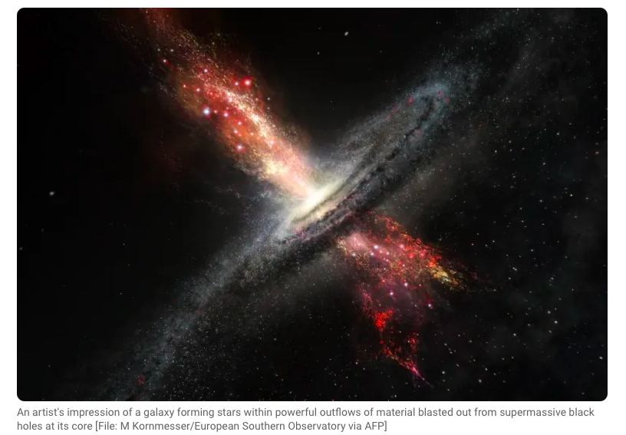

## Cricket
- The ICC Men's T20 World Cup 2026 is underway, co-hosted by India and Sri Lanka, running from February 7 to March 8.
India plays New Zealand in the finals at Ahmedabad. Fans hope for World Cup final redemption At the T20 World Cup final, the cricket-crazy nation hopes to bury the ghosts of 2023 and walk away with happy memories.
## Badminton
- Lakshya Sen will face off against Chinese Taipei's Lin Chun-Yi at the All England Open badminton Championships men's singles final 08th March in Birmingham. The world No 12 came through a sensational, often gruelling, semifinal clash against Canada’s Victor Lai on Saturday at the prestigious All England Open but that seemed to have compromised him physically. The 24-year-old, who had also reached the summit clash in 2022, not only overcame a spirited Lai but also blisters in his right foot to win 21-16, 18-21, 21-15 in an hour and 37 minutes.## Hockey
## Football
Lamine Yamal gives Barcelona hard-fought 1-0 win at Athletic Bilbao. Yamal goalkeeps the champions four points clear of Real Madrid at the top of the La Liga standings
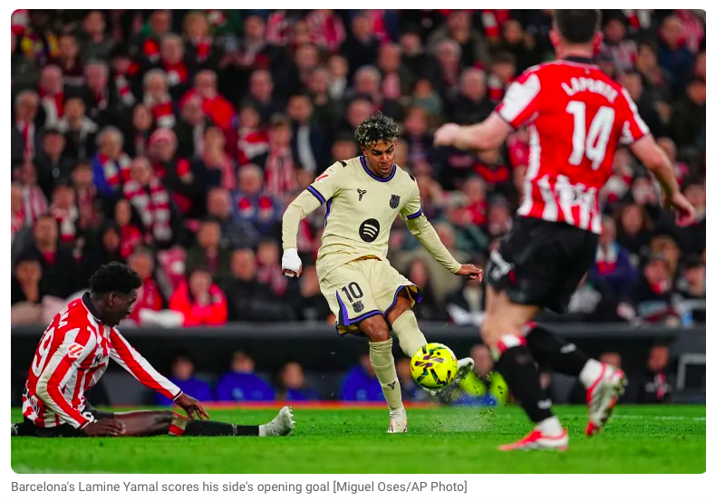
# SPORTS SCOREBOARDS

INTER#

