
India hosts AI Impact Summit
India hosted an artificial intelligence summit from 16th to 20th February 2026, bringing together heads of state and tech executives with hot-button issues on the agenda, including job disruption and child safety. From generative AI tools that can produce text and images to advanced systems used in defence, healthcare and climate modelling, AI has become a central focus for governments and corporations across the world.

India and Brazil talks in New Delhi
Prime Minister Narendra Modi and Brazilian President Luiz Inacio Lula da Silva held delegation-level talks in the national capital.Earlier, PM Modi and President Lula held discussions at Hyderabad House on Saturday, 21st February.

Army commander inaugurates ‘Banwat Ekta Sthal’
Army’s Northern Commander Lt Gen Pratik Sharma on Saturday inaugurated the 'Banwat Ekta Sthal' -- a public monument symbolising national pride and sovereignty -- near the Line of Control in Poonch district of Jammu and Kashmir. The project was completed in a record 45 days and features a towering 105 feet National Flag, the tallest in Poonch district, a defence spokesman said.

Jharkhand Civic Polls
The campaigning for the polling to Jharkhand's 48 urban local bodies, including Ranchi, concluded on Saturday evening, a State Election Commission official said. The voting will be held on February 23, 2026.

Consulate in Malaysia
To further her Diplomatic ties with Malaysia, India has set up a new Consulate General in Malaysia to strengthen commercial ties. India - Malaysia signed an MoU for Ayurvedic academic collaboration.

38th National Games
Uttarakhand hosted the 38th National games, with Services winning the most gold medals. Meghalaya was named the host for the 39th National Games.

Women’s Cricket
India beat Australia by 17 runs in the third and final Women's T20, sealing the series 2-1. The series was held in Australia.

Diplomatic Shift
The Bangladesh High Commission in New Delhi, along with its assistant missions in India (Agartala, Kolkata, Guwahati, Mumbai, Siliguri), resumed full visa services, including tourist, medical, and business visas, on February 20-23, 2026, following a two-month suspension. The move signals a diplomatic reset under the new government.

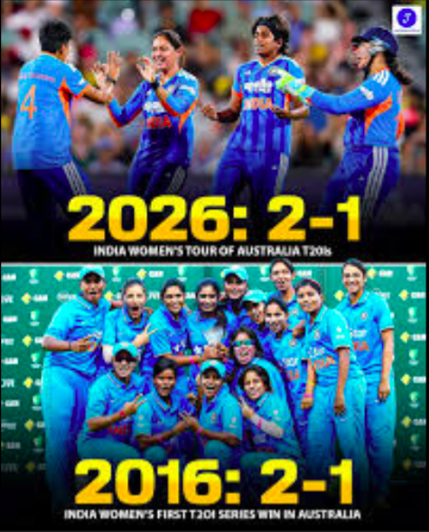
# CURRENT AFFAIRS INTERNATIONAL

INTER
Trump lashes out to Supreme Court judges:
The Supreme Court on Friday struck down most of President Donald Trump’s sweeping tariffs, a ruling that deals a major blow to his signature economic policy and represents a political setback. President Trump slammed the judges, some who were nominated by him. They voted against his signature tariff policies.

Russian Divers recover bodies at Lake Baikal:
Russian authorities say divers have recovered the bodies of seven Chinese tourists, including a 14 year old boy, and the Russian driver, who died after their mini-bus plunged under the ice, to the bottom of Lake Baikal in Siberia. The depth at the site of the accident was 18m, and the divers had to use underwater cameras to search for the bodies. The lake is a popular tourist destination. It often freezes during harsh winters and has seen a number of deadly accidents over the years.

NASA astronauts’ lunar mission delayed:
NASA has delayed the crewed Artemis ll lunar mission beyond its scheduled March 2026 date, due to a newly discovered issue with the rocket’s helium system, likely pushing the launch to April 2026 or later. The technical flaw in the upper stage, requiring the rocket to be removed from the pad, follows previous delays caused by hydrogen leaks.

150 giant endangered tortoises released:
Over 150 giant endangered were released on a Galapagos island where they were extinct for 180 years, marking a massive conservation win.

Inspiring Achievement:
A US high school student achieved national recognition for being accepted into 155 colleges. Chase Matthews, a 2025 senior at Westlake High School, Georgia, achieved this record-setting feat across all 50 states, securing over $6 million in scholarship offers.

Bangladesh election results 2026

Bangladesh Nationalist Party led by Tarique Rahman has won a historic majority in the first elections after the 2024 uprising. The Bangladesh Nationalist Party (BNP), led by Tarique Rahman, has won a two-thirds majority in the South Asian country’s historic elections – the first since the 2024 student-led uprising that ousted the government of Sheikh Hasina. The Jamaat-e-Islami party registered its best performance, emerging as the main opposition party. Hasina’s Awami League was barred from participating in the elections. She fled to India after the student revolution ended her 15 years of authoritarian rule in August 2024.The general elections were also accompanied by a national referendum on “the July Charter”, aimed at reforming state institutions.

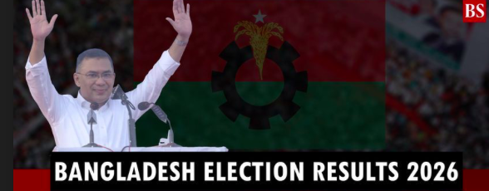
# CURRENT AFFAIRS INDIA

INTER
THE WORLD AROUND US-A NEWSLETTER
Edition 8 25th February 2026

In libris graecis appetere mea. At vim odio lorem omnes, pri id iuvaret partiendo. Vivendo menandri et sed.

Despicable Me 4

In Lycée Pas Bon, where rivals reunite,
Gru and Maxime, a tale of might.

From talent shows to epic feuds,
Cockroach enhancements,
villainous moods.

Maxime's escape, AVL on the chase,
To Mayflower they relocate, a new place.
Poppy, the neighbor, a budding thief,
Draws Gru back to his villainous belief.

With Lenny the badger, they plan the heist,
But Übelschlecht's camera reveals the twist.
Maxime strikes, Gru Jr. in danger,
Megaminions unleashed, chaos a ranger.

In a showdown of roach and man,
Gru's words break the hybrid's plan.
Maxime defeated, justice prevails,
Gru Jr. restored, roach form curtailed.

Back home they return, bonds reaffirmed,
Gru and Maxime, a lesson learned.
Enemies turned performers,
in prison they sing,

Poppy at Lycée, mischief still in her wing.
But wait! The tale's not quite complete,
For heroes and villains often meet.
Gru visits Maxime in his cell,
To reconcile the past, bid farewell.
"Everybody Wants to Rule the World," they croon,
Prisoners and guards, under the moon.
Past adversaries, now joined in song,
Forgiveness and redemption, righting wrongs.

Meanwhile, Poppy enrolls in the school,
Lycée Pas Bon, where being cool
Means daring heists and clever tricks,
A legacy carried by villains and flicks.

The Minions, too, find their way,
From AVL recruits to mischief's play.
Dave, Mel, Gus, Tim, and Jerry,
From Mega-Minions to pranks quite merry.
So in this world of villains and glee,
Where adventures unfold for all to see,
From roach hybrids to heists so grand,
Gru and his family, hand in hand.
May laughter and lessons forever prevail,
In the world of Despicable, a whimsical tale.


Indian movie ‘Boong’ bags BAFTA award for Best Children’s & Family Film. The film directed by Lakshmipriya Devi, is an emotional drama backed by Excel Entertainment.

The cast of the film includes Gugun Kipgen, Bala Hijam Ningthoujam and Angom Sanamatum in prominent roles. The film is about a schoolboy, Boong, who navigates racial tensions and border challenges in Manipur, driven by resilience and determination to reunite his divided family.

Director Lakshmipriya Devi makes an emotional plea for peace. The film’s debutant director, Lakshmipriya Devi, made an emotional plea for peace in her acceptance speech after receiving the coveted trophy from Paddington Bear, the lead character starring in the West End show ‘Paddington The Musical’. “The walk up till here felt like the last few steps to reach a summit of a mountain we never knew we were climbing in the first place,” said Devi.

“Just want to use this opportunity to say that we pray for peace to return to Manipur, we pray that all the internally displaced children, including the child actors in the film, regain their joy, their innocence and their dream once again. We pray that no conflict is ever formidable enough to destroy the one superpower that all of us have as human beings, that is forgiveness. So, thank you BAFTA for giving us not only an award but this stage to express our hope,” she said. The film, starring Gugun Kipgen and Bala Hijam, beat international competition from other nominees ‘Lilo and Stitch’, ‘Arco’ and ‘Zootropolis 2’.

Boong stars child actor Gugun Kipgen in the title role. He is a Kuki-Zo tribal boy playing a Meitei character who missed attending BAFTA, being busy giving his grade 6 exams in New Delhi.

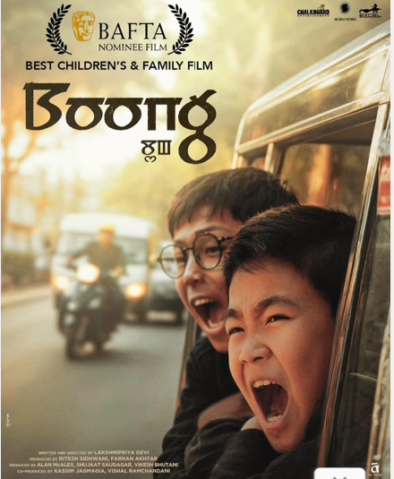
# REASON TO CHEER

INTER
# WEEKLY WATCH

INTER

# FEED FORWARD
# CURRENT AFFAIRS साप्ताहिक

INTER

Managing Editors- Aniruddha Iyer Bali, Sabir Singh Ahuja, Vaibhav. S.Uppal, Vihaan.S. Uppal
Hey everyone!  We are teenagers from a boarding school in the foothills, who believe change begins with us. The newsletter, a fortnightly, explores stories, events and ideas that shape our world. From happenings to global issues, we'll dive into it all. Join us, collaborate, critique and voice your opinions as we share our perspectives, insights, and creativity with you!

Your feedback and contributions would be a game changer!

Do write to us, @theworldthisweek4@gmail.com

# WEEKLY WATCH
# HEAL THE WORLD

Israeli strikes kill at least 10 in Lebanon
Israeli strikes have killed at least 10 people in eastern Lebanon, despite the ceasefire, officials say. The strikes are among the deadliest in Lebanon since a ceasefire ended the war between Israel and Hezbollah in November 2024.

Israeli settlers have defaced and set fire to a mosque in the occupied West Bank during the Muslim holy month of Ramadan, marking the latest incident in a wave of Israeli violence against Palestinians in the territory.The Wafa news agency reported on Monday that settlers graffitied racist slogans on the walls of Abu Bakr as-Siddiq Mosque, located between the towns of Sarra and Tal, near Nablus in the north of the West Bank. Worshippers arriving for the day’s first prayers found the damage and a smouldering fire that spewed black smoke across the mosque’s entrance and stained the ornate doorway, The Associated Press reported. The attackers spray-painted graffiti denigrating the Prophet Muhammad, as well as the words “revenge” and “price tag” – a term used to describe attacks by Israeli settlers against Palestinians and their property.

Iran students stage first anti-government protests since deadly crackdown: Students at major Iranian universities, including Sharif University of Technology, Amir Kabir and Tehran University, have launched new anti-government protests marking the start of a new semester. These demonstrations are in response to a violent crackdown in January 2026 where thousands were killed. The students shouted “Death to the Dictator” and “Death to Khamenei”, condemning the Supreme Leader. Protests involved marches, sit-ins and clashes with the Basij militia.

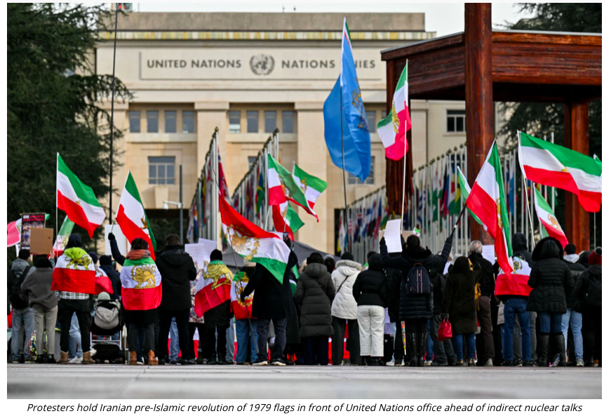
Anthony Hopkins had just landed a role in a film called "The Girl from Petrovka," based on a novel by American journalist George Feifer. Like any serious actor, he wanted to read the source material. He spent an entire day searching bookshops along London's famous Charing Cross Road. Nothing. The book wasn't available anywhere in the UK. Frustrated and defeated, Hopkins walked into the Leicester Square Underground station to catch a train home. That's when he noticed something on a bench. Someone had left a book behind. He picked it up. Turned it over, the book he'd been searching for all day, abandoned on a subway bench in a city of eight million people. Hopkins took it home, read it, and noticed something strange. The margins were filled with handwritten notes in red ink, ‘annotations’. He didn't think much of it. He used the notes to help him understand his character, prepared for his role, and filed the coincidence away as one of life's unexplainable moments. Months later, Hopkins traveled to Vienna for the film and met George Feifer, the author. They talked about the film, the characters, the story, Feifer mentioned "I don't have a copy of my own book anymore,I lent my personal copy to a friend a couple of years ago. It had all my notes in the margins. He lost it somewhere in London. I've never seen it since." Hopkins exclaimed, "I found a copy, on a bench in the Underground. It has handwritten notes throughout." Feifer looked at him skeptically as Hopkins retrieved the book and handed it to the author. It was Feifer’s personal copy he'd lent to a friend years earlier.





# LIVING LEGEND

There are moments in sports when the scoreboard becomes irrelevant, when what unfolds in front of us feels less like competition and more like history. Though Novak Djokovic did not win the historic 11th Australian open title, while he stood across the net , at the age of 38 he played on equal terms with Carlos Alcaraz, the best player in the world today- a player who was only a year old when Novak played his first Australian open! This was Djokovic competing, suffering, adapting and believing at the highest possible level- against youth speed and the new era embodied in Alcaraz. Nobody in tennis has managed anything remotely close to this. Not across eras and generations. What we saw in Australia was courage in its purest form. The courage to step onto the biggest stage knowing that time , physics and history are stacked against you and conquering it anyway. Novak Djokovic’s greatness is about character . About standing alone and showing up . He carried conviction and fought battles beyond scoreboards. He belongs in the company of figures larger than sports itself.
Novak Djokovic did not lose in Melbourne. He showed us what timeless greatness looks like !

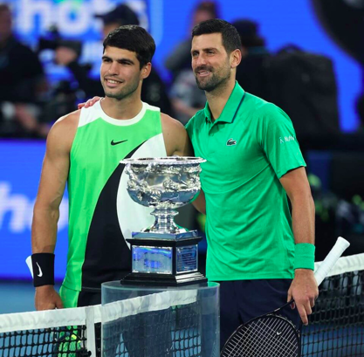

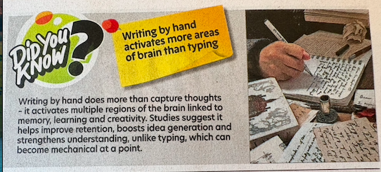

# MONEY MATTERS

INTER#
# TECH TALKING

INTER#
Union Budget of India -2026, Decoded

Did you know ? The budget was presented on the first Sunday of February till 1999. Now it is always the 1st of February, every year ! The budget doesn’t just represent a change in the way things work, it represents a change in mindset. The Indian economic philosophy used to be the defensive ‘import substitution’, or making things internally in India, not buying things externally. The new philosophy is ‘strategic resilience and global indispensability’, focusing on making India vital to the global supply chain. Nirmala Sitharaman, to describe the accelerating pace of India's economic reform agenda called it the ‘Reform Express’,

The capital expenditure (investment by the government on infrastructure, machinery, and equipment - commonly known as capex) target has been raised to a record ₹12.2 Cr. To understand this decision, one must understand the Multiplier Effect. According to this, whatever the government spends on infrastructure will be doubled or tripled in the broader economy, according to Mint. The fiscal deficit ( the gap between the government's total expenditure and its total revenue) for this year is pegged at 4.3% of GDP, showing a reduction from that of last year. This (higher capex and lower fiscal deficit) insulates the domestic economy from "global headwinds" like trade frictions and geopolitical tensions by building internal resilience, according to Rediff. These also show the government making actual, decisive, action. This balancing act is called fiscal prudence. This is managed in two main ways - robust tax collection (with the help of advanced technology), and the growth of GDP.

The Indian economic philosophy used to be the defensive ‘import substitution’, or making things internally in India, not buying things externally. The new philosophy is ‘strategic resilience and global indispensability’, focusing on making India vital to the global supply chain. In order to reduce litigation, the new Income Tax Act is 50% shorter than the 1961 one. Aside from that, there is ‘GST 2.0’, a “next-gen reform”. According to this, individual health and life insurance is now at 0% GST (Goods and Services Tax). This is a response to the added cost that many used to complain about. Also at 0% GST are 33 life-saving drugs, and school supplies too. Items previously at 15-18% GST (including many medical and farm supplies) are now at a much lower 5%, amongst many other GST lowerings, a significant relief for the population.

Why was the Semiconductor Mission, or ISM 2.0 allocated ₹1000 Cr? ISM 2.0 focuses on Indian IP (Intellectual Property), Indian companies designing and building semiconductor chips on their own, not getting the designs externally. Rare earth elements are those used in these chips. Thus, four ‘Rare Earth Corridors’ have been proposed namely - Odisha, Kerala, Andhra Pradesh, and Tamil Nadu.

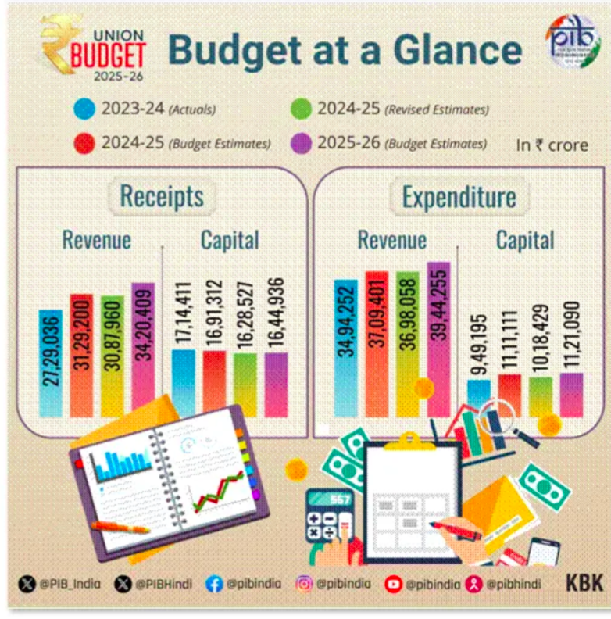
The India AI Impact Summit 2026 has emerged as a major global talking point, positioning India as a bridge between the West and developing nations in the evolving artificial intelligence landscape. Unlike AI debates in the US and Europe that often revolve around hype or fear, the summit focuses on human progress, inclusive growth, and practical implementation of AI in real-world scenarios.

Experts believe it challenges the current narrative and presents India as a credible voice capable of bringing together innovation, responsibility, and equitable development on one platform. The New Delhi gathering should be seen as a complement rather than competition to Western AI leadership. While countries like the US and European nations continue to lead in research and safety frameworks, India’s focus is on combining innovation with large-scale social impact.

What makes this summit stand apart is its strong focus on applied AI rather than theoretical risks. Sessions concentrate on closing the AI adoption gap between developed and developing regions, where usage levels remain significantly lower. Discussions revolve around practical solutions like AI-driven healthcare in rural areas, precision farming for small-scale farmers, and workforce skilling for an automated future.


## Cricket
- The ICC Men's T20 World Cup 2026 is underway, co-hosted by India and Sri Lanka, running from February 7 to March 8.
- J&K Cricket Team made history by reaching their first Ranji Trophy final in 66 years.
## Badminton
- India will host the BWF World Championships in New Delhi in August 2026.
## Hockey
- India won the Men's Hockey Asia Cup, securing a spot in the 2026 Hockey World Cup.
## Athletics
- Tejaswin Shankar won gold in the Men's Heptathlon.
## Tennis
- The Australian Open took place from January 12 to February 1.
## Upcoming Events
- *Indian Premier League (IPL)*: March 26 to May 31, 2026
- *BWF World Team Championships (Thomas & Uber Cup)*: April 24 to May 3, 2026, in Denmark
- *Men's FIH Hockey World Cup*: August 14-30, 2026, in Belgium and Netherlands .
# SPORTS SCOREBOARDS

INTER#

