
# CURRENT AFFAIRS INTERNATIONAL

INTER

India continues to assert its presence on the global stage while navigating complex domestic and international challenges. This year, India has assumed the BRICS chairmanship, preparing to host the 18th BRICS Summit, a key platform for economic and geopolitical engagement among Brazil, Russia, India, China, and South Africa, along with newer members. Domestically, Prime Minister Narendra Modi has been actively engaged across states and national events, including Republic Day preparations, with a continued policy focus on demographic trends, employment generation, and social services, given warnings that the country’s demographic dividend window is gradually narrowing.
Economically, India is projected to remain one of the fastest-growing major economies, bolstered by resilient domestic demand and policy reforms that continue to attract global investment. State-owned Indian Bank recently received board approval to expand operations in Malaysia, Indonesia, and the UAE, reflecting India’s growing interest in servicing diaspora markets and expanding business opportunities abroad. Energy security has also taken center stage, with long-term LNG supply agreements with the UAE strengthening the country’s position amid a global energy transition.
On the security front, coordinated efforts under initiatives like Operation Gang Bust have led to significant arrests targeting organized crime networks across northern and central states, reflecting the government’s ongoing commitment to law and order. Meanwhile, the Central Industrial Security Force (CISF) has embarked on its largest-ever sports quota induction drive, a move aimed at enhancing institutional capabilities and national preparedness.
India’s focus on science, technology, and environmental sustainability remains robust. Technological advancements across sectors, including artificial intelligence applications and digital infrastructure for public services, are being prioritized alongside climate resilience initiatives. Biodiversity projects, such as the discovery of new frog species in Arunachal Pradesh and the launch of “Bio-Happy Districts,” showcase India’s commitment to ecological conservation integrated with local livelihoods. In a pioneering move for the blue economy, India has launched its first open-sea marine fish farming project in the Andaman Sea, aiming to harness ocean resources for sustainable growth and strengthen coastal economies.
Cultural initiatives also marked the nation’s journey into 2026. The large-scale theatrical presentation RASHTRAGRANTH, focusing on the Constitution of India, is being launched across Maharashtra in conjunction with Republic Day celebrations, combining civic awareness with artistic expression. The Republic Day parade in New Delhi showcased military strength, cultural diversity, and diplomatic engagement.

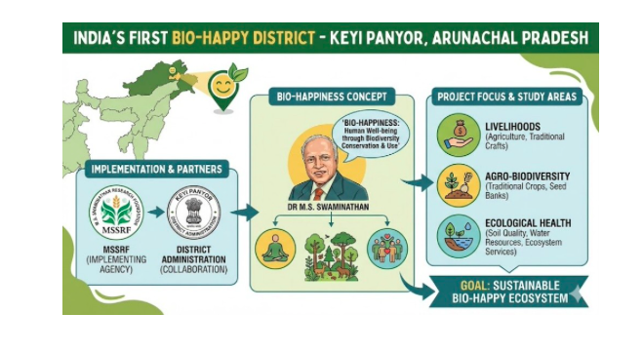
Protesters marched in duelling demonstrations in Venezuela’s capital, Caracas, as the country’s National Assembly weighed a bill that would grant amnesty to political prisoners. The demonstrations marked Venezuela’s National Youth Day and were the first major showing of opposition to the government led by interim President Delcy Rodriguez. She has led the country since the United States abducted Venezuelan President Nicolas Maduro in January. Her government called on its supporters to flood the streets with counterprotests, and both rallies attracted thousands of people. The show of defiance came as the National Assembly debated a landmark bill that would grant amnesty to political prisoners detained under Maduro.

Trump is the ‘elephant in the room’ as the African Union holds new summit. Trump’s policies on tariffs, foreign aid and immigration have outsized impact as African Union leaders seek ‘balance’. Donald Trump is not set to attend the 39th annual meeting of the African Union, which kicks off its leaders’ summit on Friday. But his presence will still be felt as delegations from the 55 member states grapple with the new, disruptive reality of the United States president’s second term. Trump’s historic cuts to foreign aid, his overhaul of US trade policy, and his sweeping changes to immigration admissions have all had an outsized impact on Africa, though he gave the continent only slight mention in his wider global agenda. Amid the upheaval, the Trump administration has sought to forge new, bilateral agreements with African countries, focused on resources and security gains.

Canada’s PM Carney to visit Tumbler Ridge after mass school shooting. Police say 18-year-old Jesse Van Rootselaar killed her mother and stepbrother before carrying out mass shooting in BC. Canadian Prime Minister Mark Carney has said he will shortly visit the remote British Columbia town of Tumbler Ridge, where nine people died in one of the country’s worst mass shootings, according to his office. Across Tumbler Ridge, a town of about 2,400 in the Canadian Rockies, flowers and stuffed animals could be seen at unofficial public memorials. “Hold your kids tight, tell them you love them every day. You never know,” a tearful Lance Young, father of 12-year-old victim Kylie Smith, told reporters ay.
Carney announced that Canadian flags will be flown at half-staff for seven days on federal buildings following the mass school shooting.

Oslo Accords figure deeply linked to Epstein network
New documents reveal Terje Rod-Larsen facilitated visas for Jeffrey Epstein’s victims and was listed for a $10m payout, prompting Palestinians to question whether the peace process was engineered by blackmailed diplomats.


# CURRENT AFFAIRS INDIA

INTER
THE WORLD AROUND US-A NEWSLETTER
Edition 7 14th February 2026

In libris graecis appetere mea. At vim odio lorem omnes, pri id iuvaret partiendo. Vivendo menandri et sed.

This is an article that tells a story. A story that takes us back, before the two World Wars, even before the turn of the 20th century. This is the story of book-to-film adaptations.
In the 1890s, when the film industry actually began, filmmaking was regarded as some sort of gimmick, a cheap novelty, not a serious art form. This needed the film industry to prove itself to the world. So, they turned to proven plots that the world had loved, found in the only form of entertainment media before films - books. They began to adapt well-loved stories, like Cinderella, to the big screen, and succeeded. Literature was proving to be a trustworthy helping hand for the emerging film industry. Many of the first Oscars were awarded to book adaptations. Now that you know the story behind it, we must understand why this article has been written. This is 2026. A milestone in filmmaking history, with a year full of eager moviegoers all over the world

This year is filled with adaptations which have been given a long wait. Starting off with Christopher Nolan’s ‘The Odyssey’. Releasing on July 17, this has been named a once-in-a-lifetime event. Starring actors like Matt Damon, Anne Hathaway, Tom Holland, Robert Pattinson, and Zendaya, this 3-hour-long movie is probably the most ambitious movie in the history of the film industry.

Speaking of Matt Damon, the author of the book his film ‘The Martian’ adapted, Andy Weir, has another book being adapted to the big screen this year. ‘Project Hail Mary’, directed by Phil Lord and Chris Miller, another riskily emotional plot.

With another classic, we’ve got Emily Brontë’s ‘Wuthering Heights’, directed by Emerald Fennel. Also coming out this year is ‘Verity’, a psychological thriller directed by Michael Showalter, based on the novel of the same name by Colleen Hoover. We also have the awaited ‘Hunger Games: Sunrise on the Reaping’, for November. More like ‘Crime 101’ (Don Winslow), and ‘People We Meet on Vacation’ (Emily Henry) are also expected this year.

Nowadays, almost everywhere you look, you see a film that’s actually adapted off of a book. Statistics show that around half of all movies made till date, are actually book adaptations. Many, you might not even know of. We all know about The Hobbit, and The Lord of the Rings, and Harry Potter, but what about other well-known motion pictures which are so famous, they eclipse their books? Take ‘Shrek’ for example. This was actually based on a 1990 children's book, ‘Shrek!’, by William Steig. Even hallmarks of the spy film industry, like the 007 franchise. These were actually based on a series of short stories written by author Ian Fleming, who also penned what was the inspiration for the classic comedy ‘Chitty Chitty Bang Bang’. Take the classic comedy romance ‘Forrest Gump’. This, believe it or not, was based on a book by Winston Groom, wherein Forrest becomes an astronaut and plays chess with a gorilla!

So, whether you study in a day school or a boarding school, this year’s holiday seasons are brimming with endeavours to bring rich texts to life.

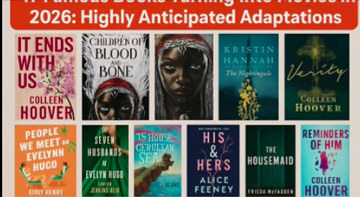
Aloka, the dog who has captured hearts across the world, is much more than a charming companion—she has become a symbol of empathy, spirituality, and inclusivity. What began as a quiet bond with a small group of monks has now blossomed into a global phenomenon, with Aloka inspiring millions with her story. She first came into the lives of a monastery in northern India, where she began following a group of monks during their daily rituals and meditative walks. Calm and attentive, she quickly adapted to their routines, sitting quietly during prayers, wandering alongside them on long pilgrimages, and even providing comfort to visitors who came seeking solace. Observers noted that Aloka seemed to absorb the monks’ sense of serenity, exuding a calm that was rare even among humans. Her presence did not go unnoticed. Pictures and videos of Aloka peacefully accompanying the monks began circulating on social media, and before long, she had gone viral. What captured people’s attention was not just her adorable appearance, but the profound sense of harmony she brought wherever she went, becoming an emblem of coexistence—showing that devotion, peace, and mindfulness are not confined to humans alone.
Beyond her viral fame, Aloka has emerged as a symbol of inclusivity. Her story resonates across cultures and religions, reminding people that compassion transcends species, language, and social boundaries. Children, adults, and spiritual seekers alike see in Aloka a living example of empathy, patience, and acceptance. She often sits quietly with visitors from diverse backgrounds, offering a silent reminder that the simplest acts of presence and kindness can bridge divides, her influence extends beyond her immediate surroundings. Online communities celebrate her as a mascot of unity, using her story to promote messages of inclusion, mindfulness, and nonviolence. In a world often marked by division, her quiet companionship and gentle nature provide a model for coexistence—a living embodiment of the values that the monks themselves strive to teach. She reminds the world that love and compassion can come in all shapes and sizes, that a dog can lead by example, and that true inclusivity begins with small, mindful gestures. Through her daily presence, her viral story, and her symbolic impact, she has become much more than a viral sensation—she is a gentle ambassador for empathy, unity, and the quiet power of connection.


# REASON TO CHEER

INTER
# RECOMMENDED READS

INTER

# FEED FORWARD
# CURRENT AFFAIRS साप्ताहिक

INTER

Managing Editors- Aniruddha Iyer Bali, Sabir Singh Ahuja, Vaibhav. S.Uppal, Vihaan.S. Uppal
Hey everyone!  We are teenagers from a boarding school in the foothills, who believe change begins with us. The newsletter, a fortnightly, explores stories, events and ideas that shape our world. From happenings to global issues, we'll dive into it all. Join us, collaborate, critique and voice your opinions as we share our perspectives, insights, and creativity with you!

Your feedback and contributions would be a game changer!

Do write to us, @theworldthisweek4@gmail.com

# WEEKLY WATCH
# HEAL THE WORLD
Stranger things S5: The end of Beginning

Stranger Things Season 5 has been one of the most awaited seasons in recent television, as it is the final season of the popular sci-fi series on Netflix. It is the brainchild of the famous duo, the Duffer Brothers, and it started in the year 2016. When it started, the idea behind the series was to pay a nod to the pop culture phenomenon of the 1980s.

Season 4 wrapped up with some ominous and action-packed events, with the Upside Down starting to blur into the real world and Hawkins being left in shambles. Season 5 is rumored to see the group take on Vecna in the ultimate showdown and deal with the aftermath of the gate being opened. Eleven, Mike, Dustin, Lucas, Will, and Max are in for the adventure of a lifetime as they prepare for the ultimate showdown.

Contrary to the earlier seasons, Season 5 is anticipated to be more intense and focused, with less emphasis on mysteries and more action-oriented plot development. The emotional arcs of the characters, particularly Eleven and Will, seem to take a prominent place, as the plot develops in a cyclical pattern, culminating in the starting point itself.
The final season, Stranger Things Season 5, is already on the cards, and fans can expect a whole lot of emotional farewells and an ultimate conclusion. The season will try to live up to the friendships and spirits that made Stranger Things so universally adored.



Israel deprives Palestinians of proper education by withholding revenues. Palestinian education is being destroyed by Israel’s policy of withholding customs revenues from the Palestinian Authority. Nablus, the occupied West Bank – For decades, the Zenabia Elementary School has been offering an intimate learning environment to aspiring young students from across the educational spectrum in the northern West Bank city of Nablus.

But now, due to Israel’s years-long withholding of tax revenues owed to the Palestinian Authority, the Palestinian school system is effectively broke. Like administrators at all government-run schools in the West Bank, the Zenabia school principal, Aisha al-Khatib, is struggling to keep her small, public school in session.

For most of the week, the Zenabia school is shuttered, and children roam the streets or stay at home. School supplies are woefully missing, with even regular schoolbooks now reduced to “bundles of pages”.

“We do everything we can, but we do not have the time or the materials or the consistency to properly teach our children and keep them off the streets,” says al-Khatib. “And this is everywhere in the West Bank.”

Targeting the education of Palestine’s children, she says, “means destroying the nation”.

Under the direction of far-right Finance Minister Bezalel Smotrich, Israel has systematically been withholding billions of dollars in tax revenues over the past two years that Israel collects on behalf of the Palestinian Authority (PA). The measure is partly intended to punish the PA for its longstanding policy of paying families of Palestinians imprisoned by Israel for resisting the occupation – even after the PA announced early last year that it was reforming such policies.

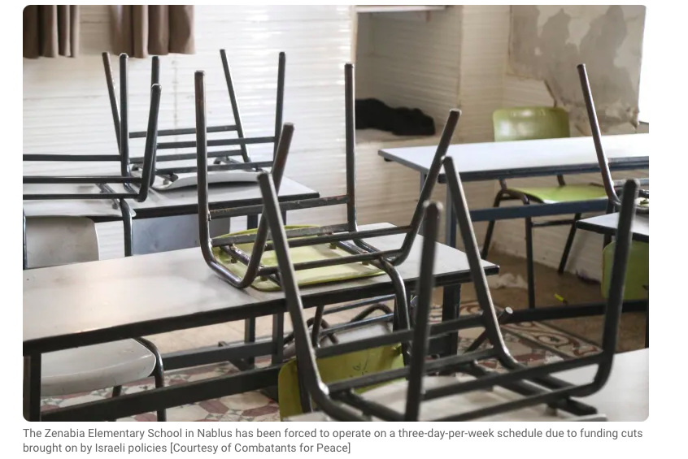

# LISTENER’S CHECKLIST

Tune in, jive and play as you listen to foot thumping music curated for the weekend or simply to take a much needed breather between the gruelling schedule of exams.
Listener’s Checklist
1. With or Without You by U2
2. Can’t Feel My Face by The Weeknd
3. Feel it by d4vd
4. Love me Again by John Newman
5. Viva La Visa by Coldplay



# MONEY MATTERS

INTER#
# TECH TALKING

INTER#

Singapore’s Business Momentum

The economy of Singapore remains remarkably more resilient in 2025, thanks to an equally strong manufacturing sector and initiatives that made it an even more attractive global business destination. Estimates by authorities place 2025 economic growth at 4.8 % overall, reflecting the highest growth rate since 2021, thanks to a YoY increase of 5.7 % in Q4, which was largely fueled by a manufacturing sector growth of 15 % overall, and more specifically in biomedical and AI semiconductors and electronics.

In the midst of worldwide uncertainty such as trade tensions and geopolitics, Singapore is gearing up for a conservative 2026 yet pressing on with opportunities in the area of digital innovation as well as environmental innovation. For instance, the effort by Microsoft, Enterprise Singapore, and NUS Enterprise to support 150 tech startups with artificial intelligence reflects Singapore's enthusiasm for high tech industries with strong growth potential. The Monetary Authority of Singapore is suggesting a legislative overhaul in a bid by the Singapore Exchange (SGX) to make dual listings more appealing with Nasdaq.

The wider business environment in Singapore also witnessed various interesting incidents, with Atome obtaining a $345 million borrowings facility in order to scale up its Buy Now Pay Later capabilities within Southeast Asia, indicating that investors are very optimistic about the fintech industry in Singapore. Second, over 30 businesses are working on listing on stock markets in 2026, indicating that Singapore's stock markets are revamping with activity.

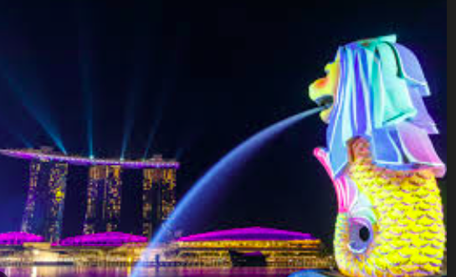
What the first medical evacuation from the International Space Station tells us about healthcare in space. For the first time in 25 years of continuous crewed operations, an astronaut has been medically evacuated from the International Space Station (ISS). The Crew-11 mission ended when a SpaceX Dragon capsule brought the four astronauts of Crew 11 home following a medical incident in early January 2026. To protect the crewmember’s privacy, Nasa hasn’t yet disclosed details about what happened. But the evacuation raises a question worth exploring: how do astronauts stay healthy in space, and why is this early evacuation so unusual?

Astronauts undergo rigorous medical screening before selection. They are assessed for conditions that might worsen in microgravity, evaluated for psychological resilience, and monitored throughout their careers. ISS doesn't have a “rescue vehicle” at its disposal, but it's guaranteed that at least one vehicle, either a Soyuz capsule designed by Russia or, as of recent developments, a SpaceX Crew Dragon, remains permanently docked to it.
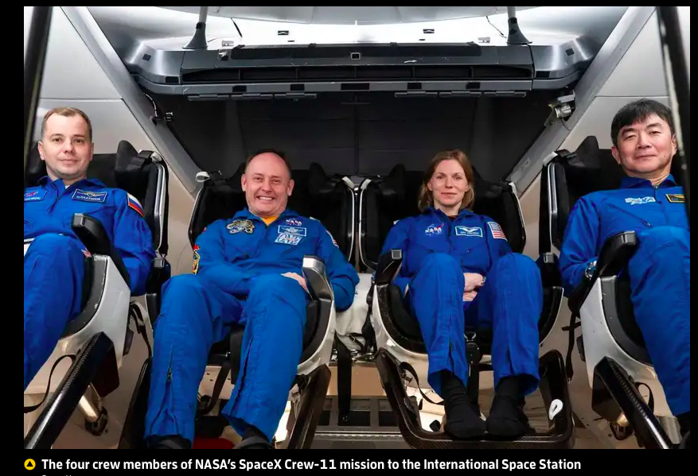


-The United States, Canada, and Mexico.
-48 teams (up from 32 in previous years).
-Argentina (winners of the 2022 World Cup in Qatar).
-False. Mexico is actually making history by becoming the first country to host (or co-host) the Men's World Cup for a third time (1970, 1986, and 2026).
-June (specifically June 11, 2026).
- MetLife Stadium in New York/New Jersey.
-USA, Canada, and Mexico.
-12 groups (of four teams each).

Football Fever- A quiz to test your knowledge and earn brownie points !

1.⁠ ⁠Which three countries are co-hosting the 2026 World Cup?
2.⁠ ⁠For the first time ever, the tournament has expanded. How many teams will compete in 2026?
3.⁠ ⁠Which nation is the defending champion entering the 2026 tournament?
4.⁠ ⁠True or False: This is the first time Mexico has ever hosted a World Cup.
⁠In which month does the tournament kick off?
6.⁠ ⁠Where will the final match be played on July 19, 2026?
7.⁠ ⁠Because they are the hosts, which three teams automatically qualified for the tournament?
8.⁠ ⁠How many groups will there be in the opening stage of the 2026 World Cup?

# SPORTS SCOREBOARDS

INTER#

