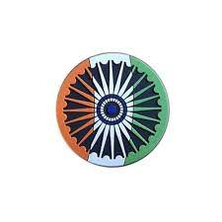
# CURRENT AFFAIRS INTERNATIONAL

INTER

Republic Day is celebrated in India every year on 26 January because on this day in 1950, the Constitution of India came into force, making the country a sovereign democratic republic. It is a day that reminds Indians of the values of equality, justice, and freedom.

The 77th Republic Day, prominently celebrated 150 years of the national song "Vande Mataram". A Ministry of Culture tableau at Kartavya Path showcased the song's history, from its composition by Bankim Chandra Chatterjee to modern renditions. The theme emphasized the song as a "freedom chant" and a symbol of national unity.

Key Highlights of Vande Mataram
Theme: The celebration focused on 150 years of the national song.
Tableau: The Culture Ministry's tableau featured a special, multi-dimensional display, including a 1923, artistic representation and modern interpretations to connect with the younger generation.
Significance: "Vande Mataram" is honored as a vital,, cultural, and historical anthem, with nationwide, year-long celebrations.
Performances: Pan-India band performances on the theme were conducted, and a dedicated banner was unveiled at the end of the parade.
Impact: The song, which served as a rally cry for freedom, is being celebrated to highlight the spirit of Aatmanirbhar Bharat (self-reliant India)

The parade showcased India’s military strength, cultural diversity, and growing global confidence, making 2026 a turning point in how India represents itself to the world. Simran Bala , a 26-year-old woman officer led an all-men CRPF contingent, symbolising women’s leadership and progress in the armed forces.

Prestigious and illustrious awards namely the Padma Awards, Gallantry awards, and Service Medals were announced and included national luminaries from cinema, sports and social service.

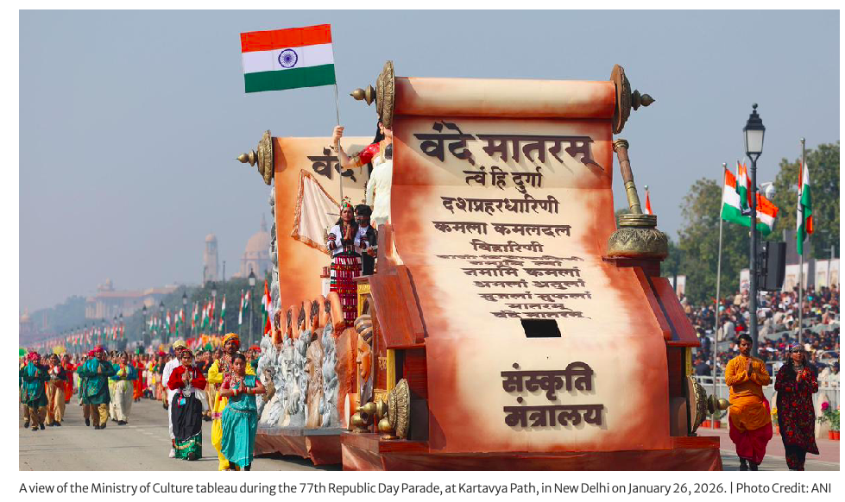
January 2026 unfolded as a consequential month on the world stage, shaped by major diplomatic gatherings, economic warnings, geopolitical shifts, climate extremes, humanitarian crises, and scientific breakthroughs. These developments underscored the complexity of global challenges and the interconnected nature of modern affairs.

The most prominent event of the month was The World Economic Forum in Davos, held from January 19 to 23. Heads of state, business leaders, and thought leaders convened amid continuing economic uncertainty. A standout moment was Mike Carney’s keynote address, in which the former central banker delivered a sobering assessment of global financial stability.

Carney cautioned that lingering inflationary pressures, energy market volatility, and the aftereffects of past monetary stimulus posed significant risks to economic recovery. He urged stronger cooperation between governments and central banks to safeguard growth while steering capital toward sustainable and green investments. His remarks resonated widely, shaping discussions about fiscal policy, climate financing, and future global economic frameworks.

January also saw renewed focus on geopolitical tensions. In the South China Sea and broader Indo-Pacific region, military posturing and naval exercises drew international attention as nations recalibrated their strategic postures.

China’s unveiling of an advanced ballistic missile submarine added to concerns about strategic competition in the region, prompting dialogue among neighbouring states and alliance partners about maritime security and defence postures.

Climate and environmental matters remained urgent. Australia experienced extreme heatwaves early in the month, with many regions breaking long-standing temperature records. Such events heightened awareness of climate risks and reinforced calls from scientists and environmental groups for accelerated mitigation and adaptation efforts worldwide. These climate realities were echoed in Davos discussions, where policymakers and business leaders faced mounting pressure to turn commitments into measurable action.

At the World Economic Forum (WEF) Annual Meeting 2026 in Davos (January 19-23), India solidified its position as a top global investment destination, focusing on $96 billion in deals, AI, and manufacturing. With a record participation from ten states, India presented a "growth story" built on infrastructure, digital public goods, and clean energy, aiming for status as the world's third-largest economy.

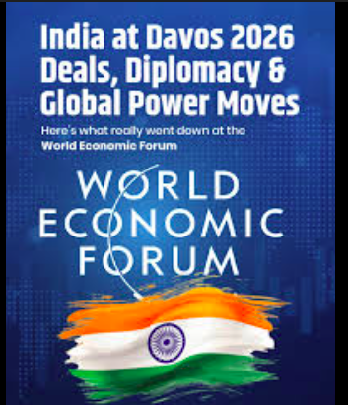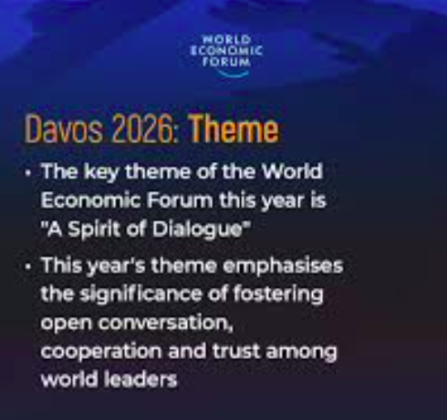
# CURRENT AFFAIRS INDIA

INTER
THE WORLD AROUND US-A NEWSLETTER
Edition 6 02nd February 2026

In libris graecis appetere mea. At vim odio lorem omnes, pri id iuvaret partiendo. Vivendo menandri et sed.

Uttarayan, the Sun’s northward journey is celebrated across the Indian sub-continent symbolising similarity in diversity, reflecting deep respect for nature and expresses gratitude to the Sun God, for providing for agriculture and life.

Pongal – A Celebration of Harvest, Gratitude, and Culture, is a major harvest festival celebrated predominantly in South India. Celebrated over four days—Bhogi, Thai Pongal, Mattu Pongal, and Kaanum Pongal—each holding special significance. Bhogi symbolizes letting go of the old, while Thai Pongal, the main day, is marked by cooking freshly harvested rice with milk and jaggery in a clay pot. Mattu Pongal honoUrs cattle for their role in farming, and Kaanum Pongal focuses on family bonding and community gatherings.

Makar Sankranti celebrated in West India, marks the Sun’s entry into Capricorn . It also celebrates the end of winter and the arrival of warmer days. Devotees honour the Sun God through holy river dips, kite flying and sharing sweets made of sesame and jaggery to symbolise health and social harmony.

Lohri in North India is celebrated to mark the start of the financial New Year, and to offer gratitude to Surya, and Agni. At its core, Lohri is a festival dedicated to the harvest of Rabi crops, specifically sugarcane, wheat, and mustard. The festival also fosters a spirit of brotherhood and unity, as people from all social strata in the community gather to dance and share festive foods (like Sarson da Saag and Makki di Roti).

Bhogali Bihu or Magh Bihu in East India, begin on Uruka, the night before Magh Bihu. On this night, people gather near rivers or open fields and build temporary huts called Bhelaghar using bamboo, hay, and leaves. Community feasts are organized where everyone cooks and eats together, strengthening social bonds.The next morning, people light the Meji, a large bonfire made of bamboo and straw. Offerings such as rice cakes, betel nuts, and vegetables are made to the fire as a symbol of respect and gratitude. The burning of the Meji signifies the end of the old and the beginning of a new phase of life.. Traditional Assamese delicacies prepared during this festival include pitha, laru, chira, akhoi, and doi. These items, mostly made from rice, reflect Assam’s agrarian lifestyle and the abundance of the harvest season.
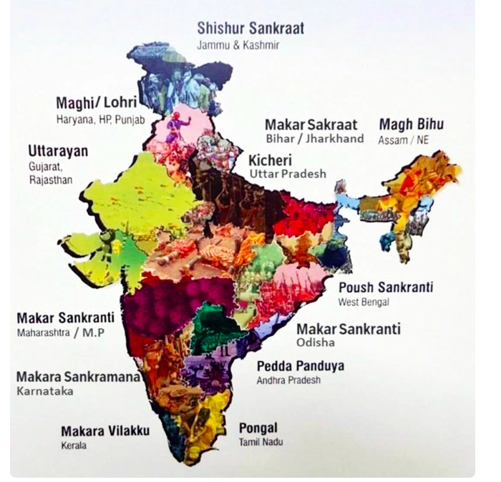
The Government of India announced the Padma Awards 2026 on the eve of the 77th Republic Day. This year, the list of 45 achievers places a profound emphasis on “Unsung Heroes”—individuals who have worked silently at the grassroots level to bring about transformative social change.

The 2026 list celebrates extraordinary service across medicine, literature, and social reform.
While the list has 45 names, the wider Padma list reportedly includes:

Cinema and Music
-Veteran actor Anant Nag and Tamil star Ajith Kumar (Padma Bhushan).
-Renowned violinist L. Subramaniam and Grammy winner Ricky Kej.

Healthcare & Science
-Armida Fernandes (Maharashtra): Pediatrician, pioneered Asia’s first human milk bank, significantly improving neonatal survival rates.
-Kumarasamy Thangaraj (Telangana): A renowned geneticist whose research traced human migration from Africa to India.
-Dr. Shyam Sundar (Uttar Pradesh): Extensive contributions to medicine and public health.

Literature & Education
-Anke Gowda (Karnataka): Known as the “Bookman of Mandya,” this former bus conductor established Pustak Mane, a free-access library with over 2 million books.
-Charan Hembram (West Bengal): A Santhali author and composer dedicated to preserving tribal linguistics.

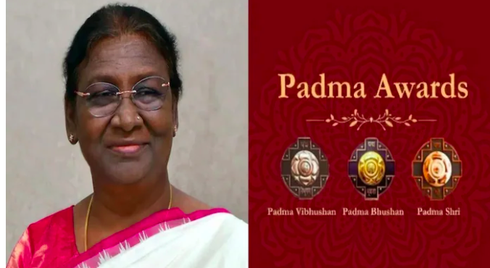

# INCREDIBLE INDIA

INTER
# एक परिवार, एक त्योहार

INTER

# FEED FORWARD
# CURRENT AFFAIRS साप्ताहिक

INTER

Managing Editors- Aniruddha Iyer Bali, Sabir Singh Ahuja, Vaibhav. S.Uppal, Vihaan.S. Uppal
Hey everyone!  We are teenagers from a boarding school in the foothills, who believe change begins with us. The newsletter, a fortnightly, explores stories, events and ideas that shape our world. From happenings to global issues, we'll dive into it all. Join us, collaborate, critique and voice your opinions as we share our perspectives, insights, and creativity with you!

Your feedback and contributions would be a game changer!

Do write to us, @theworldthisweek4@gmail.com

# WEEKLY WATCH
# HEAL THE WORLD

The Golden Globe Awards 2026, held on January 11, 2026, celebrated outstanding achievements in film and television, with the winners reflecting a year of bold creativity, powerful performances, and global storytelling. The ceremony highlighted both established artists and emerging voices, making it one of the most memorable Golden Globe events in recent years.
Best Motion Picture – Drama was awarded to Hamnet, a deeply emotional adaptation inspired by William Shakespeare’s life. The film praised for its sensitive storytelling and artistic depth, Its lead actress, Jessie Buckley, won Best Actress in a Motion Picture – Drama for her moving and nuanced performance.

Best Motion Picture – Musical or Comedy went to One Battle After Another, a bold and unconventional film that blended humour, music, and social commentary. The film dominated major categories, with Paul Thomas Anderson winning Best Director as well as Best Screenplay, reinforcing his reputation as one of contemporary cinema’s most influential filmmakers.
One of the most talked-about moments of the night was Timothée Chalamet’s win for Best Actor in a Motion Picture – Musical or Comedy, his performance was praised for its charm, emotional depth, and versatility, marking another major milestone in his career. The win confirmed Chalamet’s status as one of the most talented and bankable actors of his generation and was met with widespread acclaim from audiences and critics alike.
Best Motion Picture – Non-English Language, highlight the Golden Globes’ continued recognition of international cinema, was won by Wagner Moura for The Secret Agent.

Best Animated Feature Film was awarded to K-Pop Demon Hunters. The film stood out for its unique visual style and energetic storytelling. It also won Best Original Song for “Golden,” which became a global hit and added to the film’s cultural impact.
Television winners were equally notable. The limited series Adolescence emerged as one of the biggest winners of the night, taking home Best Limited Series.
Overall, the winners of the Golden Globe Awards 2026 reflected an industry embracing diversity, innovation, and strong storytelling. By recognising outstanding performances and celebrating films and series from around the world, the ceremony captured a defining moment in modern entertainment.

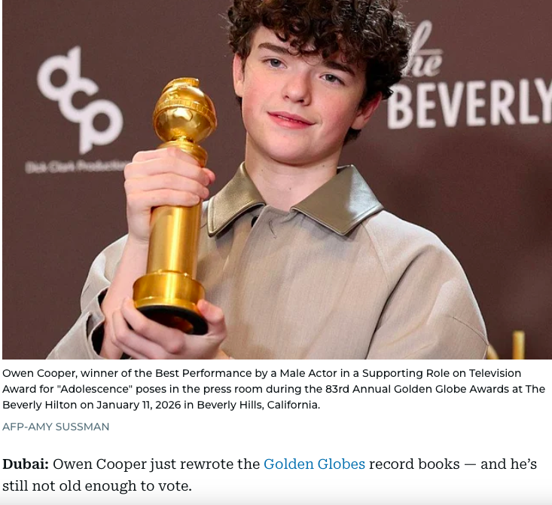

Humanitarian crises continued to dominate parts of Africa and the Middle East. In Sudan, clashes between rival factions intensified, displacing hundreds of thousands of civilians and exacerbating famine-like conditions. Aid organizations struggled to deliver relief amid security challenges. Similarly, Haiti faced political instability and gang violence that have severely disrupted daily life, driven many into poverty, and highlighted the need for sustained international humanitarian support.
Protests in Iran persisted through January as economic grievances, inflation, and political repression fuelled public discontent. Security forces’ responses to demonstrators drew international concern over human rights and civil freedoms, prompting calls from global organizations for restraint and dialogue.
In international diplomacy, ceasefire efforts in conflict zones such as Yemen and Ukraine saw cautious progress. Negotiators reported incremental agreements on humanitarian corridors and prisoner exchanges, though core political disputes remained unresolved. These developments provided cautious optimism for future negotiations even as underlying tensions persisted.

Curtain Falls on Bangladesh’s Interim Government as Critical Elections Approach. On 12 February, Bangladeshis will vote in their country’s first national elections since student-led protests forced long-time ruler Sheikh Hasina from power in August 2024. The elections mark the final step in the delicate political transition that has been under way for a year and a half. The trigger that led to Hasina’s downfall was the Supreme Court’s decision in June 2024 to revive job quotas for the descendants of “freedom fighters” in the country’s 1971 liberation war – an initiative widely seen as favouring supporters of her party, the Awami League. Hasina first tried to crush the protests denouncing this measure, but her regime’s violence only spurred more anger, turning the demonstrations into a mass movement demanding the government’s resignation

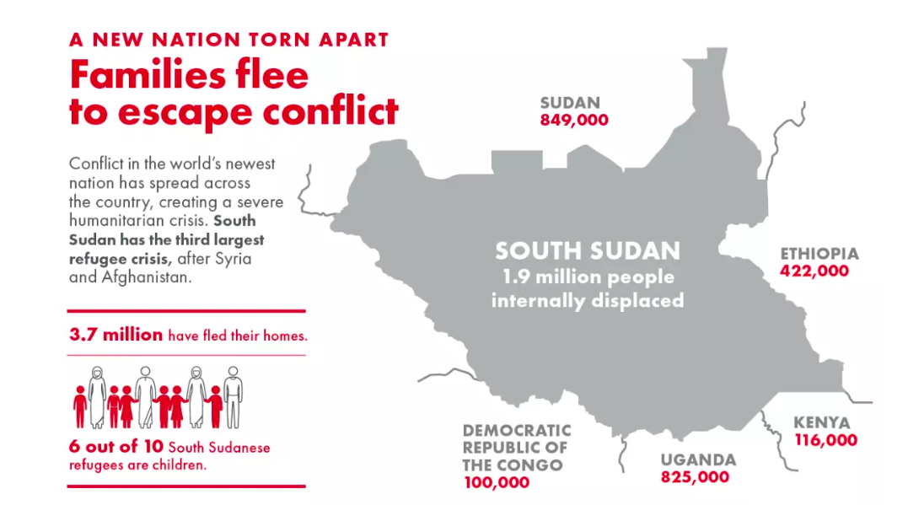

NASA astronaut Sunita Williams has retired from the space agency, capping a stellar 27-year career during which she completed three missions aboard the International Space Station and set various human spaceflight records.

Ms. Sunita ‘Suni’ Williams was born to a Gujarati father, Deepak Pandya, hailing from Jhulasan in Mehsana district and a Slovenian mother, Ursuline Bonnie Pandya, on September 19, 1965, in Euclid, Ohio, in the U.S.

A trailblazer in human spaceflight, shaping the future of exploration through her leadership aboard the space station and paving the way for commercial missions to low Earth orbit. Her work advancing science and technology has laid the foundation for Artemis missions to the Moon and advancing toward Mars, and her extraordinary achievements will continue to inspire generations to dream big and push the boundaries of what’s possible.

She also completed nine spacewalks, totalling 62 hours and 6 minutes, ranking as the most spacewalk time by a woman and fourth-most on the all-time cumulative spacewalk duration list. She was the first person to run a marathon in space

The Needham, Massachusetts, native holds a bachelor’s degree in physical science from the United States Naval Academy and a master’s degree in engineering management from Florida Institute of Technology in Melbourne, Florida. A retired U.S. Navy captain, Ms. Williams is an accomplished helicopter and fixed-wing pilot, having logged more than 4,000 flight hours in 40 different aircraft, it said.

“Anyone who knows me knows that space is my absolute favourite place to be,” she has been quoted saying.

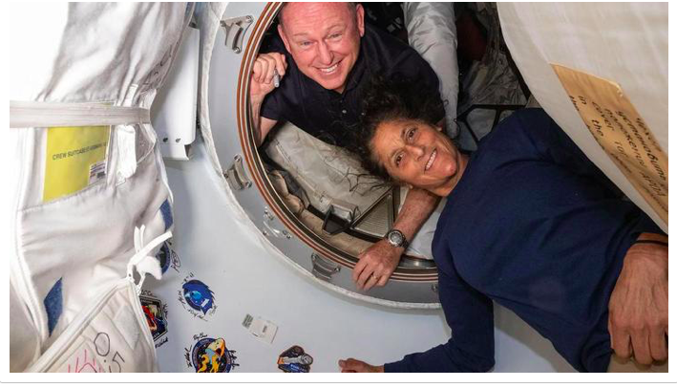
# END OF AN ERA

INTER#
# TECH TALKING

INTER#

Astronomers were treated to a rare observational opportunity when the interstellar object 3I/ATLAS approached a near-opposition alignment. This alignment allowed researchers to gather valuable data on the object’s composition and trajectory, offering rare insights into materials from beyond our solar system. The scientific community hailed the event as a once-in-a-generation chance to broaden understanding of interstellar matter.
The European Union announced new digital regulation frameworks aimed at curbing the power of major tech firms and protecting consumer data privacy. These rules, set for phased implementation throughout the year, could influence global tech policy norms. The United States moved ahead with legislation targeting semiconductor manufacturing incentives, aiming to boost domestic production and reduce reliance on overseas supply chains amid ongoing concerns about technological competitiveness.
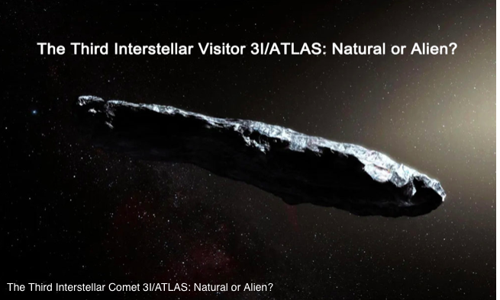
DID YOU KNOW ?


# FUN-TASTIC FIGURES

INTER#

