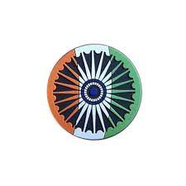

Can fish hook voters in India’s West Bengal elections?
In battle for India’s West Bengal election, PM Modi’s men campaigned with fish in hand to try to connect with voters. Waving a big Catla fish in his hands, Sharadwat Mukherjee , a candidate from Bharatiya Janata Party (BJP), which rules nationally but has never come to power in the state, went door to door canvassing for votes before election to the state legislature in the eastern Indian state of West Bengal begins on 23rd April.

Maharashtra government employees begin indefinite strike over pension notification. About 1.7 million staff join strike as government invokes ‘No Work, No Pay’ rule and warns of action under Maharashtra Essential Services Maintenance Act. About 1.7 million State government, semi-government, teaching, non-teaching and Class IV employees in Maharashtra began an indefinite strike on Friday (April 17, 2026), citing unaddressed demands including the issuance of a notification for a revised pension scheme. The government has said it will treat the strike as misconduct and enforce a ‘No Work, No Pay’ policy.

Four held for providing logistic support to terrorists in J&K. They identified the OGWs as Zahoor Ahmad Mir, Bashir Ahmad Bhat, and Ghulam Mohammad Bhat, all residents of Hazratbal.

Tamil Nadu elections 2026 37.56% votes polled till 11 a.m.; Vijay seeks two-hour extension of polling period
Delegates of the International Election Visitors’ Programme 2026 will visit Tamil Nadu to witness the polling process in the State. Over 5.73 crore voters will decide the electoral fate of 4,023 candidates in the fray for the crucial Tamil Nadu Assembly elections on April 23, amid tight security and a massive crackdown by election authorities to prevent inducements to influence voters. The high-stakes contest primarily pits the DMK-led Secular Progressive Alliance against the AIADMK-led National Democratic Alliance, with Chief Minister M.K. Stalin seeking to retain power and AIADMK general secretary Edappadi K. Palaniswami fighting to return to the treasury benches after five years.

Scorching summer heat puts elderly at risk. Confusion is often the earliest and most overlooked sign of heat-related illness in the elderly, a doctor said. With temperatures rising, geriatricians have started to see elderly persons with signs of dehydration and exhaustion. The scorching heat levels can put the elderly at risk of heat-related illness, and doctors have raised the need to take precautions, recognise warning signs early and seek timely medical help.

Ladakh L-G Saxena approves major tourism reforms to ease business, cut compliance burden. As part of the reforms, several documentation requirements have been removed, easing entry barriers and improving transparency

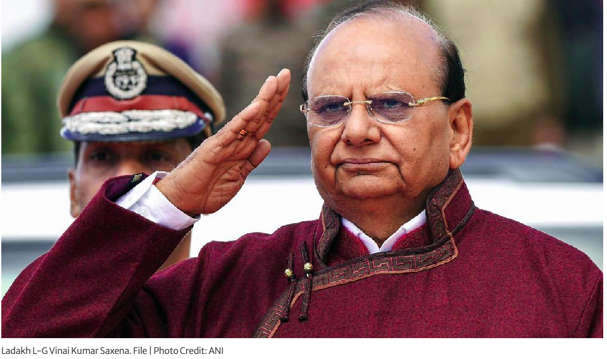

Nepal’s home minister resigns, second cabinet exit in one month. Sudan Gurung steps down after less than a month in office, citing questions about his investments ​and other matters. Sudan Gurung announced his departure , stressing that questions should be investigated, without giving further details.

Pope Leo urges justice reform in Equatorial Guinea’s prisons.Equatorial Guinea’s prison conditions face scrutiny as Pope Leo pushes for humane treatment and reform during his visit. The head of the Catholic Church told inmates at the prison in Bata city that they are not alone, as he delivered a message of hope during a visit that drew attention to human rights abuses and injustices that campaigners have denounced for years.

Six women win 2026 Goldman prize, world’s top environmental award. First all-women cohort of winners hails from Colombia, Nigeria, Papua New Guinea, South Korea, the UK and the US. or the first time since the prize was created in 1989 by philanthropists Richard and Rhoda Goldman, all recipients of the award are women: Iroro Tanshi, from Nigeria; Borim Kim, from South Korea; Sarah Finch, from the United Kingdom; Theonila Roka Matbob, from Papua New Guinea; Alannah Acaq Hurley, from the United States; and Yuvelis Morales Blanco, from Colombia. This year’s prestigious prize has been awarded to six grassroots environmental activists from around the world for their efforts to fight climate change and save biodiversity.

UK bill bans anyone born after 2008 from ever buying tobacco. People who are now 17 or younger will never be able to buy tobacco, according to the law backed by the UK Parliament. A new bill approved in the United Kingdom’s legislature will stop people born on or after January 1, 2009 from buying tobacco during their whole lives, as part of a years-long effort by ministers to create a “smoke-free generation”. Secretary of State for Health and Social Care Wes Streeting introduced the Tobacco and Vapes Bill in the House of Commons in 2024, aiming to protect public health and reduce the harm caused by smoking.

How China is gaining from Iran war by showing it is different from US. Beijing has leveraged its strong economic relationship with the US, Israel, Iran and the Gulf to keep its stakes safe while preparing for 'the day after' the war, say analysts. As Chinese President Xi Jinping called for the reopening of the Strait of Hormuz this week, the pragmatic approach Beijing has taken to the US-Israel war on Iran was on full display.

Speaking to Saudi Arabia’s Crown Prince Mohammed bin Salman (MBS) on the phone on Monday, Xi reiterated China’s support for “all efforts conducive to restoring peace and stands for resolving disputes through political and diplomatic means”.

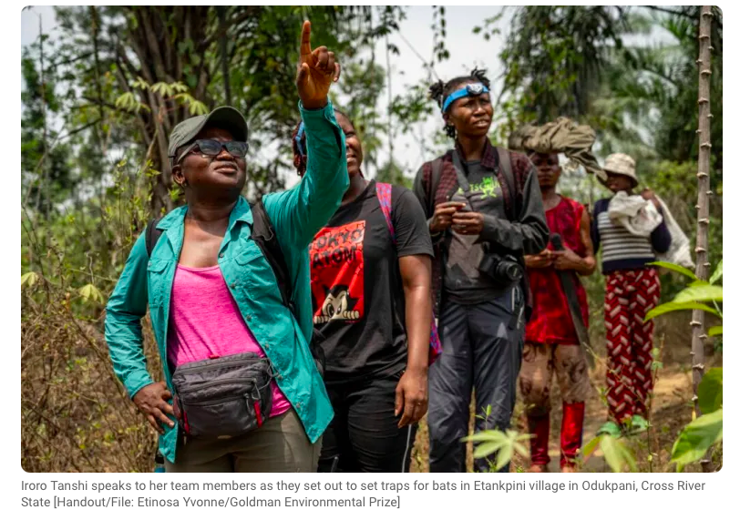
# CURRENT AFFAIRS INTERNATIONAL

INTER
# CURRENT AFFAIRS INDIA

INTER
THE WORLD AROUND US
WHEN THE GOING GETS TOUGH, WE GET WRITING!
Edition 15 26th April 2026

In libris graecis appetere mea. At vim odio lorem omnes, pri id iuvaret partiendo. Vivendo menandri et sed.

“The First Wound or the First Shield?”
What Parenting Creates”

Children are like mirrors—they reflect what they see and absorb what they feel. Before the school or society, it is the parents who lay the foundation for children. However, the way parents take care of their children plays a massive role in shaping the child's nature.

Parents' toxic behaviour can really affect the child's nature. The child tends to be more arrogant and rude to others, just how their parents act towards them. They lack trust and respect. Suppose, a child comes home from school and his father immediately tells him to start working or else he will take away his phone or something that is close to him. This type of harsh attitude can have a toll on the child's mental and physical well-being, making them feel like they are not good enough. They learn to stay silent, to hide their emotions, and to fear judgement. Over time, this fear becomes a part of who they are.

Now, imagine the same scenario, but instead of shouting orders, the father first greets his child, hugs him and then politely asks him to do work after he has rejuvenated for a bit. Instantly, the child feels more comfortable and relaxed as he is treated with love, patience and understanding. They face the world with courage because their foundation is strong. They understand that mistakes are a part of growth, not something to be punished harshly. They grow into individuals who are not afraid to express themselves. The truth is, children don’t always remember specific moments—but they remember how those moments made them feel. And those feelings shape their identity.

In this way, the parenting style of the child's parents can either shape him into a considerate, courageous and respectful individual or scar his childhood for life. Parenting, therefore, is not just about discipline or success—it is about teaching a child what love feels like. Because in the end, a child will either grow up seeking love or running from fear.

“Behind every young child who believes is a parent who believed first.”

KABIR SINGH
GRADE 8
DAV SCHOOL, AMRITSAR



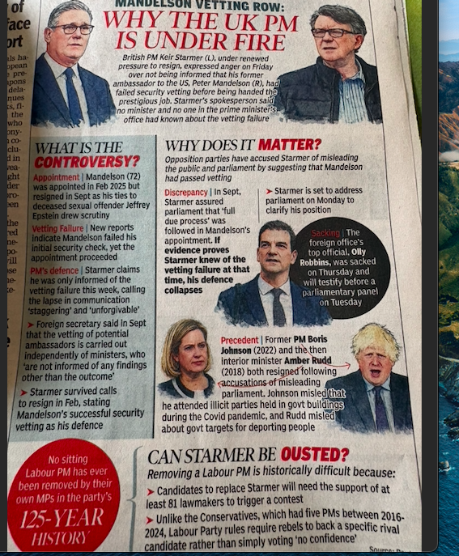
# UK’S UPHEAVAL

INTER
# GUEST EDITOR

INTER

# FEED FORWARD
# CURRENT AFFAIRS साप्ताहिक

INTER

Managing Editors- Aniruddha Iyer Bali, Sabir Singh Ahuja, Vaibhav. S.Uppal, Vihaan.S. Uppal
Hey everyone!  We are teenagers from a boarding school in the foothills, who believe change begins with us. The newsletter, a fortnightly, explores stories, events and ideas that shape our world. From happenings to global issues, we'll dive into it all. Join us, collaborate, critique and voice your opinions as we share our perspectives, insights, and creativity with you!

Your feedback and contributions would be a game changer!

Do write to us, @theworldthisweek4@gmail.com

.
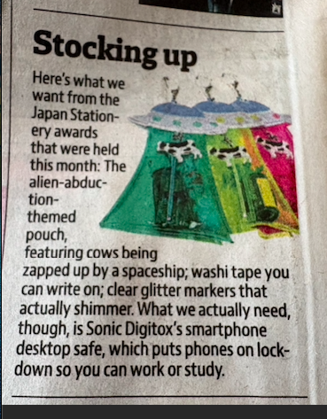

# HEAL THE WORLD
# WEEKLY WATCH

Top Gun 3 confirmed — Tom Cruise back as Maverick. Gen Z loved Maverick, so hype is real. Paramount has officially confirmed Top Gun 3 is in development, with Tom Cruise set to return alongside producers Jerry Bruckheimer and David Ellison. Top Gun: Maverick co-writer Ehren Kruger is working on the script. Additionally, to mark the 40th anniversary of the original film, Top Gun and Top Gun: Maverick will return to theaters in India for a special one-week run beginning May 15, 2026

Avengers: Doomsday trailer is out — Thor vs Doctor Doom, OG Avengers reunite. Marvel fans are excited. Thor Battles Doctor Doom, Chris Evans Picks Up the Hammer, X-Men Back in Action in Thrilling CinemaCon Footage
# Top of the billboard
The winner for Spring 2026: "Choosin' Texas" — it’s got the numbers, the TikTok virality, and it is the song of summer 2026 already.

Dr. Amir Ali — Iranian Red Crescent / Minab Response
Where: Southern Iran, specifically Minab after the Feb 28, 2026 school airstrike.

What he’s doing?
Lead trauma surgeon coordinating emergency medical response for the 168+ child casualties. He’s been working 20-hour shifts setting up field hospitals after local clinics were overwhelmed. Iranian state media quoted him: “We ran out of pediatric IV lines. We used adult ones and prayed.”
Why it matters?
He stayed when foreign NGOs evacuated. Posting updates on Telegram to get med supplies through the naval blockade.

Jean Arnault — UN Special Envoy
Where: En route to Tehran April 2026 as US-Iran cease-fire expires
What he’s doing: Veteran UN mediator who handled Colombia + Guatemala peace processes. Now doing shuttle diplomacy between US, Iran, Pakistan to keep talks alive. Iran told the UN it “stands ready to engage constructively” specifically through his channel.
Why it matters: One of the only neutral figures both sides will still take calls from. Pushing Pakistan-China’s 5-point plan: stop hitting schools, power plants, desalination.

Sister Hanan Al-Fatlawi — Dominican Sisters of St. Catherine of Siena
Where: Iraq/Iran border regions + refugee camps for Iran war displaced
What she’s doing: Iraqi nun running makeshift clinics + trauma counseling for kids from war zones since 2014 ISIS crisis, now handling Iran war refugees. The Sisters of Mercy highlighted her work: despite bombs + kidnapping threats, she stayed to run schools + clinics. Now distributing water filters + insulin to Iranians fleeing to Iraq.
Why it matters: She’s quoted: “We do not have the right to be afraid when people need us.” Operating with zero government support.

Teen-relevant angle:
If you want someone Gen Z follows → Motaz Azaiza, Palestinian photojournalist, was in Gaza 2023-2024 documenting war. He’s now raising funds + awareness for Iran war victims too.

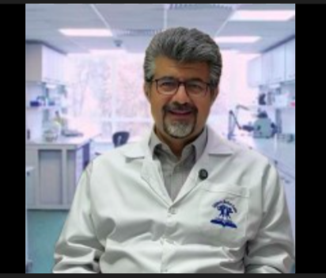

# RECOMMENDED READS

The Seven Dials Mystery -Agatha Christie
Based on buzz, reviews, and teen appeal, the standout is:
Starred reviews across the board: Kirkus calls it “wry and wickedly entertaining”. SLJ says “will enthrall teens everywhere”.

A healthy young man dies in his sleep, despite the ringing of eight separate alarm clocks…

Gerry Wade had proved himself to be a champion sleeper; so the other house guests decided to play a practical joke on him. Eight alarm clocks were set to go off, one after the other, starting at 6.30 a.m. But when morning arrived, one clock was missing and the prank had backfired with tragic consequences. For Jimmy Thesiger in particular, the words ‘Seven Dials’ were to take on a new and chilling significance…



Meta says it will cut 8,000 jobs as AI spending soars. Meta will cut thousands of jobs next month as it spends more than ever on artificial intelligence (AI) projects.
The company told employees in a memo on Thursday that it planned to cut 10% of its workforce - roughly 8,000 staff. It said it would also not fill thousands more open jobs it had been hiring for.

A key reason for the layoffs is Meta's increased spending in other areas of the company, including AI, for which it will this year spend $135bn (£100bn). This is roughly equal to the amount it has spent on AI in the previous three years combined, according to a person who viewed the memo.
A spokesman for Meta confirmed the planned job cuts but declined to comment further. Mark Zuckerberg, Meta's co-founder and chief executive, made public comments in January that essentially telegraphed the company would be cutting jobs again this year. The Meta boss said he had seen how much more productive workers who relied heavily on AI tools had become, noting a single person could now complete projects that would have previously required a large team.

A key reason for the layoffs is Meta's increased spending in other areas of the company, including AI, for which it will this year spend $135bn (£100bn). This is roughly equal to the amount it has spent on AI in the previous three years combined, according to a person who viewed the memo.
A spokesman for Meta confirmed the planned job cuts but declined to comment further. The Meta boss said he had seen how much more productive workers who relied heavily on AI tools had become, noting a single person could now complete projects that would have previously required a large team.

Warner Bros Discovery shareholders have approved the company's $111bn (£82bn) takeover by Paramount in a deal which could drastically alter the media landscape.
The deal would see Skydance owner Paramount take control of all of Warner Bros' titles and channels, which include Harry Potter, Game of Thrones and news network CNN.
"With Paramount, we look forward to creating an exceptional combined company that will expand consumer choice and benefit the global creative talent community," Warner Bros chair Samuel DiPiazza said. The deal still needs approval from the US Department of Justice and European competition regulators.

Stock markets are too high and set to fall, says Bank of England deputy. The Bank of England expects stock markets around the world to fall as share prices do not reflect the many risks facing the global economy, its deputy governor has told the BBC. Sarah Breeden said: "There's a lot of risk out there and yet asset prices are at all-time highs. We expect there will be an adjustment at some point."
It is unusual for a senior figure at the Bank to be so forthright on market movements.

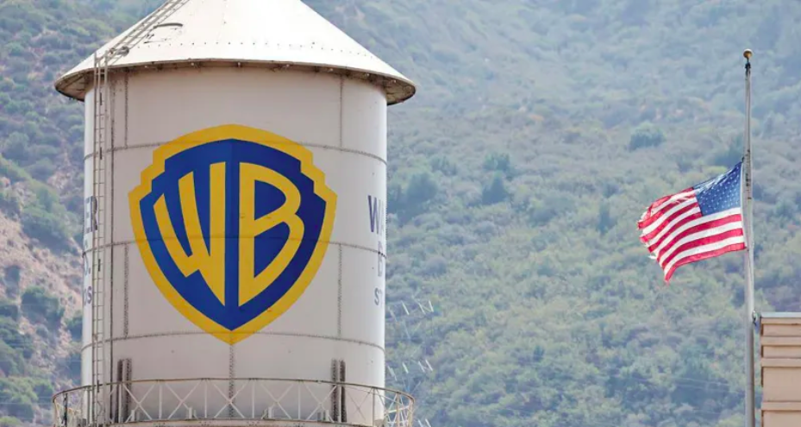
# TECH TALKING

INTER#
# MONEY MATTERS

INTER#

Earth Day 2026 was observed on Wednesday, April 22, 2026, with the theme "Our Power, Our Planet". This annual global event focuses on promoting renewable energy, sustainability, and urgent climate action. Events worldwide, including tree plantings, clean-ups, and educational workshops, emphasize collective responsibility to protect the environment and combat global warming.

World Earth Day 2026: It serves as a day of protest, education, and celebration of the planet, aiming to drive policy change and individual responsibility. has grown into the world's largest environmental movement, bringing together over a billion people across 193 countries. It is not just a day of celebration but also one of awareness, activism, and education, encouraging both policy change and individual responsibility toward the planet. First observed in 1970 as a small grassroots initiative, Earth Day has since evolved into a powerful global call to action. Each year, it reminds people of the beauty and fragility of our planet while urging them to take meaningful steps, big or small, to protect it.

At its core, Earth Day is about raising awareness of the urgent need to preserve natural resources for future generations. And that urgency is only growing. From climate change and deforestation to pollution and biodiversity loss, the challenges facing the Earth today are unprecedented. Yet, the day also carries a sense of hope. It serves as a moment for collective action, a chance for individuals, communities, and governments to come together and recommit to protecting the natural world

Key Aspects of Earth Day 2026
"Our Power, Our Planet" highlights individual and collective action to drive renewable energy and sustainability.
Global Impact: Over 190 countries participate in activities designed to improve environmental health.

Events included planting trees, reducing plastic use, community clean-ups, and promoting sustainable lifestyles.
NASA Participation: NASA celebrated by highlighting images of Earth taken by the Artemis II crew during their lunar flyby.
Focus Areas: The movement pushes for urgent action against climate change and environmental destruction.

