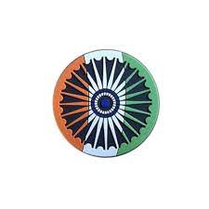

History’s biggest census
India launches population count after a delay of five years and will include caste enumeration for the first time in a century. India has begun counting its population in the world’s largest census, which will include caste enumeration for the first time in nearly a century. This year’s census is a $1.24bn exercise during which more than three million Indian officials will spend a year surveying about 1.4 billion Indians about their household composition, living conditions and access to basic amenities.

Why is a census important?

Dipa Sinha, a development economist who works on social policy, said that along with counting the number of people in the country, a census shows demographic trends. “It also tells us the distribution between rural and urban areas. It gives broad demographic structure,” adding that details of people’s occupations and religions are also collected in census surveys. She said such information helps governments plan policies and citizens to claim their rights. Census data also form the basis for allocations under antipoverty programmes, she noted. Sinha added that India’s latest census is drawing particular attention because the government is planning a delimitation exercise, which is basically redrawing the boundaries of electoral constituencies based on population.

How has India’s census evolved?

When India’s census was carried out under British rule, questions mainly focused on registering household data, such as the number, age and gender of residents, their caste and religion. How proficient a person was in the English language was also part of the data collected in the census then. Postcolonial India’s census has evolved to include questions not only about individuals’ identities but also to assess their socioeconomic status and living conditions.

In 1971, according to the Press Information Bureau, the census also tracked internal migration by collecting data on people’s last place of residence, which provided crucial insights into India’s population movement patterns.

Details on employment, disability and fertility status were standard questions in the 2011 census. This year, questions on couples’ relationship status have also been included. Couples in a live-in relationship will be counted as married “if they consider their relationship as a stable union”, according to the census portal.

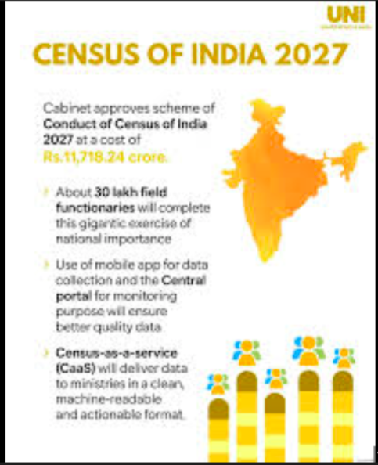
THE WORLD AROUND US
WHEN THE GOING GETS TOUGH, WE GET WRITING!
Edition 12 06th April 2026

Oman, Iran discuss smooth transit in Strait of Hormuz
Oman and ⁠⁠Iran ⁠⁠have held deputy foreign ⁠⁠minister-level talks, discussing ⁠⁠options to ensure the smooth transit of vessels through the Strait ‌‌of Hormuz, according to the Omani Foreign Ministry. The talks have focused on a ‘smooth passage’ through the Strait of Hormuz, as Tehran effectively blocks the vital waterway. The meeting was held “at the level of undersecretaries in the foreign ministries of the two countries”, the ministry said in a post on X, adding that it was “attended by specialists from both sides”.

“We blame Trump”

Drivers line up for free gas as prices surge in the US, in Chicago as fuel prices surge, driven by the US-Israeli war on Iran disrupting global oil supplies, with some blaming President Donald Trump.

Jeremy Hansen, the first Canadian to head to the moon
Canadian Space Agency President Lisa Campbell expresses her pride as the Artemis II moon orbiting mission carries the first Canadian to the moon along with three Americans. She also discusses the significance of this mission.

Gulf is ‘fundamental’ for Europe’s security
In a trip that included visits to Saudi Arabia, Qatar and the UAE to discuss tensions brought about by the US-Israeli war on Iran, Italian PM Meloni emphasized the importance of the Gulf to Italian and European national security.

Cuba releases over 2,000 prisoners
There have been emotional scenes in Cuba where 2,000 prisoners are being pardoned and released from jail. Authorities say it’s a “humanitarian gesture” for Holy Week, but it comes as the Trump administration intensifies pressure on Cuba over political prisoners.

Thousands rally in Iraq against ‘senseless’ US-Israel war Protesters chant against the US and Israel, urging the global community to confront their actions in the Middle East. Tens of thousands of Iraqi Shia leader Muqtada Sadr’s supporters rallied across Baghdad and other cities on Saturday, protesting against the US-Israel war on Iran. Iraq has been unwillingly drawn into the regional tension, suffering attacks targeting both US interests and pro-Iranian factions within its territory. In Baghdad’s Tahrir Square, enormous crowds, including some women, filled the streets, brandishing Iraqi flags and shouting: “No, no to Israel” and “No, no to America”
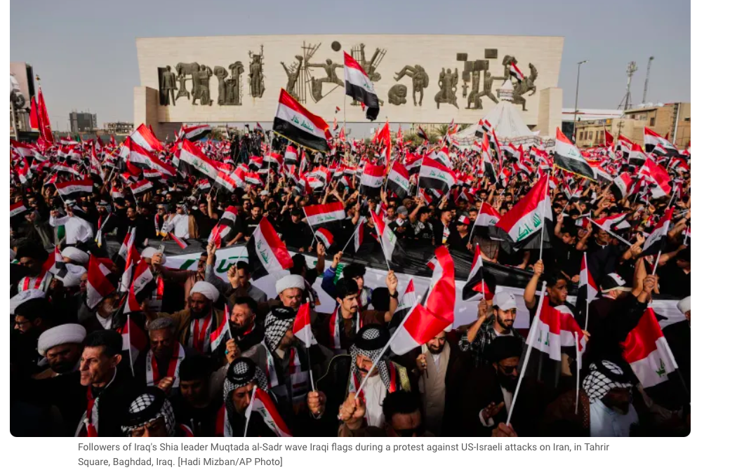
# CURRENT AFFAIRS INTERNATIONAL

INTER
# CURRENT AFFAIRS INDIA

INTER

In libris graecis appetere mea. At vim odio lorem omnes, pri id iuvaret partiendo. Vivendo menandri et sed.

# TRIVIAL PURSUITS

INTER
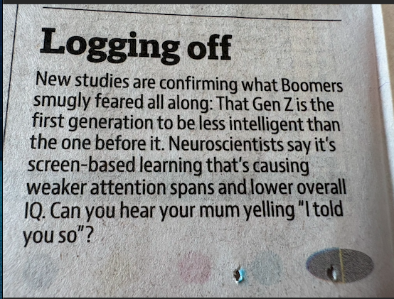

The One and Only Ivan
Katherine Applegate’s book won the 2013 Newberry Medal. It has emotionally charged characters. I absolutely love her writing style.
The novel is inspired by the story of a real silverback gorilla. Ivan was captured as a baby and brought to live with humans. He spent a large portion of his life living in a shopping centre. Applegate heard about Ivan and wanted to tell his story. She wanted to give the gorilla a voice of his own, which is why ‘The One and Only Ivan’ is narrated by the gorilla. Like in real life, the fictional Ivan was taken as a baby and raised with humans. He is then moved to a cage in the Exit 8 Big Top Mall and Video Arcade. He is joined by Stella, an elderly elephant and a stray dog called Bob. When a young elephant, Ruby, is added to their group, Ivan begins to see his life differently.
Since he’s grown up among humans, he has memories of his life in the jungle, but he rarely misses it. Instead, he watches TV and thinks about his friends. Most of his thoughts are about art and how to capture the taste of mango or the sound of leaves using colour. Ivan loves to paint. He can remember making designs on his mother's back as a young ape, and now Mack sells the pictures that Ivan creates each day. The custodian's daughter also loves to paint and shares her supplies with Ivan, giving him new ways to express his experiences.
Although a heart breaking story, it is sweet enough for its young audience. A complex tale with many layers, runs deep, with endearing animals and their beautiful , profound friendships. There is pathos and a sense of loss yet it doesn’t pull one down. The tale of courage, trying to find happiness amongst the grim reality and finding a sliver of hope, this book and the protagonist blends humour into an evocative and deeply touching story of friendship, camaraderie and cheer.

Recommended For Grades: 3 – 6, Ages: 8 - 12
Format: Paperback Book

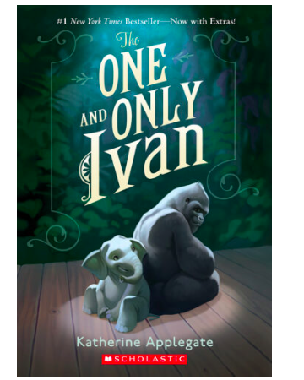
# RECOMMENDED READS

INTER

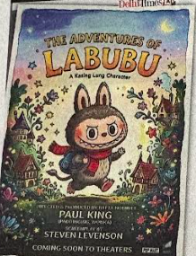



# FEED FORWARD
# CURRENT AFFAIRS साप्ताहिक

INTER

Managing Editors- Aniruddha Iyer Bali, Sabir Singh Ahuja, Vaibhav. S.Uppal, Vihaan.S. Uppal
Hey everyone!  We are teenagers from a boarding school in the foothills, who believe change begins with us. The newsletter, a fortnightly, explores stories, events and ideas that shape our world. From happenings to global issues, we'll dive into it all. Join us, collaborate, critique and voice your opinions as we share our perspectives, insights, and creativity with you!

Your feedback and contributions would be a game changer!

Do write to us, @theworldthisweek4@gmail.com

# WEEKLY WATCH
# GUEST EDITOR

"Video Games don't just entertain- they teach you how to think, adapt and never give up"

Video games have become quite an important part of many people's lives. We all love to play games on our computers, consoles and phones, but we never think how they can help us in real life. Video games are a big form of entertainment now-a-days, which also teach us life lessons. They, with proper time management, should be tried by everyone.
Video games teach us values. In the game 'Minecraft', we can build anything we want as the game is based on a simple variety of blocks. This, teaches us to be creative in life and to never give up, as everything is possible. It boosts our creativity and innovation skills. On the other hand, fast-paced games like 'Call Of Duty' and 'Fortnite' help us with our on-the-spot decision making and problem solving skills. They also increase our awareness of our surroundings and also teach us teamwork. "The courage to try in a game builds confidence in real life."
On the other hand, gaming also has some disadvantages. In some situations, it can have an adverse effect on our health. Playing video games for prolonged hours increases our exposure to screens and pixels, ruining our vision in the long run. It can quickly become an addiction. It can also result in problems like lack of focus and concentration, posture issues, etc. While playing video games, we must remember to take a break from the screen ever so often to give our eyes a rest as well.
Video games are more than just a source of entertainment. They help in developing skills useful in life, such as problem-solving, teamwork, creativity, patience, and quick decision-making. Through winning and losing in video games, we learn the value of persistence and self-improvement. They are a great boon to us when used with proper time management.
“Play is our brain’s favourite way of learning.”

KABIR SINGH
GRADE 8
DAV PUBLIC SCHOOL
AMRITSAR



Ramayana Update: Ranbir Kapoor has revealed that the upcoming film ‘Ramayana’, directed by Nitesh Tiwari, will be a massive six-hour project divided into parts, comparing its scale to The Lord of the Rings movie.
Ranbir Kapoor revealed that he isn’t just playing the role of Lord Rama in Ramayana, but will also portray Lord Parshurama in the magnum opus. Ramayana is set for a release on Diwali 2026.

Record sales of Indian Art: Raja Ravi Varma's Yashoda and Krishna painting set a new record, selling for ₹167.2 crore, at Saffronart, a Mumbai based auction house, setting a new record for Indian art. It was bought by Cyrus S Poonawalla of the Serum Institute of India, surpassing the previous record set by a painting by M. F. Husain.

Concert Cancellations: Punjabi singer Karan Aujla has canceled his upcoming concerts in Ludhiana and Lucknow. These were cancelled following controversy over his Mumbai show last month. Fans alleged poor management, a near stampede-like situation, with several people fainting in the scorching afternoon heat.

U2 Drops New EP: U2 surprise-released their second EP, Easter Lily, shortly after Days of Ash, per BBC News. It is a six-song collection. The band has been together since 1976, completing 50 years in 2026.

Dune 3 First Look: Timothee Chalamet has teased an intense first look at Paul Atreides for the upcoming Dune 3, which has fans highly anticipating its release.

Netflix Anime Controversy: Fans of Jojo's Bizarre Adventure have been flooding Netflix with reactions due to the lack of information on the ‘Steel Ball Run’ release. After a record-breaking debut, fans are demanding for the missing Episode 2.

The Super Mario Galaxy Movie draws a mixed reaction. Some critics are praising its imagination and pace, but others are saying it falls flat compared to the first film. It is the sequel to 2023's Super Mario Brothers Movie.

Harry Potter TV Series: Listen up muggles, the first trailer for the forthcoming Harry Potter TV series has been released. It is a spin-off from the original books and the subsequent film franchise.
Author JK Rowling is an executive producer on the series, which HBO says will be a "faithful adaptation" of her books.

The Oscars are leaving Hollywood, to move to downtown Los Angeles. In 2029, the year the telecast moves from ABC to YouTube, the ceremony itself will move from its long time home at the Dolby Theatre in Hollywood to downtown Los Angeles and the Peacock Theater, 14.5 kilometres away.

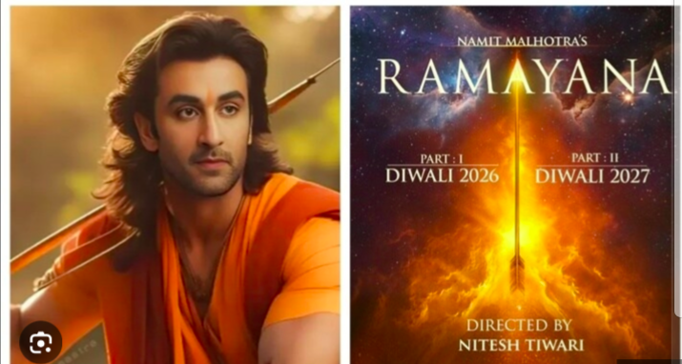

# REASON TO CHEER
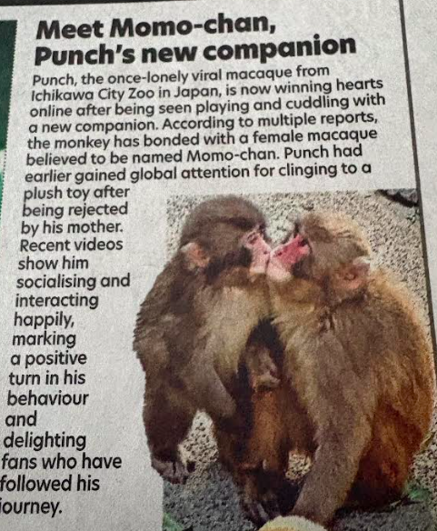

'Absolutely spectacular'
Artemis II crew see first glimpse of far side of Moon- The crew for Nasa's Artemis II mission have described seeing the far side of the Moon for the first time. Nasa astronauts Reid Wiseman, Victor Glover, and Christina Koch, and Canadian Space Agency astronaut Jeremy Hansen have entered the third day of their mission on the Orion spacecraft that will carry them around the far side of the Moon and back to Earth. "Something about you senses that is not the Moon that I'm used to seeing," Koch said.
The crew shared a photo they took of the Orientale basin of the Moon, which Nasa said marked "the first time the entire basin has been seen with human eyes". As of 23:00 BST on Saturday, Nasa's online dashboard showed the Artemis II spacecraft was more than 180,000 miles (289,681km) from Earth.
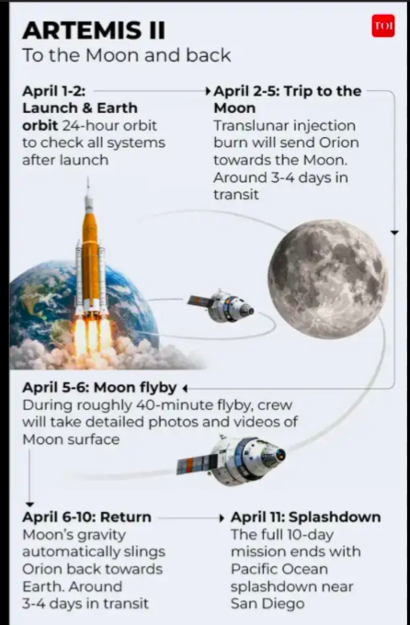

# TECH TALKING

INTER#

India's Defence Exports
Record High: ₹38,424 crore in FY26, up 62.6% from ₹23,622 crore in FY25. Key Contributors: Defence Public Sector Undertakings (DPSUs) - 54.84%, Private Sector - 45.16%
Economic Indicators
GDP Growth: 7.4% in FY26
Defence Budget: ₹7.8 lakh crore, 15% increase from FY25
Inflation Target: 4% for 2026-31
Global Business
IMF Forecast: Global GDP growth at 3.3% in 2026
Oil Prices: Jumped on Iran war concerns, WTI crude futures at $111.50 a barrel
Key Developments
SpaceX IPO: Elon Musk's SpaceX is planning an IPO, potentially raising $40 billion to $80 billion.
Iran-Israel Conflict: Escalating tensions are impacting global energy prices and trade.
AI Investment: Continued AI investment boom is expected to drive growth and productivity gains

# MONEY MATTERS

INTER#

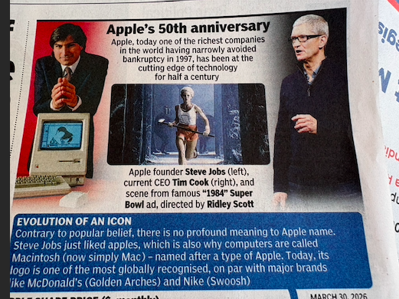
# HAPPY BIRTHDAY GENIUS

Cricket: IPL Update 2026
The Rajasthan Royals secured a thrilling 6-run win over Gujarat Titans in Ahmedabad, moving to the top of the table. Riyan Parag led the side to their second consecutive win.
Sameer Rizvi continued his hot form, slamming 90 runs to guide .Virat Kohli becomes the first batsman, in IPL history, to cross 4000 runs.
World Archery Para Series: India secured 16 medals, including seven gold, at the World Archery Para Series in Bangkok, with teenage archer Payal Nag winning gold, thus helping India secure three gold medals in compound events.
Boxing: Nikhat, Priya, and Preeti advanced to the semifinals of the Asian Boxing Championships 2026, confirming three medals for India.
Football -FA Cup Quarter-final: Erling Haaland scored a hat-trick to lead Manchester City to a dominant 4-0 win over Liverpool, securing a spot in the semi-finals.
FIFA World Cup 2026 news: The tournament will take place from June 11 to July 19, 2026. It will be jointly hosted by sixteen cities—eleven in the United States, three in Mexico, and two in Canada. The tournament will be the first FIFA World Cup to be hosted by three nations, and the first to include 48 teams, an expansion from 32.World Cup Qualifiers: Iraq has officially qualified for the 2026 FIFA World Cup. Iraq's national team received a massive celebration in Baghdad after qualifying for their first World Cup in 40 years.
SAFF U-20 Championship at Male, Maldives:
On 3 April 2026, Bangladesh clinched their second title by defeating India 4–3 on penalties in the final after a 0–0 draw at the end of normal time. Team India was the runners up.

# SPORTS SCOREBOARDS

INTER#

