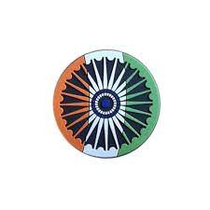

The Indian rupee has dropped to a new record low of around ₹92.45 against the US dollar amid rising global crude oil prices and geopolitical tensions affecting energy markets. Since India imports over 80% of its crude oil requirements, higher global oil prices increase demand for US dollars for imports, which can weaken the rupee and pressure financial markets.
Key Highlights
🛢 Brent crude prices remain above $100 per barrel
📉 Foreign investors continue selling Indian equities
⚠ Rising oil prices increase India’s import bill and inflation risk

Rajya Sabha polls:
Odisha Congress suspends three MLAs for cross-voting
Datteswar Ray Hota, who was fielded as a common candidate by the Congress, the BJD and the Left, lost to BJP-backed hotelier and Independent, Dilip Ray. NDA wins nine Rajya Sabha seats from Bihar, Odisha, Haryana
BJP national president Nitin Nabin and Bihar CM Nitish Kumar romp home as NDA secures all five Rajya Sabha seats in Bihar; the party also secures victory of three candidates in Odisha; BJP and the Congress file separate plaints in Haryana.

The incontrovertible nature of both life and death makes them fiendishly difficult to legislate or adjudicate. Interfering with the very elemental beginning and end points of life must seem daunting. Nothing else can explain the long dalliance that laws have had with euthanasia to facilitate the intentional ending of a life, globally. In India, last week, the Supreme Court, in a landmark decision, approved the withdrawal of life support, including artificial nutrition and hydration, for Harish Rana, who went into a persistent vegetative state (PVS) following a head injury over 12 years ago.

Nurses in private hospitals across Kerala went on an ‘indefinite strike’ from March 9 to 13, demanding higher wages and better working conditions. Though the agitation has been temporarily withdrawn after a Kerala High Court directive, the United Nurses Association, the main organiser, says it will be resumed if there is no progress in the mediation efforts.

Khelo India Winter Games: The 2026 Winter Games officially began in Gulmarg, focusing on developing better sports infrastructure.

Indian runner Pooja Aatmaram has been banned for 3 years by the Athletics Integrity Unit (AIU) for evading a dope test.
High Jump: Indian High Jumper, Sarvesh, who finished sixth in the 2025 World Athletics Championships, missed out on the qualifying standards for the 2026 Asian Games (2.19m) and 2026 Commonwealth Games (2.22m).

Election Council of India announces election schedule for four States and Puducherry. Kerala, Assam and Puducherry will go to the polls on April 9, while Tamil Nadu will vote in a single phase on April 23. Voting in West Bengal will be held in multiple phases beginning April 23.

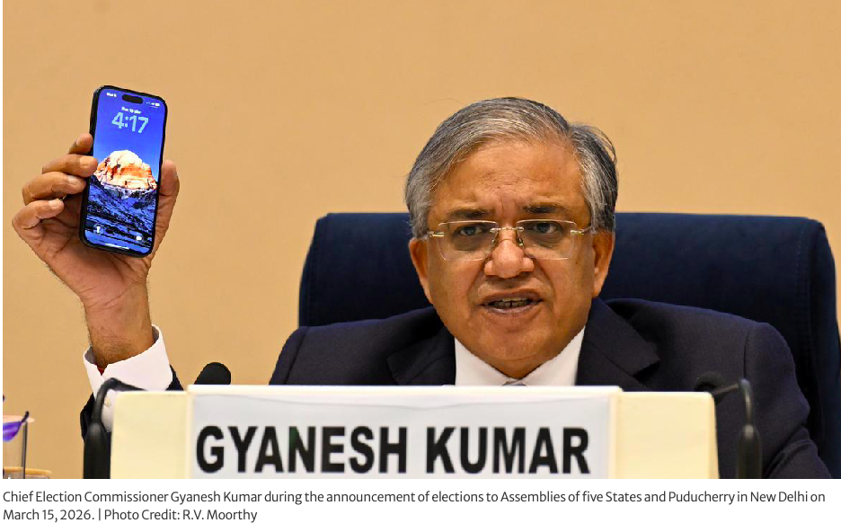
# CURRENT AFFAIRS INTERNATIONAL

INTER

Debris from intercepted missile kills one in Abu Dhabi; explosions reported across Dubai, Doha. Drones, rockets attack U.S. Embassy in Baghdad; UAE air traffic returns to normal after brief closure.

Israeli air strikes have rained down on three neighbourhoods in Beirut while Israeli army says it launched new attacks on the Iranian capital Tehran.
Missile and drone attacks continue to target the Gulf region and beyond, with Qatar, Saudi Arabia, UAE and Kuwait reporting interceptions.

Trump seeks to delay meeting with China’s Xi by ‘month or so’ amid Iran war. The US president delays March 31-April 2 trip to China to focus on the escalating war against Iran. It underscores how the Iran war has upended his foreign policy agenda, also risks magnifying tensions ⁠between Washington and Beijing, as the war on Iran has joined trade and Taiwan as among the spectrum of issues separating the world’s two biggest economies.

Twitter trial accusing Musk of driving down stock set for closing arguments. The civil trial centres on a class-action lawsuit filed just before Musk took control of Twitter, which was renamed X.

EU says Iran is ‘not Europe’s war’. EU foreign policy chief Kaja Kallas said there is no appetite to expand Europe’s naval mission to the Strait of Hormuz. She said the bloc is not part of the war but remains focused on restoring key energy and trade routes.

Large protest held in London against US-Israeli war on Iran
Thousands of demonstrators took to the streets of London to oppose US-Israeli aggression against Iran, Lebanon and Gaza.

More than 120 migrants, including at least 20 minors, were rescued in the central Mediterranean over the past 48 hours. Italian NGO Emergency says its vessel carried out three rescue operations and is now heading to Italy’s Civitavecchia with 123 survivors on board, many fleeing African countries including Sudan.

Palestinian activist Leqaa Kordia was released from an ICE detention facility in Texas after a year in custody. The 33-year-old from the occupied West Bank was the last person connected to the Columbia University anti-genocide protests still held by US immigration authorities.


# CURRENT AFFAIRS INDIA

INTER
THE WORLD AROUND US-A NEWSLETTER
Edition 10 17th March 2026

In libris graecis appetere mea. At vim odio lorem omnes, pri id iuvaret partiendo. Vivendo menandri et sed.

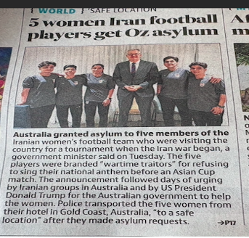
Lights, camera, Conan:
Conan O’Brien returned to host the Oscars for a second year, taking the stage of the Dolby Theatre after A-list stars braved the red carpet in 80-degree Los Angeles weather. He dressed as nominee Amy Madigan's "Weapons" character, Aunt Gladys, for the opening segment, which featured a tribute to the nominated films.
It was a big night for Warner Bros. Discovery: Paul Thomas Anderson’s “One Battle After Another,” which was nominated in 13 categories, dominated the show, taking home six, including the coveted best picture. Ryan Coogler’s “Sinners,” which made Oscar history with 16 nominations, followed with four awards.

The wins for Warner Bros. come as the media conglomerate is preparing to merge with Paramount Skydance, the company owned by David Ellison.
Autumn Durald Arkapaw became the first woman to win the best cinematography Oscar for her work in "Sinners." After thanking Coogler, she asked all the women in the room to stand up. "I feel like I don't get here without you guys," she said.
Major Winners
Best Picture : One Battle After Another
Best Director :Paul Thomas Anderson for One Battle After Another
Best Actor : Michael B Jordan for Sinners
Best Actress : Jessie Buckley for Hamnet
Best Supporting Actor : Sean Penn for One Battle After Another
Best Supporting Actress : Amy Madigan for Weapons
Other Notable Winners
Best Original Score : Ludwig Göransson for Sinners
Best Original Song : "Golden" from KPop Demon Hunters
Best International Feature Film : Sentimental Value (Norway)
Best Animated Feature Film : KPop Demon Hunters
Best Visual Effects : Avatar: Fire and Ash
Autumn Durald Arkapaw became the first woman to win Best Cinematography for Sinners. One Battle After Another dominated the night, winning six awards, including Best Picture and Best Director

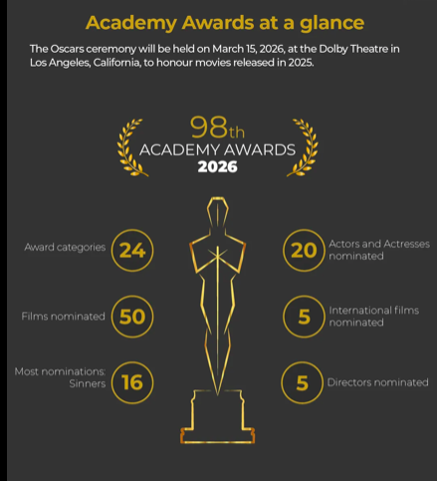
# REASON TO CHEER

INTER
# WEEKLY WATCH

INTER





# FEED FORWARD
# CURRENT AFFAIRS साप्ताहिक

INTER

Managing Editors- Aniruddha Iyer Bali, Sabir Singh Ahuja, Vaibhav. S.Uppal, Vihaan.S. Uppal
Hey everyone!  We are teenagers from a boarding school in the foothills, who believe change begins with us. The newsletter, a fortnightly, explores stories, events and ideas that shape our world. From happenings to global issues, we'll dive into it all. Join us, collaborate, critique and voice your opinions as we share our perspectives, insights, and creativity with you!

Your feedback and contributions would be a game changer!

Do write to us, @theworldthisweek4@gmail.com

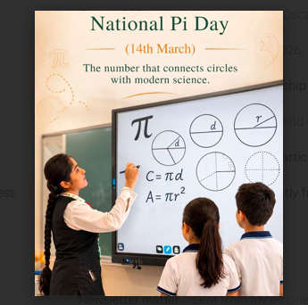

# RECOMMENDED READS
# LORE OF A LEGEND

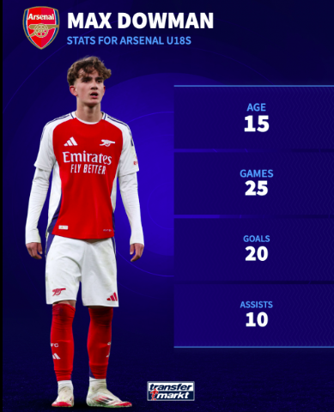

Arsenal's Max Dowman made history when he became the youngest goalscorer in Premier League history in their 2-0 win over Everton on Saturday. The substitute - aged 16 years and 73 days - ran from his own half before scoring into an empty net after Toffees keeper Jordan Pickford had come forward for a set-piece in injury time.

Ever since he pulled on an Arsenal shirt, Max Dowman has broken records for the Gunners.
This season, he has become the youngest player ever to play in the Champions League, the youngest player to start a match for Arsenal and the youngest player to feature for the Gunners in the FA Cup too.

And now, after his goal in the 2-0 win over Everton, he is the youngest scorer in Premier League history (aged 16 years and 73 days).
Dowman is also the second-youngest player to represent the club and second-youngest to play in the Premier League, just behind fellow academy graduate Ethan Nwaneri.

For those who have followed Dowman's short but exciting career, these achievements and his goalscoring heroics have come as no surprise.

This is a player who has been training with the Arsenal first team since he was 14 and whose talent has received comparisons with Lionel Messi from his manager Mikel Arteta.

This is someone who is about to take their GCSEs this spring, a young boy who cannot even change with his Arsenal team-mates because, as he is under the age of 18, that would break safeguarding rules.

RECOMMENDED READS
1. Maya Angelou: Why the Caged Bird Sings (It’s an autobiography, a fascinating and absorbing story of Maya Angelou’s first 17 years. It is both joyous and painful, mysterious and memorable).

2. ⁠Lois Lowry: The Giver ( A classic dystopian story about a boy discovering the truth behind his "perfect" society). Newberry Medal winner

3. ⁠Kwame Alexander: The Crossover
(It’s a novel in verse about basketball and family. The challenges of twin boys as they navigate adolescence, sibling rivalry and the sudden loss of their father).
A Newberry Award winner .

4. J.D. Salinger: Catcher in the Rye (It is a modern classic, an exciting and compelling read. It is a combination of brutal reality, some humour and moments of depression).

5. Tanhha Lai: Inside Out & Back Again (Another book written in verse, it’s the story of a Vietnamese family. It explores all that comes when change happens - the good, the bad and the different). A Newberry Honour winner and The National Book Award Winner)

6. ⁠Kelly Barnhill: The Girl Who Drank the Moon (It’s a coming-of-age story, beautifully written and darkly funny. It’s a fantasy filled with love and magic). A Newberry Honour Award winner.

7. ⁠Harper Lee: To Kill a Mocking Bird (Set in the 1930, it is considered to be one of the greatest novels. There is a strong sense of morality and right & wrong. The book explores racism, injustice and lost innocence.
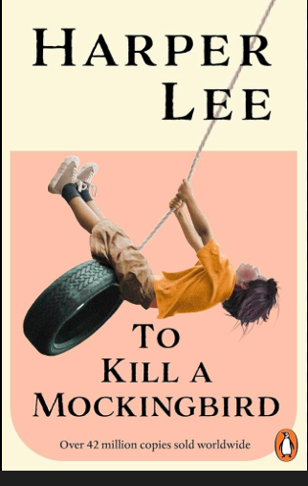ce).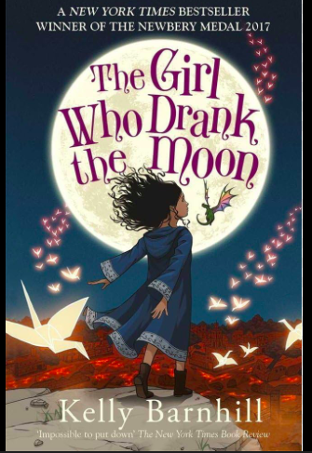

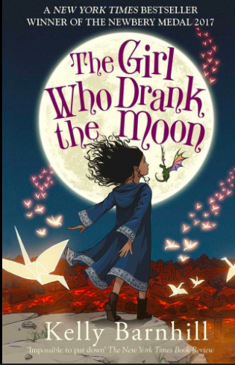



# TECH TALKING

INTER#
# MONEY MATTERS

INTER#
The Agave Restoration Initiative, established and led by Bat Conservation International (BCI) with over 100 partners across Mexico and the United States, is the world’s first landscape-scale foraging habitat restoration effort for migratory bats. Launched in 2018, the Initiative is restoring a 1,200-km "nectar corridor" spanning Mexico and the U.S. Southwest that is essential to the survival of three nectar bat species – including the endangered Mexican long-nosed bat – and the livelihoods of tens of thousands of rural people.

Populations of the Mexican long-nosed bat have declined by 50% with fewer than 10,000 remaining, largely due to agave loss from unsustainable grazing, drought, wildfire, and overharvest. The degradation of the agave corridor not only pushes these bats towards extinction but also threatens the livelihoods of people who depend on agaves.
Establishing agave seed networks, building community nurseries for agave production, restoring degraded land, and planting agaves in climate-resilient areas. We support community green businesses, regenerative agriculture and ranching, and innovative monitoring technologies. Regional partner networks, community training, and peer-to-peer knowledge sharing strengthen local capacity. At a broader scale, the Initiative provides a replicable model for restoring connected migratory corridors worldwide.

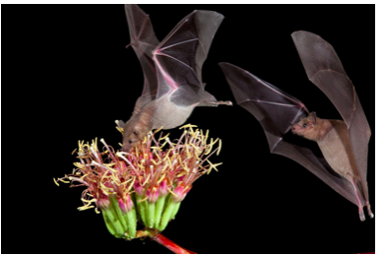
As of mid-March 2026, global markets are reeling from surging oil prices driven by Middle East conflicts. As per Groww.in, the top ten Indian firms are losing to the tune of ₹4.48 lakh crore in market capitalisation and the US tariff probe, impacting international trade. Key focuses include the final advance tax deadline (FY26) on 15th March, ongoing Iran-Israel tensions affecting oil supply, and potential AI-driven market corrections.
Indian markets are susceptible to crashing due to fears of energy crises. All Asian stocks are affected, following the attacks in the region.

Expect potential supply chain impact on semiconductors and on fertiliser. Global banking experts want all to exercise caution as interest rates by central banks are expected to change.

Market impact: The world market looks volatile due to rising energy costs. AI investments are behaving as a buffer for emerging markets. Indian banks continue to enhance digital lending, with IDFC First Bank, as it introduces new card services and RBI wishes to revamp its lead bank scheme.

Indian Market Update: Indian markets are facing pressure, with experts warning of a $1.2 billion hit to gem and jewellery exports.

The war has sent oil prices surging, thus pushing airline ticket costs on some routes sky-high. Australia’s Qantas Airways, Scandinavia’s SAS and Air New Zealand have announced airfare hikes, blaming an abrupt spike in the cost of fuel caused by the US-Israel attack on Iran that is rattling the global aviation sector.

J. Swaminathan, Deputy Governor, RBI, recently pointed out that the root cause of financial crises lies in government failures, not insufficient knowledge. With an eye on India’s 2047 vision, he called for unwavering leadership and sound judgment. He emphasised on proactive governance.

Several Gulf nations have declared force majeure on oil and gas shipment since the US-Israel’s war on Iran was launched. Gulf countries, including Qatar, Bahrain and Kuwait, have declared force majeure on gas exports following the United States-Israel war on Iran, now in its third week, and the disruptions to shipping through the Strait of Hormuz, as Tehran has retaliated across the region, targeting US assets. QatarEnergy was among the first to halt production, shutting down gas liquefaction on March 2 and sending ripples through global energy markets. Kuwait Petroleum Corporation and Bahrain’s Bapco Energies followed days later, while India invoked emergency measures to redirect gas supplies to priority sectors. Force majeure, from the French meaning “superior force”, is a clause in contracts that allows a party to be excused from its obligations when an event beyond its control prevents performance.

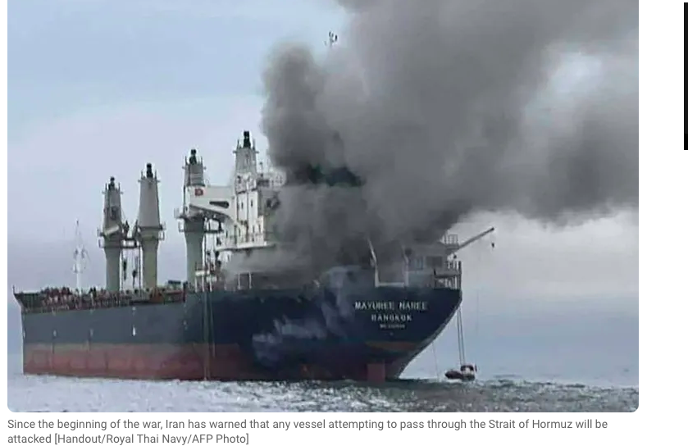
India Wins the T20 World Cup:
India were the defending champions, having won the previous World Cup, held in 2024. India beat New Zealand by 96 runs, thus becoming the first team to win two successive titles. 55 matches were played across five venues, with 20 teams participating.

Hockey:
England defeated India in the Women’s FIH World Cup Hockey’s qualifiers final in Hyderabad on 14 March 2026. England won 2-0. Both England and India secured their spots in the World Cup to be held in Netherlands in August 2026.

Arsenal & Premier League Title Race:
Arsenal secured a late victory over Everton (2-0), enhancing their position in the Premier League title race, moving 9 points ahead of Manchester City. Man City’s Guardiola admits they are running out of time.

Formula 1 cancels Grand Prix in Bahrain and Saudi Arabia scheduled for April as tensions escalate due to the war in Middle East. This is due to the safety concerns linked to the Iran conflict thus forcing the sport to drop both races for the 2026 season.

Tennis:
Daniil Medvedev brought an end to Carlos Alcaraz’s flawless start to the 2026 season with a commanding semi-final victory at Indian Wells. The Russian defeated the Spanish player, world number one 6-3, 7-6 (7/3) on Saturday to move into the title clash in the Indian Wells semi-finals in California.
World No. 1 Aryna Sabalenka has advanced to the 2026 Indian Wells final after defeating Linda Noskova 6-3, 6-4 on Friday, extending her 2026 record to 12-1. She will face Elena Rybakina in the final, marking a rematch of their recent Australian Open clash. Sabalenka is seeking her first Indian Wells title.

# SPORTS SCOREBOARDS

INTER#

