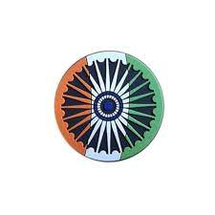
# CURRENT AFFAIRS INTERNATIONAL

INTER
The Sports Governance Conclave was organised by the Government of India, in association with the Government of Gujarat and the Indian Olympic Association (IOA), at the Veer Savarkar Sports Complex in Ahmedabad on 9th January, 2026.

The National Sports Governance Act also partially came into effect from January 1, 2026. This Act establishes the National Olympic Committee, the National Paralympic Committee, and the National and Regional Sports Federations for each sport.

The first International Spice Routes Conference was organised in Kochi, Kerala, from January 6 to 8, 2026. The event, organised by the Muziris Heritage Project, was held at the historic Bolgatty Palace, Ernakulam, a site intrinsically linked to centuries of maritime trade and cultural encounters.

The Supreme Court denied bail to Umar Khalid and Sharjeel Imam in connection with the 2020 Delhi riots case, relying on an expansive definition of a “terrorist act” under the Unlawful Activities Prevention Act (UAPA). The provision qualifies that striking terror is by use of “bombs, dynamite or other explosive substances or inflammable substances or firearms…or any other means.” In denying bail, the SC relied on the prosecution’s interpretation that a “chakka jam” (roadblock) that Khalid and the other accused allegedly conspired to organise would fall under the definition of “any other means.”

The Indian National Cine Academy (INCA) was launched in Mumbai, leading to the formation of an umbrella film body, which will bridge the gap between the 12 regional film industries from across the country, projecting the Indian film industry as one whole unit. INCA will hold its inaugural awards show on March 9 in Mumbai, in which the categories and participation will cut across languages and regions.

Union Agriculture Minister Shivraj Singh Chouhan has said that India has become the world’s largest rice producer, surpassing China, with a total output of 150.18 million tonnes during 2024-25.

Union Home Minister Amit Shah inaugurated the operationalisation of the National IED Data Management System (NIDMS), a centralised and secure national platform, developed under the aegis of the National Security Guard (NSG), for the management of data related to Improvised Explosive Device (IED) incidents.

Somnath Swabhiman Parv was organised from January 8 to January 11 to mark 1,000 years since the first major attack on the Somnath Temple in 1026, by Mahmud of Ghazni. The temple is located in Prabhas Patan, Veraval, in Gujarat.
The formal installation of 33-ft-long and 210-tonne Shiva Lingam for the under construction ‘Virat Ramayana Temple’ in Kaithwalia in East Champaran, Bihar was installed on January 17.

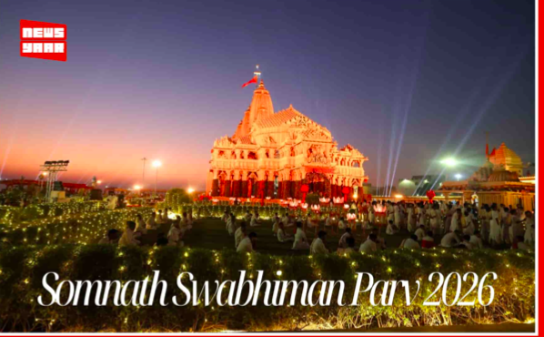
The global economy is forecast to grow by 2.7 per cent in 2026, slightly below the 2.8 per cent estimated for 2025, 40 bps faster than previously anticipated, according to a report prepared by the United Nations Department of Economic and Social Affairs (DESA) and the United Nations Conference on Trade and Development (UNCTAD). According to the report, the increase in global military expenditure in 2024 to $2.7 trillion reflects “the steepest annual increase since at least 1988”. The rise has been driven by the world’s 10 largest spenders, which make up nearly 75 per cent of the total, the UN said.

The January 4 OPEC+ (all 22 oil-producing nations) meeting came after oil prices fell more than 18% in 2025 — their steepest yearly drop since 2020 — amid growing oversupply concerns. After a quick meeting, they decided to keep oil output unchanged.

Tensions between Saudi Arabia and the UAE flared last month over a decade-long conflict in Yemen, when a UAE-aligned group seized territory from the Saudi-backed government. The crisis triggered the biggest split in decades between the former close allies.

In the wake of the U.S.’s operation to depose Venezuelan President Nicolas Maduro, President Donald Trump has coined a new term to describe his approach to foreign policy: the “Donroe Doctrine.” The “Donroe Doctrine” owes its name to two parents: The nineteenth-century “Monroe Doctrine” and the twenty-first-century worldview of Donald Trump. Donald Trump’s doctrine comes with unapologetic primacy, readiness to use force, and the belief that the United States may not only intervene but also supervise political outcomes.

Signing a memorandum titled ‘Withdrawing the United States from International Organisations, Conventions, and Treaties that Are Contrary to the Interests of the United States’, Donald Trump directed all executive departments and agencies to take immediate steps to put into effect the US withdrawal from 66 international organisations, including the Intergovernmental Panel on Climate Change, the International Union for Conservation of Nature, and the International Solar Alliance (ISA).
The ambitious and first-of-its-kind Mars Return Sample mission, planned between Europe and the US, has been officially called off, due to the Donald Trump administration’s heavy budgetary sanctions imposed on NASA.

Soon after the capture of Venezuelan leader Nicolás Maduro, key officials of the United States President Donald Trump administration stated that Greenland should be part of the US territory. Currently, Greenland belongs to Denmark, which has shown no interest in ceding the territory to the US.

One of the latest environmental discoveries is a giant sea bug called Bathynomus vaderi, found in the cold waters near the Spratly Islands in the South China Sea. The angular-headed bug is being called the Darth Vader superbug, thanks to its striking similarity to the iconic villain’s helmet. This new species is impressively large, weighing over 2.2 pounds (1 kilogram) and growing up to 12.8 inches (32.5 centimetres) long.

# CURRENT AFFAIRS INDIA

INTER
THE WORLD AROUND US-A NEWSLETTER
Edition 5 19th January 2026

In libris graecis appetere mea. At vim odio lorem omnes, pri id iuvaret partiendo. Vivendo menandri et sed.

European stock markets were mostly steady as investors tried to make sense of growing political tension around the world. Some markets edged slightly higher while others moved lower, showing a cautious mood. One area that clearly stood out was defense-related companies, which continued to attract attention as governments focus more on security.
Companies involved in making military equipment, aircraft, and defense technology have been gaining interest. Many investors believe countries may increase spending on defense as global tensions rise. This expectation has helped support defense companies across Europe, even while other parts of the market remain uncertain.
A major topic influencing market sentiment is Greenland, a large Arctic island that is part of the Kingdom of Denmark. U.S. President Donald Trump has said the United States needs Greenland for national security reasons and has suggested that different options are being considered, including military involvement. These comments have caused concern among European leaders.
Denmark and other European countries quickly responded, saying that Greenland belongs to its people and is not for sale. They stressed that only Greenland and Denmark can decide the island’s future. European leaders also spoke together to defend the idea that borders and national sovereignty must be respected.
Greenland has become more important in recent years because its location in the Arctic is gaining attention. As ice melts, new shipping routes and access to natural resources are opening up. This has drawn interest from major global powers, making the region more sensitive from a security point of view.
In response to the situation, Denmark announced plans to spend more money on protecting Greenland. Danish officials said this was necessary because of growing security concerns in the Arctic. At the same time, they made it clear that Denmark wants to remain a close ally of the United States, but only through cooperation and mutual respect.
Not all companies performed well during this period. One European delivery company saw its share price fall after a strong rise linked to takeover interest. This kind of movement is common when investors react quickly to big news.
Overall, investors appear alert but calm. While political uncertainty is creating tension, markets have not shown signs of panic. Many are now watching closely to see how discussions between the United States and Europe develop and what this could mean for global stability in the future.

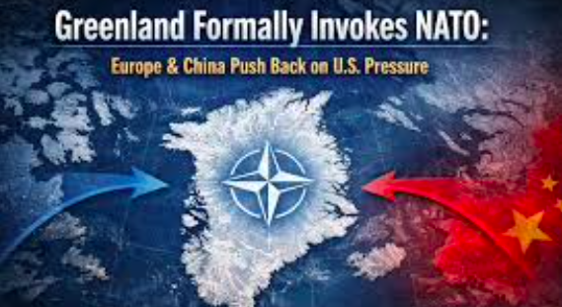
On January 1, 2026, Indian Standard Time quietly completed 120 years. It was not a date most of us circled on our calendars, yet it marked something deeply personal for every Indian, because IST had shaped the rhythm of our everyday lives for more than a century.
It was hard to imagine, even then, that there had once been a time when India did not run on a single clock. Different cities had followed their own local times, guided by the sun overhead. That system may have worked in a simpler age, but as railways spread and communication grew faster, the confusion became impossible to ignore. So on January 1, 1906, India adopted one standard time, set at five and a half hours ahead of Greenwich Mean Time, based on a longitude passing near Mirzapur. Without much fanfare, a shared sense of “now” was born.Anyone who had lived in or visited the Northeast knew how early the sun rose there, while evenings lingered far longer in the western states. And yet, we all woke up to the same alarm time, began work at the same hour, and welcomed the New Year together according to IST. It was a small daily compromise we rarely thought about, but it quietly reinforced a sense of belonging to something larger than our region or state.
As an Indian, there was something comforting in that shared ticking of the clock. From classrooms beginning their morning assemblies, to offices logging in, to families timing prayers, meals, and celebrations, IST was woven into our lives in ways we barely noticed. No fireworks marked the moment, but across the country, over a billion lives continued moving in step with the same measure of time. In a nation defined by diversity, that simple, steady synchrony remained one of our most enduring achievements.
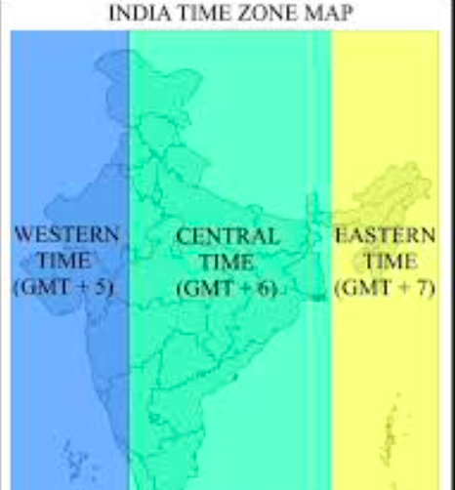
# INCREDIBLE INDIA

INTER
# MONEY MATTERS

INTER

# FEED FORWARD
# CURRENT AFFAIRS साप्ताहिक

INTER

Managing Editors- Aniruddha Iyer Bali, Sabir Singh Ahuja, Vaibhav. S.Uppal, Vihaan.S. Uppal
Hey everyone!  We are teenagers from a boarding school in the foothills, who believe change begins with us. The newsletter, a fortnightly, explores stories, events and ideas that shape our world. From happenings to global issues, we'll dive into it all. Join us, collaborate, critique and voice your opinions as we share our perspectives, insights, and creativity with you!

Your feedback and contributions would be a game changer!

Do write to us, @theworldthisweek4@gmail.com

# TECH TALKING

# SPORTS SCOREBOARD

Climate Change and Renewable Energy Innovation Climate change is counted among the formidable scientific problems that humanity has to tackle at present. The planet is suffering from global warming, rising sea levels, and extreme weather events that are becoming a norm hence rapid climate change on Earth.

According to scientific studies, the primary reason for this change is human activities, especially the case of fossil fuel combustion for energy. Consequently, the breakthrough of renewable energy technology has turned into a big global effort that has the potential to eliminate a major part of the greenhouse gases coming from fossil fuels and, thus, save the future of the planet. Coal, oil, and natural gas—the three fossil fuels—when burned, give off a huge amount of carbon dioxide.

This gas, also known as a greenhouse gas, contributes to trapping heat within the atmosphere, which, in turn, causes global warming and disturbs the climate long term. In order to mitigate these effects, scientists and legislators are now promoting the transition towards cleaner energy sources as an urgent matter. Renewable energy sources like solar, wind, hydroelectric, and geothermal energy are providing sustainable pathways with the least negative impact on nature for electricity production. Renewable energy technologies have gone through a dramatic transformation in the last few decades. For instance, solar power has been the major beneficiary of new photovoltaic cells that give a boost to the efficiency and lower the production cost at the same time.

Today, even a moderate amount of sunlight is enough for modern solar panels to produce a considerable volume of electric power. Likewise, wind energy has undergone an enormous change through the installation of gigantic and more productive turbines that are capable of harnessing power from both onshore and offshore sites. All these advancements in technology have contributed to making renewable energy not only available but also economically viable and competitive across the globe. However, the issue of renewable energy reliability remains as one of the greatest scientific challenges. On the contrary to fossil fuels, renewable resources such as wind and solar cannot be controlled and are subject to nature.

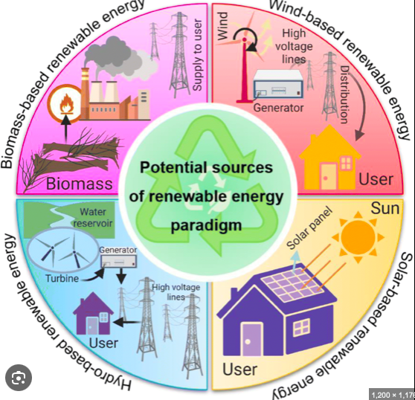

Football in 2026:
A Global Game at a Turning Point Football (or soccer) in 2026 is at a very interesting juncture, influenced by its traditions, technology, and its ever-increasing global presence.

Football remains the most popular sporting genre that continues to bring countries together, but the presence of the FIFA World Cup makes the current year very special for it in several ways. The biggest seminal moment in the year 2026 will be the FIFA World Cup, to be hosted together by the USA, Canada, and Mexico. This will mark the first World Cup to adopt an extended format to include 48 teams. This will offer an extended schedule of play because there will be more fixtures taking place.

This new initiative to accommodate a higher number of teams coincides with the growing inclusivity associated with the world of football. Many new nations in Africa, Asia, and the Americas will have the platform to compete in the world’s biggest stage against major football heavyweights such as Brazil, Germany, and Argentina. “On the pitch, the play style in 2026 is characterized by speed, tactical variability, and technical intelligence,” adds Batanayeu. “Players are more diverse than in any other period in history.

Young stars that broke out in the early 2020s are now at the peak of their powers, and a new wave of teenagers, scouted using AI analytics systems all over the globe, is entering the fray. Technology is also playing a crucial role in determining the future of football in the year 2026.

Video Assistant Referee technology, which was once criticized, is now more refined and accepted, and quick decision-making and communication to the audience is now more efficient. Wearable technology is also accepted in all professional clubs, which is helping coaches measure player fitness and work on reducing injuries.

Even fan engagement is now more refined, and supporters can now be more closely related to football than ever before. Away from the field, football in the year 2026 remains to face various pressing matters of a more social and economic nature. The debates being promoted regarding sustainability, proper governance, and the well-being of football players are more dominantly presented, especially due to the constantly increasing burden of full stadiums and commercial pressures against players. The women’s version of football remains to experience extensive growth.

Finally, soccer in 2026 remains a sport that consumes people with passion and unpredictability. In the ever-changing realms of formats, technology, and the international landscape, the core of the game has remained the same: the same ball, the same rules, the same ability to connect two billion and beyond through moments of shared glory, sorrow, and drama.

Stay fit and fierce… until the next edition !


# RECOMMENDED READS & WEEKLY WATCH

INTER#
# FUTURE FORWARD

INTER#
Harry Potter and the Philosopher’s stone

I recently finished reading Harry Potter and the Philosopher’s Stone, and I finally understand why this book has stayed so popular for so long. My elder sister recommended it to me, saying it was all the rage when she was growing up, and she was absolutely right. The story begins on a sad note, with Harry living with his aunt's family, the Dursleys, who treat him badly and even force him to sleep in a cupboard under the stairs. Everything changes when Harry discovers he is a wizard and is invited to study at Hogwarts. One of the strongest parts of the book is the magical world created by J.K. Rowling through details like Quidditch, moving staircases, and enchanted paintings. An integral part of the story is the friendship between Harry, Ron, and Hermione. They are very different from each other, argue at times, and make mistakes, but when things get dangerous, they trust one another and work as a team. My favorite plot moment is the giant wizard chess game they play near the end of the book. It is intense and clever and shows how the trio must think strategically and rely on each other to overcome real danger. There is also a surprising twist involving Professor Quirrell. If you enjoy adventure and magic, this book is definitely worth reading.

Homebound-India’s entry for the Academy Awards

A Heartbreaking Story of Friendship and Dreams” I recently watched Homebound, and it hit me harder than I expected. I usually like action or comedy, but this movie is emotional, quiet, and full of a powerful message about society, dreams, and how unfair life can be. The movie follows two childhood friends, Shoaib and Chandan, who want to become police officers so they can earn respect and support their families. As they try to reach this goal, they face problems related to caste, religion, and background, which shows how tough things can be for some people no matter how hard they work. The acting by Ishaan Khatter and Vishal Jethwa is amazing, and their friendship feels completely real. One moment that stayed with me was when Shoaib loses his job and doesn’t get into the police. Instead of giving up, he goes to Chandan for comfort and starts working with him. That moment shows true friendship and support. The ending is heart breaking, and it left me feeling sad and quiet for a long time. Homebound made me think a lot. It reminded me to value life, stay away from unfair things like caste and religion, and that being a true friend and never giving up is what really matters.



FDRE typically stands for Firm and Dispatchable Renewable Energy, a system in India integrating renewables (solar/wind) with storage (batteries) to provide reliable, round-the-clock (RTC) clean power, meeting specific hourly demands of utilities, unlike intermittent standalone renewable projects. It's a newer tender format making green energy as dependable as fossil fuels, crucial for India's grid stability, with projects involving hybrid plants and flexible reserves to ensure consistent supply.
Key Aspects of FDRE
Hybridization: Combines solar and wind power.
Energy Storage: Uses batteries or other storage to save surplus energy for later, ensuring power when the sun isn't shining or wind isn't blowing.
Dispatchability: Power can be scheduled and delivered to match utility needs (like peak hours).
Performance: Projects must meet high reliability standards, like fulfilling 90% of the contracted demand monthly.
Tender Process: Governed by guidelines from India's Ministry of Power (MoP) to encourage these advanced projects.
Why FDRE Matters
Grid Stability: Solves the intermittency problem of renewables, making them a stable power source.
Cost-Effective: Increasingly competitive with, and often cheaper than, new coal plants when full costs are considered.
Future-Ready: Helps build a resilient, decarbonized, and reliable power system.
Paraprosdokians are figures of speech in which the latter part of a sentence or phrase is surprising or unexpected and is frequently humorous. The term comes from the Greek words "Para" (beyond) and "Prosdokia" (expectations). Winston Churchill loved and used it extensively with a straight face and wit.
-Where there's a will, I want to be in it.
-Since light travels faster than sound, some people appear bright until you hear them speak.
-If I agreed with you, we'd both be wrong.
-War does not determine who is right, only who is left.
-Knowledge is knowing a tomato is a fruit. Wisdom is not putting it in a fruit salad.
-To steal ideas from one person is plagiarism. To steal from many is research.
- I used to be indecisive, but now I'm not so sure.
-To be sure of hitting the target, shoot first and call whatever you hit the target.
-Going to temple doesn't make you a Hindu, any more than standing in a garage makes you a car.
-You're never too old to learn something stupid.
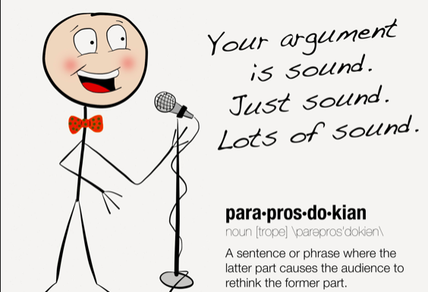

# FUN-TASTIC FIGURES

INTER#

