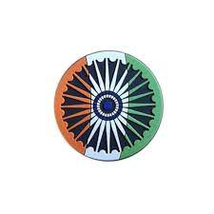
June’s arrival scorched lands, With heatwaves stretching distant sands. Wildfires raged in forests old, nature’s fury grew bold.
Floods struck cities, rivers swelled, Homes and roads in water dwelled. Governments rushed to aid the harmed, While warnings sounded, urgent, alarmed. In Europe, talks for peace were slow, Ukraine’s struggle continued to show. Allies debated how much to send, Borders remained tense without an end. Voices of youth demanded change, Across continents, across each range.
Energy prices jittered, grain in flux, Trade routes shifted, politics deluxe. Space saw satellites and missions launch, Eyes in orbit with cosmic staunch.
July burned with heat extreme, Glaciers melted in the sun’s bright beam. Drought struck crops, rivers shrank, Famine fears on the global bank. In Africa, elections sparked debates, Some rejoiced, while others faced fates. Protests surged, leaders gave speech, Trying to bridge the gap, the breach. Markets reacted to crises near, Inflation, oil, global fear. Financial systems wavered, then held, A tightrope walked, economies meld. Space missions aimed for Mars and Moon, Telescopes captured stars in June. Science thrilled and politics stressed, Humanity strived, its limits pressed.
Climate warnings could not be denied, Heat, fire, ice, storms amplified. July ended with tension, yet fire, A planet alive, with need to inspire.
August roared with youthful might, Voices rose for future’s right. From climate halls to city squares, The young demanded justice, unawares. Protests in Latin lands were strong, Economic woes and laws gone wrong. Governments faced a growing call, As citizens sought a fairer hall. Asia faced floods and typhoon rage, Monsoon storms wrote nature’s page. Aid was rushed and shelters filled, Communities tested, spirits skilled.
September brought the leaders’ a-stage, Summits, speeches, the world’s front page. Promises polished, deals outlined, Some fulfilled, some left behind. In Africa, votes shaped futures vast, Some regimes new, some legacies cast. Asia faced storms, lands under threat, Humanitarian aid moved, governments met.
Peace talks crawled while bombs still fell, Civilians carried the heaviest hell. Markets braced for seasonal shift, Inflation, trade, stocks adrift. Energy and food prices swayed, Global systems in delicate array.
October hummed with tech’s advance, AI and robotics led the dance. Autonomous systems, medical aid, Promised futures, but fears were laid. Protests flared for rights and change, Governments struggled with laws strange. Youth demanded justice, clean and fair, Around the globe, people took to air. Energy crises shook some lands, Markets fluctuated by unseen hands. Oil, grain, and trade felt the strain, Global economies adjusted again. Ukraine’s war continued to weigh, Allies debated night and day. Diplomats pressed for some accord, battles raged, civilians were ignored.
November ballots and battles brought elections’ light, Voters cast decisions bright. Some lands shifted, new leaders rose, Some old powers faced fresh throes. Protests lingered where promises stalled, Youth and workers, loudly called. Economic woes stirred public ire, Markets reacted to political fire.AI continued shaping lives, Ethics boards debated what survives. New tools for work, study, and play, Raised questions of how humans stay.
Natural disasters marked the month, Floods and droughts across the front. Climate warnings grew more dire, Yet humans struggled to inspire. Space missions launched probes anew, Exploring heavens with vision true.
December’s winds sharp and cold, A year of trials, stories told. Conflicts simmered, peace delayed, Yet human courage never swayed. Elections with new leaders sworn, Some reforms passed, some still torn. Economies balanced, some fell hard, Markets watched with cautious guard. Climate crises pressed the globe, Heat, drought, flood—no easy robe. Scientists urged urgent change, Nations debated, goals in range. Technology shaped work and play, Humans questioned the price to pay.
A year of fire, water, ice, and wind, Of battles lost, and victories pinned, Where youth demanded right, Where science soared to cosmic height. We saw the planet cry in pain, Yet human spirit would remain. Conflicts raged, yet hope endured, Through storms, through loss, through plans obscured.
Let us reflect on what we’ve learned, On climate, war, and progress earned. To act with care, to speak, to mend, To guard the future we defend !
For 2025 is history’s page, A mirror, warning, and a stage. May we move forward, clear and wise, With hearts awake and open eyes.

# THE YEAR THAT WAS

INTER

THE WORLD AROUND US-A NEWSLETTER
Edition 4 03rd January 2026

January -The year walked in on uneasy feet, With ceasefires hoped for, none complete. Gaza’s wounds still shaped the news, While talks stalled fast, as violence brewed. Ukraine’s winter bore the strain, As aid and arms crossed seas again. NATO met with cautious tone, Security fears not yet outgrown. Elections loomed in lands afar, Democracy tested by mistrust and scars. Campaigns sparked both hope and fear, As truth grew blurred in the info-sphere. Artificial minds grew sharper still, As governments raced to shape their will. AI laws debated line by line, To guard the human, not the machine. Markets opened with guarded cheer, Rates held steady, inflation near. Oil surged when shipping stalled, Red Sea routes re-drawn, alarms called. Climate broke records yet again, Heat in summer zones, floods in rain. Scientists warned, the world took note— Some listened, some looked away remote. Space launches pierce the night, Nations race for orbital might with cautious breath— A world awoke, rehearsing for what’s next.
February — Fault Lines and Forecasts spoke in sharper tones, Through icy streets and global zones. Talks of peace were drafted, redrafted, While shells still fell where truces fractured. The Middle East stayed tense and tight, Aid trucks moved through watchful night. Diplomats circled words like flame, Each clause weighed down by loss and blame. Ukraine’s allies argued cost, What must be sent, what lines not crossed. Parliaments debated aid, While soldiers waited, underpaid.
Elections echoed continent-wide, From island states to nations wide. Turnout rose, distrust remained, As truth was filtered, bent, and strained. Artificial intelligence grew loud, New models praised, new fears allowed. Schools, courts, and offices weighed, What work was lost, what futures made. Markets dipped then found their feet, As rate cuts teased, but didn’t meet. Supply chains bent from straits to seas, Disrupted trade on global knees. The climate wrote in urgent ink, Heatwaves early, glaciers shrink. February closed with signals clear— The year would not slow down for fear.
March maelstroms arrived with winds of change, Across the globe, both near and strange. Floods in Asia drowned low plains, While fires raged through drought-stained plains. In Europe, leaders met and spoke, Policies weighed, promises woke. Energy prices climbed and fell, As nations juggled each tariff spell. Ukraine’s frontlines still held the strain, Aid convoys crossed snow and rain. Sanctions tightened, debates grew sharp, While civilians bore the cruel-est mark. Protests flared from town to town, Voices rose against the crown. From South America to distant shores, People demanded rights and more.
Tech boomed in labs and hubs, AI learned, created, solved, debugged. Ethics raced to catch the pace, As humans questioned what defines a “face.” Space missions launched with dreams anew, Orbiters and telescopes pierced the blue. The world watched in silent awe, At glimpses of what science saw. Climate warnings stacked like books, Glaciers melted, oceans shook. Tensions, hope, and strife, the year pressed on, pulsing with life.
April’s Planet shone on shifting ground, Where protests echoed, voices found. From streets of Europe to Asian towns, People marched against the crown. In Africa, elections stirred, Debates grew heated, lines were blurred. Voter turnout, fervent and strong, Democracy proving both right and wrong. Markets swayed with cautious breath, Investors weighed growth, debt, and death. Oil and grain prices climbed anew, As nations balanced what they could do. AI policy sparked fierce debate, Ethics and law tried to navigate. Tech companies vied for global sway, Promising progress, yet fears held sway. Ukraine still faced the winter’s end, Borders tense, allies to defend. Ceasefire talks crept, tentative, slow, While hope and despair continued to grow. Climate news pressed on the page, Floods in Europe, droughts on stage. The Arctic warmed, storms ran wild, The Earth’s fury could not be mild. Space missions launched with pride and fear, Orbiters watched the world from clear. April closed with cautious eyes, The globe awake beneath the skies.
May’s Movement and Momentum arrived with streets alive, Protests, marches, calls to strive. In Asia, monsoons tested lands, Rivers swelled, reshaping sands. Aid convoys raced to towns in need, Showing how the world could heed. Elections passed in varied states, Leaders chosen, some debated fates. Coalitions formed, crumbling fast, Political winds forever cast. Markets jittered with cautious sway, Interest rates and debt on display. Ethics boards tried to keep pace, Regulations raced the human race. Diplomats tried to forge a path, But violence lingered in its wrath. Space exploration reached new height, Telescopes peered into cosmic night. Climate scientists issued alarm, Calling humanity to act with calm.
June — Heat, Conflict, and Hope
June’s arrival scorched the lands, With heatwaves stretching distant sands. Wildfires raged in forests old, As nature’s fury grew bold.
Floods struck cities, rivers swelled, Homes and roads in water dwelled. Governments rushed to aid the harmed, While warnings sounded, urgent, alarmed.
In Europe, talks for peace were slow, Ukraine’s struggle continued to show. Allies debated how much to send, Borders remained tense without an end.
Protests flared for climate and rights, Students marched through days and nights. Voices of youth demanded change, Across continents, across each range.
Markets swayed on interest news, Investors weighed their global cues. Energy prices jittered, grain in flux, Trade routes shifted, politics deluxe.
Tech and AI leapt once more, Innovations reached for skies to explore. Ethics boards tried to keep pace, Regulations raced the human race.
Space saw satellites and missions launch, Eyes in orbit with cosmic staunch. June closed with tension, hope, and fire, The world paused, but dared to aspire.

In libris graecis appetere mea. At vim odio lorem omnes, pri id iuvaret partiendo. Vivendo menandri et sed.

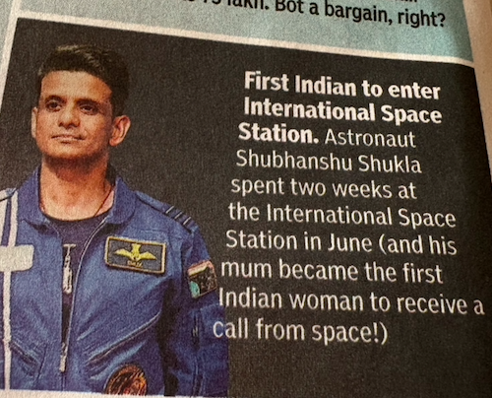
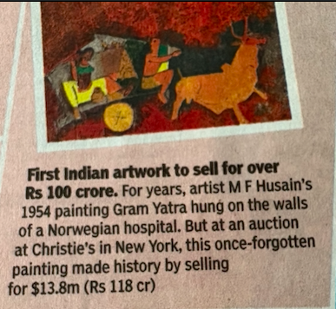
# INCREDIBLE INDIA

INTER
2025 has certainly not been very peaceful, with many apocalypticists and doomsayers believing this to be the end of the world.

In Bangladesh, unrest has been triggered by the assassination of 32-year-old anti-India activist Sharif Osman Hadi on the 12th of December. Violent protests followed the demise of this popular figure, other activists and police believing Hadi’s murderers’ fleeing to India. Protests have even escalated to attacks on Indian diplomatic buildings in Dhaka. Another excuse for these tumultuous anti-India protests is the supposed fleeing (again, to India) of the former President of Bangladesh. The UN has called for an "impartial and transparent" investigation into Hadi's killing and related affairs.

In a seemingly redemptive mood, the military-controlled Myanmar government has, after 5 years, decided to host elections. However, the conditions of these elections must also be glanced upon. The ruling party has banned the most popular party, the NLD (National League for Democracy), from participating, and has also imprisoned their leaders, including 1991 Nobel Peace Prize laureate Aung San Suu Kyi. The imprisonments are also active on citizens, on charges ranging from free speech against the votes to liking such social media posts. This election, dubbed a “sham” election by modern Western governments due to the lack of legitimacy, is being held after a gap of 5 years. The last elections ended in an utter victory for the NLD, leading to a coup against them in 2021, bringing the military to power. The United Nations refuses to recognise these recent elections.

Antisemeticism: In what is being called the worst terrorist attack in Australian history, a father and son opened fire at a Hanukkah festival on Bondi Beach, killing 15 people and wounding 40. The attack is described as the deadliest act of antisemitic violence globally since 2023. Anti-semitic violence in the Jewish festive week continues in the USA, as a Jewish man was stabbed in Brooklyn, New York, projectiles were fired at a Jewish family’s Hanukkah-decorated home in Redlands, California, and an arson attack was committed on a Jewish student centre in San Francisco, California, amongst others. In response to these crimes, actions have been taken. The US Justice Department Task Force is a multi-agency group formed to root out antisemitic violence in schools and on campuses. NGOs also engage with tech companies to improve content moderation, reporting tools, and AI training to identify antisemitic content.

Other events: The US has intensified its talks with both parties of the Ukraine War, now proving to be Europe’s largest conflict since World War II.

The Israeli-Palestinian conflict, the Gaza peace plan calls for ceasefire, hostage return, and international stabilization force. In the Sudan Civil War, now the world’s largest humanitarian crisis, the civilian "Third Pole" initiative is forming a new antiwar bloc. International sanctions are also being made.

Tensions remain high in the broader Middle East, including between Israel and Iran, Israel and Hezbollah in Lebanon, and from Houthi attacks in the Red Sea.

Defensive actions are being made with international help, though not yet completely resolved. An explosion at the Ali Bin Abi Talib mosque in Homs, Syria killed 8 and injured 18 during Friday prayers. The United Nations unequivocally condemns the attack and stresses the need for justice.

"Happiness can be found even in the darkest of times, if one only remembers to turn on the light"

# HEAL THE WORLD

INTER

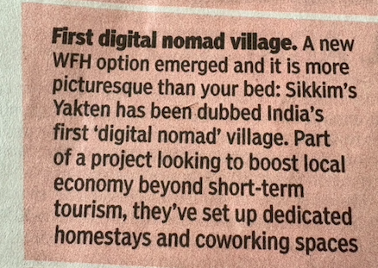
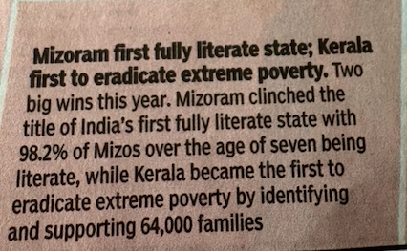



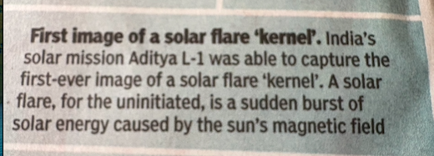
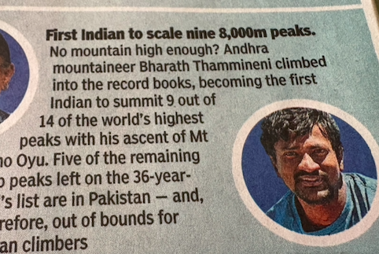

# FEED FORWARD
# CURRENT AFFAIRS साप्ताहिक

INTER

Managing Editors- Aniruddha Iyer Bali, Sabir Singh Ahuja, Vaibhav. S.Uppal, Vihaan.S. Uppal

-Editor of the Month-Swarit Choudhary, The Doon School
-Guest Columnist- Aditya Soni, The Doon School
Hey everyone!  We are teenagers from a boarding school in the foothills, who believe change begins with us. The newsletter, a fortnightly, explores stories, events and ideas that shape our world. From happenings to global issues, we'll dive into it all. Join us, collaborate, critique and voice your opinions as we share our perspectives, insights, and creativity with you!

Your feedback and contributions would be a game changer!

Do write to us, @theworldthisweek4@gmail.com

# GEOPOLITICS ‘ GRAVITIONAL FORCE

# SPORTS SCOREBOARD

A World Under Pressure
Geopolitics, Climate Change, and Governance in 2025
It can be stated that the year 2025 indicated a time of immense pressure in the global setting with unresolved wars, political instabilities, natural disasters triggered by climatic change, and large-scale diplomatic efforts towards a new definition of global collaborations. It was not an event but a series of events which indicated a shift in this unstable global setting. Russia-Ukraine war can be named as one of the fault lines in global politics, in its fourth year with diplomatic efforts such as summit meetings of European leaders and other European countries in NATO, but it did not end with a quick resolution. Mid-year summit meetings in NATO countries emphasized a strategy of deterrence in the long term, with an understanding from certain countries in NATO to increase defence spending, thus making a quick resolution less likely. In other parts of the world, including the Middle East, there were challenges despite precarious ceasefires and humanitarian crises.
Gaza remains a hub of international attention, with aid agencies warning of a degradation of civilian life. In contrast, nations in the Gulf State region have become increasingly involved in international diplomacy and relief efforts, including a staggering financial donation to future relief appeals by the United Nations from the United Arab Emirates.
The Global South got unprecedented coverage in 2025. The summit of the G20, organized in Johannesburg, shall be remembered not only for taking place in Africa for the very first time but also for dealing with debt relief, climate funding, and food security. While some leading countries participated in the summit with lower delegations, developing nations did not miss this chance to demand an overhaul of global financial institutions. The BRICS summit in Rio de Janeiro highlighted a vision of a new order in global economy governance without relying on a Western order.
One of the core elements of this year is the domestic unrest and political uprising. The uprising in Nepal among the youth against corruption and restricting digital freedom escalated to a national uprising, which in effect led to the fall of the government and an interim government emerging. With varying democracies, elections and uprising indicated a lack of contentment with governance and performance in issues such as inflation and unemployment, thus setting a pace in a rising fall in political institutions in the global platform.
Climate change demonstrated some of the most striking consequences of 2025. The South and Southeast Asia area reported record-breaking floods during monsoons, resulting in millions of people being left stranded and thousands of deaths. Research studies were put out in the press with scientific evidence of record-breaking high temperatures being a principal factor in increased rainfall. Other areas reported catastrophic record-breaking heat waves and bushfires that tested the capabilities of emergency services to the limit with small island nations making heartfelt appeals for increased global commitment to global warming. However, not all news in 2025 was negative. A massive operation led by law enforcement authorities to counter illicit trade in animals saw tens of thousands of trafficked animals rescued, bringing to light the scale of illicit trade in animals. The regulation of artificial intelligence advanced with a global summit in Paris offering a basis for a common set of principles in dealing with AI safety and regulation. As 2025 drew to a close, it had become clear that a new era wherein crises have become reality rather than a series of separate occurrences, had arrived.
Wars, climate change, social upheavals, and technology intertwined to become issues where international cooperation is a necessity !

The year 2025 will be remembered as a thrilling and unforgettable chapter in global sports. Across football fields, cricket grounds, tennis courts, and athletic tracks, fans witnessed historic victories, emotional moments, and the rise of new champions alongside legendary stars.

Football delivered the biggest highlights of the year. Paris Saint-Germain finally lifted their first UEFA Champions League trophy after a tense final against Manchester City. Women’s football also shone brightly as Spain defeated Germany to win the UEFA Women’s Euro 2025, continuing their dominance on the international stage.

Tennis saw a mix of consistency and breakthroughs. Jannik Sinner and Carlos Alcaraz ruled the men’s Grand Slams, while Madison Keys claimed her first-ever Grand Slam title at the Australian Open. The women’s game remained highly competitive, with stars like Iga Świątek, Coco Gauff, and Aryna Sabalenka delivering outstanding performances.

In athletics, the World Championships in Tokyo thrilled fans as Noah Lyles defended his 100m title and Sha’Carri Richardson proved her supremacy in women’s sprinting.
Cricket fans celebrated South Africa’s long-awaited triumph as they won the World Test Championship at Lord’s, with Aiden Markram playing a heroic match-winning innings.

Beyond competition, sport also united people. Lionel Messi’s GOAT Tour and David Beckham’s UNICEF visits highlighted how sports figures inspire communities off the field as well. Overall, 2025 showed that sports are not just about winning, but about perseverance, unity, and unforgettable moments that connect the world.

Stay fit and fierce… until the next edition !

# EDITOR OF THE MONTH-SWARIT CHOUDHARY

INTER#
# CORRESPONDENT’S COLUMN

INTER#

Brain Fuel: What Keeps It Healthy?

No, this is not another boring chapter from your biology textbook. This, in fact, is an eyeopener to make you realise the invaluable worth and potential of your brain. It may be small, but if it is capable of commanding you at every single moment, even when you're reading the sentence at this instant, it just deepens one's curiosity about what it houses within its perimeter. Being the most crucial organ in the human body, it should be safeguarded by you. Of course, your skull does the job physically, but it needs to be well fed to keep itself up and running.

The Mood Factor
There are days when you are less energetic and wary. On others, there may be no bounds to your high spirit. These swings are caused due to the secretion of chemical substances called dopamine and serotonin. They are responsible for changes in our emotions. You may be thinking about how mood fits in the context of mental health. Mood swings are a common sign of your brain not being ‘well-fed’. Social life plays a big role in shaping your emotions. Many of us love to hang out with our friends, and it genuinely proves to be beneficial for our brains. Alongside this, meditation, exercise, hobbies, too help to keep our brain in good health.

Zzzzzz’s
Congratulations, reader! You have arrived at the section that emphasises your dream job. Sleep. Show this to any person who opposes your extended durations of sleep. Jokes aside, it is by far the most crucial activity that your brain requires to stay fit. It serves as a recovery period for your brain to kick out the trash and retain the valuable memories so that it doesn't become a messy landfill. It also helps overcome exhaustion.
Dear reader, do understand that sleep is not a waste of time. Your brain can store information amounting to several thousand encyclopedias. So you really don't want it to fill to the brim with pointless information. Otherwise, you would be no better than an overfilled dump yard. Sleep acts as the garbage truck, so its significance is equivalent to that of your most valuable thing.

‘The right diet’
In case you're eager to read this section just to see me side with you guys as a proponent for Cheetos, Lay's, Knickers, M&Ms, etc., just like how I did for Glorious Sleep, my hearty condolences to you but I would love to watch your parents constantly poke their noses in your food (if they do). And I would encourage them to exceed limits so that out of frustration, you start having your veggies like good kids. Having junk food is basically like preparing your brain's tombstone. Imagine devouring loads of preservatives, chemicals, etc., and still calling it tasty. That's how you look with that bag of chips. An excess of it impedes the functioning of your brain. On the other hand, vegetables strengthen your brain and help it to develop progressively, reducing the probability of acquiring diseases or disorders.

‘A blessing in disguise’
Certain practices, such as sleep, are enjoyable, but others, like eating your veggies, may just add to your endless woes. On the contrary, they are beneficial and aid none but you. Adviseably, if you consider these to be the daily medicines that would cure you from illness, it would eventually become habitual. Upon becoming so, you would surely develop a likeness towards them.

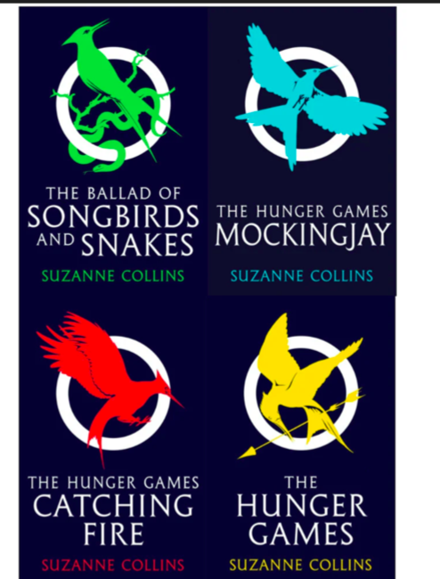
Shifting Seasons: What’s Next?

For centuries, our seasons were steady and quite predictable. Farmers planted crops around the monsoons, and winters brought relief from the heat, every season arrived on time. Today, this is no longer the case. Nature is no longer in balance, and we can feel it all around us.

Increasing global temperatures have absolutely changed the natural weather cycles. Summers last longer and are way more intense, while winters are becoming shorter and less severe. Rainfall patterns have also changed. Some regions face flash floods, while others have long droughts. In countries like India, unpredictable monsoons affect agriculture, water resources, infrastructure, and most importantly, our health.

These changes don’t just affect the weather. Glaciers melt, which in turn leads to rising sea levels, heatwaves threaten our health, and ecosystems are destroyed as plants flower earlier and animals migrate at the wrong times.
Reducing the consequences of shifting seasons has to start with cutting greenhouse gas emissions. This can be done by increasing the use of renewable energy, reducing pollution from transport and industry, and protecting forests that help regulate the climate. Sustainable farming and water management can also help.
At the same time, we must adapt to changing weather patterns because some damage has already been done. Climate-proof infrastructure, improved flood control, and early warning systems can significantly reduce damage from extreme events. Strong environmental laws, global cooperation, and responsible individual choices are important to support long-term stability.
These shifting seasons are not just a sign of change—they are a warning that we cannot ignore. The damage is already visible all around, and delaying action will only make the consequences worse. What we do today will decide whether future generations live on a stable planet or a world of everlasting crisis. The time to act is not later.
IT IS NOW !
-ADITYA SONI
THE DOON SCHOOL

