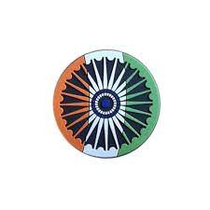

# MONEY MATTERS

INTER
THE WORLD AROUND US-A NEWSLETTER
December Edition 3 23rd December 2025

In Iraq’s 2025 elections, parties and figures associated with the Tishreen reformation protest failed to win seats in Parliament. The Donbas region, the annexing of which was the primary reason for the Russia-Ukraine War, remains an intractable issue in talks between the two sides.

US pressure aims to choke off Russian oil supplies to India, but Modi and Putin are seeking to deepen cooperation in other areas. Once envied for its political stability, Tanzania is forever changed after the election day killings of protesters.

The UK's indecision over the Chinese ‘mega-embassy’ highlights the need for a more coherent UK-China policy. Zelenskyy’s right-hand man, Andriy Yermak, has resigned, leading the President to need to re-balance power and strengthen democracy by empowering the government, parliament and local authorities.

Pakistan’s new bill, especially the 27th amendment, gives its army and army chief unprecedented powers. It could also have serious implications for regional tensions and fan the flames of border insurgencies. Tensions also rise over Tigray and Ethiopia’s contested claim of access to the Red Sea, and another war in the Horn of Africa may be inevitable.

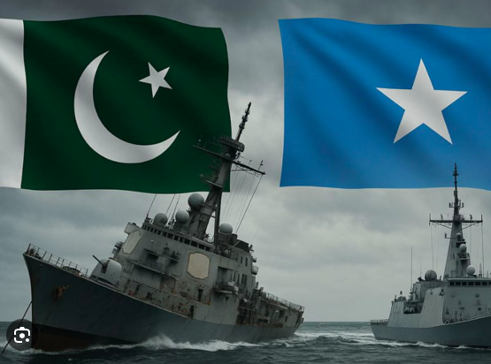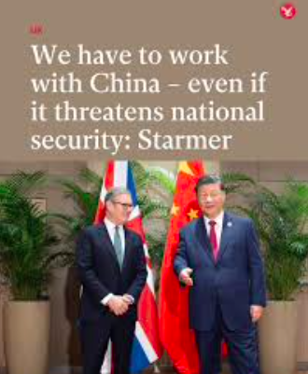

# CURRENT AFFAIRS

INTER

Putin's India visit highlights

India and Russia firmed up a five-year plan to bolster economic and trade ties in the face of Washington’s punitive tariff and sanctions regime, even as Prime Minister Modi conveyed to Putin that the war in Ukraine must be brought to an end through peaceful means.

Mr. Putin landed in New Delhi for his first visit to India in four years, witnessing a red carpet welcome by PM Modi, followed by a private banquet dinner by the latter. Denis Manturov, First Deputy Prime Minister of Russia, said the visit to India has been “very positive” and noted that Indian companies should find respective business partners in Russia as a means to boost bilateral trade and achieve a balanced trade relationship.

Prime Minister Narendra Modi and Russian President Vladimir Putin held an extensive range of talks aimed at strengthening the Special and Privileged Strategic Partnership between India and Russia

The University of Delhi (DU) on Friday (December 5, 2025) signed a Statement of Cooperation with Russia’s National Research University Higher School of Economics (HSE University) to jointly set up a Space Mirror Lab.
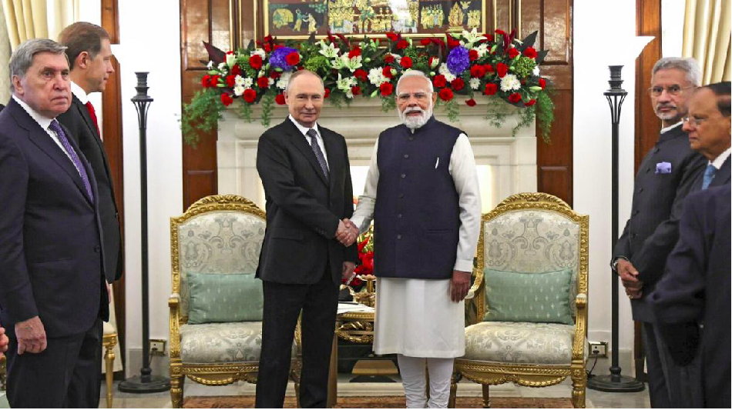

In libris graecis appetere mea. At vim odio lorem omnes, pri id iuvaret partiendo. Vivendo menandri et sed.

# FEED FORWARD
# CURRENT AFFAIRS साप्ताहिक

INTER

Aniruddha Iyer Bali, Sabir Singh Ahuja, Vaibhav. S.Uppal, Vihaan.S. Uppal

# Meet the Makers
Hey everyone!  We are four teenagers from a boarding school in the foothills, who believe change begins with us. The newsletter, a fortnightly, explores stories, events and ideas that shape our world.
From happenings to global issues, we'll dive into it all. Join us, collaborate, critique and voice your opinions as we share our perspectives, insights, and creativity with you!

Your feedback and contributions would be a game changer!
Do write to us, @theworldthisweek4@gmail.com



# CLARION CALL

INTER

A World of Endless Options- Entertainment, it has never been more varied, or more accessible. It offers something for every interest, mood, and moment. It goes from the best of movies, and trending music, to cutting-edge matches of sports, a way to unwind for everyone. A place where people can actually watch something without getting bored. Streaming platforms like Youtube, Instagram, Twitch, etc, now bring global storytelling right into our homes, whether it be the 2022 world cup (1.5 billion views) or the ‘Despacito’ song (8.7 Billion views). Everyone has a different interest. At the same time, Live entertainment gives us a vibrant comeback– I’m talking about concerts, stand-up comedy shows, theatre productions which are shared in an in-person experience.

Gaming, too, has been a cultural powerhouse for entertainment. With over 5 million games. They blend strategy, creativity, and social interaction with each other. Whether through immersive consoles like the Playstation 5, indie game, or quickly mobile challenges like candy crush. Social media continues to reshape how we consume entertainment. Short-form videos started in 2013, with vine. And completely boosted with the coming of TikTok. Podcasts, and creator driven content offers quick hits of humour, inspiration, and connection throughout the day.

For those who prefer something more calmer or creative, E-books, crafting, board games, and outdoor activities remain timeless ways to unwind. They have been going on for centuries and haven’t gotten boring, and neither will they anytime soon. Many people now enjoy mixing digital and offline entertainment to create a healthier balance. In today’s world, entertainment isn’t just an escape–it’s a reflection of who we are, what we enjoy and how we connect with our loved ones and others. With endless choices available, everyone can curate their own personal blend of joy, humour, and discovery.

Entertainment continues to expand in many exciting ways, giving everyone the freedom to choose how they relax, connect, and socialize with other people. Entertainment goes from digital media, and global streaming to live events, creative hobbies, and outdoor activities.



A call for Kindness

An act of kindness is an action that assists someone or brightens their day. It does not have to be big or expensive; even small things can make a huge difference. For example, helping a classmate understand a hard math problem or holding the door open for others are all examples of simple acts of kindness. These actions show respect, caring, and empathy.

Though people live in different countries and speak different languages, they are confronted with the same environmental issue. This has encouraged the united labour of scientists, heads of states, organizations, and simple citizens around the world.

The Paris Agreement is a legally binding international treaty on climate change. It was adopted by 195 Parties at the UN Climate Change Conference (COP21) in Paris, France, on 12 December 2015. It entered into force on 4 November 2016.

Its overarching goal is to hold “the increase in the global average temperature to well below 2°C above pre-industrial levels” and pursue efforts “to limit the temperature increase to 1.5°C above pre-industrial levels.”

However, in recent years, world leaders have stressed the need to limit global warming to 1.5°C by the end of this century. the UN’s Intergovernmental Panel on Climate Change indicates that crossing the 1.5°C threshold risks unleashing far more severe climate change impacts, including more frequent and severe droughts, heatwaves and rainfall. To limit global warming to 1.5°C, greenhouse gas emissions must peak before 2025 at the latest and decline 43% by 2030.

The Paris Agreement is a landmark in the multilateral climate change process because, for the first time, a binding agreement brings all nations together to combat climate change and adapt to its effects.

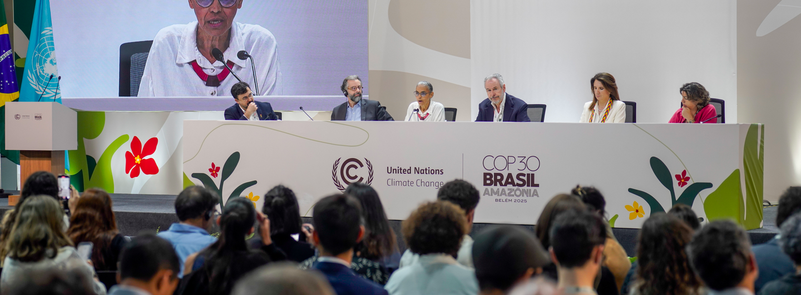
# TECH TALKING

INTER

# SPORTS NEWS

# HEAL THE WORLD

INTER#
Israel has approved a plan to take the last 5,800 Bnei Menashe Jews from Mizoram and Manipur to the Jewish country by 2030.

The Israeli government seeks to settle them primarily in Nof HaGalil and other towns in northern Galilee region in Israel that borders Lebanon. The move, Israel says, is aimed at resettling the Jewish population in the underdeveloped and sparsely populated region, which has also been affected by conflict, forcing many Israelis to flee. Indians will be resettled in conflict-hit areas with a considerable Arab population, and bolster security.

Ethnic Kuki and Mizo tribals belonging to the 'Bnei Menashe' community are feeling proud fighting a war far away in their new-found homeland – Israel. Wishes poured in last week for 206 Israelis, belonging to the community, when news broke that they had been called for "reserve duty" in Israel’s war against Hamas.

All Israeli citizens are required to serve in the military mandatorily (three years for males, two years for females) once they attain the age of 18 years. These 206 people, who have already served, were called from the reserve.
Who are the Bnei Menashe’s?
Bnei Menashe' is a community of Indian Jews from Manipur and Mizoram. Nearly half of the community have migrated to Israel over a period of time to become its citizens. a community of Indian Jews – Kukis and Mizos – from Manipur and Mizoram, claim that they belong to one of the 12 'Lost Tribes' of Israel. The population of about 10,000, is almost equally divided between Israel and India. Immigration was initiated by a Jerusalem Rabbi Avichayil Eliyahu since the early 1990s .

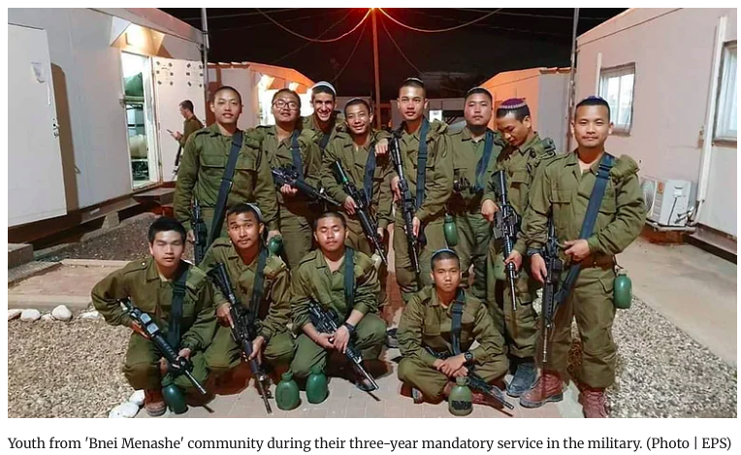

The Ashes 2025 series has been at the forefront of the cricket world. The second Test in Brisbane saw England's Joe Root silence his critics with a maiden Test century on Australian soil. Simultaneously, Australia's Mitchell Starc made history, surpassing Wasim Akram as the highest left-arm pacer Test wicket-taker. This match also featured off-field drama, with veteran spinner Nathan Lyon expressing his frustration at being dropped from the squad. Elsewhere in international cricket, the India vs South Africa ODI series is finely balanced at 1-1, heading into a decider after South Africa successfully chased a challenging 359-run target set by centuries from Virat Kohli and Ruturaj Gaikwad. The domestic circuit also saw major news, with Andre Russell explaining his shock retirement from the IPL, and Indian pacers like Mohammed Shami using the Syed Mushtaq Ali Trophy to push for national selection.

In European football, Arsenal seized a five-point lead at the top of the Premier League table with a comfortable 2-0 win over Brentford. Manchester United, however, was held to a 1-1 draw by West Ham, adding to their inconsistent run. Real Madrid's Trent Alexander-Arnold suffered a new muscle injury that is expected to keep him out for two months, raising concerns for his World Cup participation.
The football week was arguably defined by a sensational nine-goal Premier League match that captivated audiences. Manchester City won in a 5-4 thriller away at Fulham this past week, in a match where Erling Haaland became the fastest player to score 100 Premier League goals in history. City raced to a 5-1 lead before a spirited Fulham comeback made for a nervy finish, with City just holding on for the win.
The FIH Men's Junior World Cup 2025 in India has reached the knockout stage. The host nation had a perfect group stage, scoring 29 goals and conceding none. Their quarter-final clash against a strong Belgium team today promises to be a stern test. Other quarter-finals feature Spain vs New Zealand, France vs Germany, and Netherlands vs Argentina.
The Women's Junior World Cup also commenced this week in Santiago, Chile. In other hockey news, the Indian men's senior team recently secured a silver medal in the Sultan Azlan Shah Cup, while coach Harendra Singh stepped down from the women's team role.

Stay fit and fierce… until the next edition !

INTER

# REASON TO CHEER

INTER#
# CORRESPONDENT’S COLUMN

INTER#

Activists Using Fortnite to Fight Back

Players are role-playing ICE raids in Fortnite and Grand Theft Auto to prepare for real-world situations. STEVETHEGAMER55 IS LIVE on YouTube. He’s streaming a session to his 4.6 million subscribers of GTA 5 RP, a Grand Theft Auto 5 mod that allows people to role-play with other players. “

His character doesn’t get far before an SUV swings onto the sidewalk in front of him; masked ICE agents spill out of the vehicle. “Stop right there,” one of the uniformed players says. It isn’t long before SteveTheGamer55 is surrounded by agents. He hands over his ID while bystander players yell at the agents and demand his release.
For a [gaming] stream that's educating the public in a world where many people may not have seen an interaction with ICE yet, it’s a way to get folks to know or get used to what that might look like.
What their rights are as bystanders, as citizens, as noncitizens, as folks who are documented, undocumented. It felt like a really great way to see all that play out for an audience offering a chance for gamers across multiple platforms to learn about community building and how to speak up about xenophobia online. Organizers say they’ve already dealt with people claiming to be ICE agents spreading misinformation and pro-ICE propaganda in their online communities.

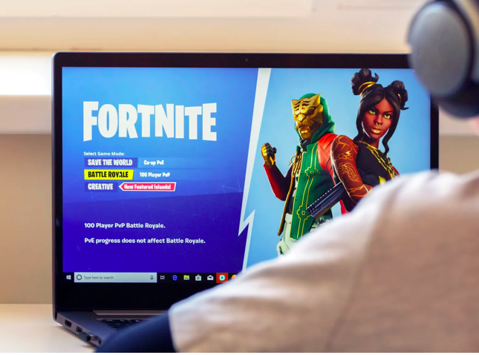
“Between the Stars”
As I stare into the deep night sky,
Reflections on time passed by.
I trace behind the constellations,
Yet feel so far from where I lie.
Always wandering, trying to fit the mould,
But the warmth of belonging still feels cold.
Both nowhere and everywhere, caught in between—
A shadow in plain sight, yet still not seen.
I’ve worn many masks, but none feel quite right.
Dancing in the shadow, lost as realisation strikes.
I belong in the sky, the spaces between,
Where the stars whisper where I’m barely seen.
Being both the question and answer I seek,
A puzzle unfinished, a voice too meek.
I look back up, my eyes confined,
And realise I belong where the stars are undefined.
I am nowhere and everywhere at once,
Always adrift,
But somehow I’ve found my place in the spaces I shift.

-Katelynn lvana Rozario



